HRM6005 - Managing and Rewarding Performance

Week One

Description
Motivating and rewarding employees provides benefits not only for the employee but also the organisation. These are important aspects of performance management, a process that is required to obtain the best from employees, provide a stimulating and interesting work environment and achieve organisational goals. In this unit, students explore the processes involved in managing employee performance within an organisation from both an individual and team perspective.

1.1 Get to know your Assessment 2 project group

Purpose
You will be working with your project group over weeks 1 and 2 to develop a presentation for Assessment 1.
Task
Each project group has its own dedicated discussion board, which can be accessed below. Visit this to introduce yourself to the rest of your group and organise your first meeting.
You can use any method to coordinate and communicate with your team - you don't need to use the discussion board after the initial meeting.
Click here for an overview of Assessment 2.

1.2 Performance management systems
Purpose
Performance management systems, like any systems, contain a set of principles and procedures that determine the way something is done. The aim of the activity is to become familiar with a PMS by examining its components.
Task
Step 1: The image below presents an outline of the various components that make up a PMS. Click on the hotspot in each component to reveal an explanation of that PMS component.
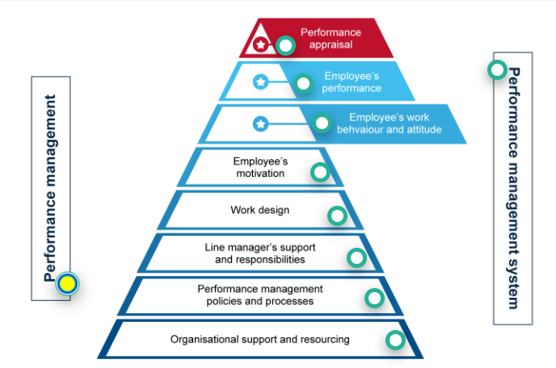
Calude: The following descriptions are what is clickable in the above image. Display them like definitions within the topic.
Performance management – isn’t the whole thing ‘performance management’? Yes and no! ‘Performance management’ can also refer to the action of a manager ‘managing’ the performance of an individual or team (that may not be performing) vis-à-vis: “I’m going to ‘performance manage’ them to success!”
In essence, when someone isn’t performing a manager may adopt a formal ‘performance improvement plan’ – which is generally a negotiated set of actions that the employee and manager agree on, so as to get the employee’s output and/or behaviour back into appropriate alignment. This action is also referred to as ‘performance management’ – though in this case, it is framed in the negative.
Managing underperformance needs to be done in a way that is appropriate and fair, and there is legislation to govern this. For your own reference, you may want to read the relevant section on ‘managing underperformance’ provided by the Fair Work Act - https://www.fairwork.gov.au/employment-conditions/performance-in-the-workplace#what-is-underperformanceLinks to an external site..
Clade: This is an important summary of the legal framework in AUS, that can be applied across the whole unit.
Note: Summarised legal framework
Here's the key legal position from Fair Work:
Underperformance = not doing the job properly, breaching policies, or unacceptable/disruptive behaviour. It's distinct from serious misconduct (safety/reputation risk, or deliberate incompatible behaviour) — that's handled differently, via notice and final pay.
Process an employer should follow:
- Check the award, agreement, contract or policy first for any specific rules.
- Hold a private meeting — explain the issue, offer a support person, agree on clear improvement steps, document it.
- If needed, issue a written warning — clear reason, documented details, clear expectations, fair and reasonable.
- Follow up with regular check-ins.
- If no improvement, consider another meeting, further warning, changed duties/training, or (as a last resort) termination.
Key legal point: there's no fixed rule requiring 1 or 3 warnings before dismissal — but the employee should generally get a genuine chance to improve. If they're later dismissed and claim unfair dismissal, the Fair Work Commission considers whether this process was followed.
Best practice tip
Employers should consider creating and sharing with employees a written performance management policy. The policy should outline what underperformance is, how underperformance will be managed and the possible consequences of underperformance. Employers should also make sure they keep the policy up to date and apply it consistently in the workplace.
A policy can help to make clear what the employer’s and employees’ expectations and responsibilities are and what can happen if underperformance occurs. It can also help prevent employees feeling they’ve been treated unfairly if an issue does come up.

Performance management systems – encompasses everything! The main emphasis on a performance management system is on the policies and processes, importantly however, it needs to be appropriately resourced by the organisation.
By conceptualizing performance management as a multi-level system – from the organisation (macro) to the manager (meso), to the employees (micro), senior managers can see where there may be particular strengths or weaknesses in the system, and put in place interventions to improve things. For example, senior managers may get a report noting that female employees receive fewer financial bonuses than their male equivalents – and they can investigate whether there are gaps in the way performance is being measured, or inherent biases present in line managers, or poorly worded policies or processes etc.
Performance management systems are sometimes classed as being ‘formal’, or ‘informal’ – but in truth, or systems have elements of formal (bureaucratic) and informal practices. Some may be more formal than others.

The performance appraisal – is the most ‘visible’ and ‘applied’ element of a performance management system. Simply, a performance appraisal is a process whereby an employee (usually) sits down with their manager, every six months or on an annual basis, and receives feedback about how they have performance.
This sounds simple enough, but as we will discover in the unit, the performance appraisal never quite captures a full account of the actual performance of an employee, and can be subject to significant bias, which can make the whole process disempowering and ironically, de-motivating.
At the same time, the performance appraisal process is an important step to ensure that an employee is doing the job they are paid to do. Finally, performance appraisals in some contexts may have a dedicated section that gives an employee an ‘overall score’, and also (potentially) a stated financial bonus or reward. However, whether an employee receives a reward or not is very much tied to their work context.

An employee’s performance is the full account of an employee’s output, both good and bad. Over the course of a year, it would be normal for an employee to have ‘a few success stories’ – where they have overdelivered on a target or ‘key performance indicator’ (KPI). At the same time, some KPI’s may have been too ambitious (often referred to as ‘stretch goals’), and they may not have been achieved, or achieved in full. It is normal that performance encompasses both success and failure – but ideally, the scale is tipped much more towards success column.
Performance is usually measured on reductionist, quantitative metrics – profit generated, widgets created etc. etc. In more and more work contexts, such quantitative measures are a poor reflection of what performance is, and occasionally narratives or case examples of employee performance are used as discussion points in the appraisal process. Notwithstanding, there remains a normative desire to quantify output, whether this is appropriate or not.

An employee’s work behaviour and attitude is an account of how they ‘operate’ at work. Some organisations place great emphasis on people dressing professionally, being on-time, being seen to work diligently etc. Other organisations can be more results-oriented, and give staff great freedom to express their personalities, dress-styles, moods etc. as they see fit. Importantly, sometimes great performers can have negative work attitudes and poor behaviour.
Equally, poor performers may present with the right ‘look and feel’ (i.e., they reflect the work culture appropriately). Accounting for an employee’s work behaviour and attitude, whether good or bad, is important to consider while evaluating performance/output – to ensure that bias isn’t negatively affecting the result. Employees may also have pathological behaviour and conduct corrupt, inappropriate, or negative work acts such as bullying, sexual harassment, embezzlement of funds etc.
Irrespective of how good they are at performance, one of the roles of Human Resource Management is to keep such behaviour in check – mitigate it from happening where possible and apply disciplinary actions where it is uncovered.
Employee motivation captures the things that drive an employee to work. Motivation is a complex thing – influenced by the self (i.e., the employee themselves), the organisation and job design, as well as the reward and recognitions structures that are put in place to drive employee’s efforts and behaviors towards certain actions.
We will do a deep dive into employee motivation concepts and theories in week three.

Work design (also known as job design) – has a huge impact on employee motivation and ultimately performance. It can be quite technical, but work design captures how, when, and where, a person undertakes their work.
It captures things ranging from the tasks that person does, the tools they use to do it (such as computers, phones, internet etc.), the hours they work, the regularity of work etc. etc. When exploring work design, we often use the Job Demands-Resources Model.
Line manager support – it may seem like a small thing, but studies show that the way that a line manager engages with their employees can predict between 50-80% of employee performance. Line managers have a fundamental role in negotiating and setting goals with their staff, and then monitoring and appraising their performance (against these) over time.
However, there is an obvious power difference in the relationship between line managers and their employees, and for this reason - biases, power struggles, politics, personality pathologies and office dynamics can get in the way of a constructive, supportive, and effective relationship.

Performance management policies and processes - In essence, most large organisations will have a performance management policy, and associated processes – it will be a set of formal parameters that articulate who does what to ensure that performance against goals are being effectively set, monitored, and ideally, are being met.
The policies will detail processes for managing underperformance and employment termination. The policy may also detail actions related to employee misconduct – or such considerations may be dealt with in a separate policy (such as a code of conduct policy).
Employee performance is (sometimes) linked with their (appropriate or inappropriate) behaviour - and thus, misconduct and underperformance are sometimes considered in tandem.

Organisational support and resourcing – it is fair to say that many organisations have performance management policies and resourcing, however, not all organisations will perform! Importantly, for a performance management system to really work, it needs to be appropriately resourced – thus, there needs to be consideration as to the remuneration of staff, bonuses, other non-financial incentives, training for managers and employees, etc. Without this organisational support, irrespective of how good ‘on paper’ any performance management policy, process or action is, it will fail.

Step 2: In your Orientation Week, you should have set up your personal learning journal tool. If you haven't done so, go to your learning journal orientation page and do so now.

Step 3: Discussion boards will be our way to share our ideas with each other. Here is your first discussion board task.

Optional Additional Reading
Schaufeli, W., & Taris, T. (2014). A Critical Review of the Job Demands-Resource Model: Implications for Improving Work and Health. In Bridging Occupational, Organizational and Public Health: A Transdisciplinary Approach (pp. 43–68)
Chapter 4 A Critical Review of the Job Demands-Resources Model- Implications for Improving Work and Health.pdf
Article Summary:
Job Demands-Resources (JD-R) Model — Summary
Core idea: Two processes drive employee wellbeing:
- Health impairment process: High job demands → strain/burnout → health problems
- Motivational process: High job resources → engagement → positive performance outcomes
Job demands = aspects requiring effort with physical/psychological costs (workload, conflict, job insecurity).
Job resources = aspects that help achieve goals, reduce demands, or drive growth (feedback, autonomy, support).
History
- 2001 (Demerouti et al.): Original model, focused on burnout only.
- 2004 (Schaufeli & Bakker): Revised model added work engagement as the positive counterpart to burnout.
- Later extended to include personal resources (self-efficacy, optimism, resilience) — these can directly boost wellbeing, buffer demands, mediate resource effects, or shape how people perceive their job.
Evidence
- Strong, consistent support across countries/industries (cross-sectional and longitudinal studies).
- Resources reliably predict engagement; demands reliably predict burnout.
- Some evidence of reciprocal causation — engagement can also build future resources ("gain spirals").
- Interaction effects (resources buffering demands) are real but weaker than the direct/main effects.
Six Unresolved Issues (the "critical" part)
- Epistemological status: It's a descriptive/heuristic model, not explanatory — it doesn't say why specific resources work, just that demands cost and resources help.
- Demands vs. resources isn't clean: e.g., a "challenge" demand can motivate; a "resource" can feel threatening. Authors suggest redefining by valence (negatively vs. positively valued), not just category.
- Personal resources' role is inconsistent — used as mediator, moderator, or third variable across studies, with no settled approach.
- Health impairment and motivational processes may not be fully separate — they seem to interact/overlap rather than run independently.
- Reciprocal causation — demands/resources and outcomes influence each other over time, not just one-way.
- Multilevel issues — applying the model to teams/organizations requires matching the level of measurement (team-level resources → team-level outcomes), which many studies get wrong.
Practical Value
The model's flexibility is its main strength — it can be tailored to any workplace (different demands/resources/outcomes per industry). The authors describe a real-world tool, the JD-R Monitor, used in an 8-step cycle: define problem → design survey → communicate → run survey/give individual feedback → analyze/report → discuss results → intervene → evaluate and repeat.
Bottom line: JD-R is popular because it's broad and practical, but that breadth means it lacks precision — using it well requires pairing it with more specific psychological theories to explain why particular demands/resources matter in a given context.
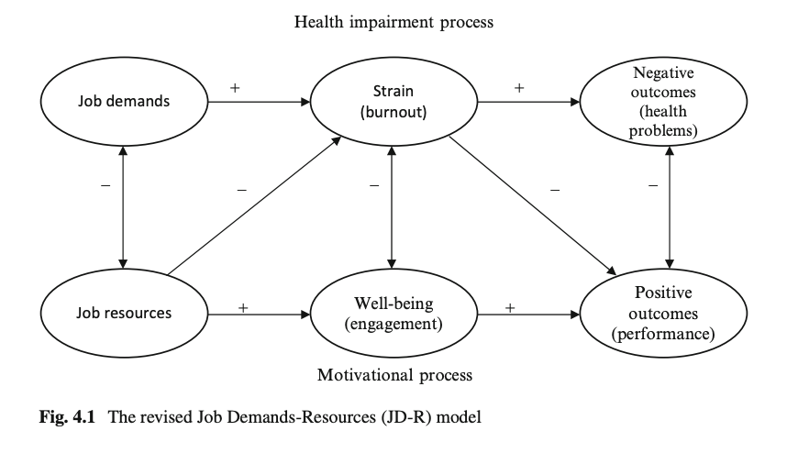

My notes from Week 1:
  - the way that a line manager engages with their employees can predict between 50-80% of employee performance
  - Effort Reward Imbalance (ERI) model
  - The revised JD-R model included work engagement in addition to burnout and considered burnout and work engagement to be mediators of the relation between job demands and health problems, and job resources and turnover intention, respectively
  - Work engagement refers to a positive, fulfilling, work-related state of mind that is characterized by vigor (that is, high levels of energy and mental resilience while working), dedication (referring to a sense of significance, enthusiasm, and challenge), and absorption (being focused and happily engrossed in one’s work).
  - burnout will lead to health problems, such as depression, cardiovascular disease, or psychosomatic complaints
  - Job resources have inherently motivational qualities (effort-recovery theory)
  - Offering many resources fosters workers willingness to dedicate their efforts and abilities to the work task (extrinsic motivation).
  - The also play an intrinsic motivational role because they satisfy basic human needs for autonomy and relatedness.
  - Personal resources = psychological characteristics or aspects of the self that are generally associated with resiliency and state management (inner game).

1.3 Performance management—a multi-level interpretation
Purpose
At a conceptual level, understanding how an organisation develops strategies and how these strategies translate into employee actions at the bottom of the hierarchy are important for seeing how PMSs work in practice. This task provides you with the cognitive tools to conceptualise organisational actions from the macro to the meso and the micro then back again.

Task
Step 1: Let’s get high level! Before clicking to reveal the text, consider the questions.
Why do we work?
Rather than being a rhetorical question, the purpose of asking why we work is an important one. We need to ask that to understand why we have organisations and why we have departments, teams, bosses, colleagues, targets, objectives, computers, the internet, etc. Organisations have emerged, particularly within the last 800 years, for specific purposes and generally to create value of some kind (money, profit, societal health, knowledge, faith, etc.).
Where does the notion of a company come from?
The word ‘company’ was derived to describe a group of wheat farmers who worked on the island of Sardinia. The biggest trading bloc at the time, the Genovese, whose court was in Florence, Italy, sent their ships over to Sardinia each year to collect wheat from the farmers. The Sardinian families realised they could negotiate a better deal for their wheat if they combined forces and undertook negotiations as a collective. The term company is derived from ‘com’, which is Latin for ‘with or together’, and ‘pania’, which means 'the making of bread'. The Sardinians' organisation was derived to create value from making bread. The etymology of the word ‘company’ gives an indirect answer as to why work and organisations exist.
How does purpose fit in?
Knowing that all organisations exist to create a particular sort of value is key to understanding how work is structured and how we measure whether that work generates the desired value (i.e. performance management). This conceptualisation is also important because it allows us to consider the macro force of the organisation itself and the role of micro forces, such as employees, in generating outcomes.

Step 2: Next, you will examine two management styles known as the top-down and bottom-up management approaches.
Look at the diagram below to get a quick insight into these approaches.
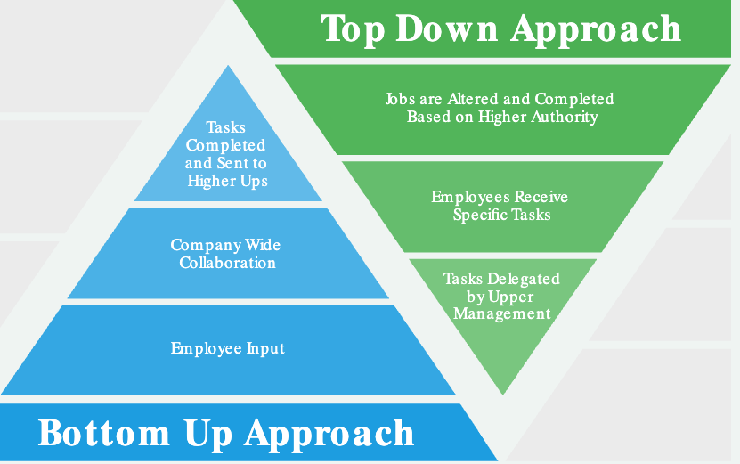

Now, read Lee (2021) Top-down or bottom-up management: Which is best for your business?Links to an external site. to gain further insight into what each approach involves and their respective pros and cons.

Step 4: Read on to see how this all ties in to performance management.
Use the arrow keys to navigate between slides. After selecting a slide, use the Tab key to move to the slide content.
How do the top-down or bottom-up management approaches fit in with performance management?
Generally, organisations form strategies from the top-down but also have important feedback loops (called heuristics) for getting new ideas from employees at the bottom of the hierarchy and championing them up the line.
However, when it comes to performance management, it is almost always a top-down process. Performance management starts with senior leaders setting broad targets for the organisation as a whole and also often for each division or function of their organisation. This is termed a ‘strategy.’ A strategy generally has a set of objectives, which are statements that articulate the desired functional performance outright or relative to competitors. Objectives also have KPIs, which are quantifiable metrics that, if achieved, show evidence that the objective has been met.
How are KPIs used in performance management?
Division managers receive the objectives and KPIs, decide which KPIs should be allocated to which work team, and then pass these on to the specific team leaders. Team leaders then bring their specific KPIs into the performance planning meetings they have with their staff and apportion the specific targets and goals to specific team members. It all sounds a bit complex, but assuredly, this is bureaucracy in action!
The above description, while broadly accurate, does vary across different organisational contexts and industries. What performance is in some organisations is difficult to quantify or make tangible, particularly in knowledge-intensive and service sectors, such as education, health and scientific research. For example, a nurse can’t be told at the start of the year that they need to save 100 people’s lives. Instead, they are given goals that dictate how they should treat patients and how they should effectively deploy their time while at work.
It is important to note that performance goals are generally set from the top-down. However, performance usually cascades up. Individual employees do their work, which combines with the output and performance of the team in which they are nested. In turn, this cascades up and combines with all of the work output of teams within a specific division, and, finally, the divisional performance is aggregated to represent the organisation’s overall performance.

Step 5: For your purposes in your learning, have a go at drawing a flow diagram that shows how goals and KPIs flow from the top of the organisation down to the employee and how performance cascades from the employees to the whole organisation.

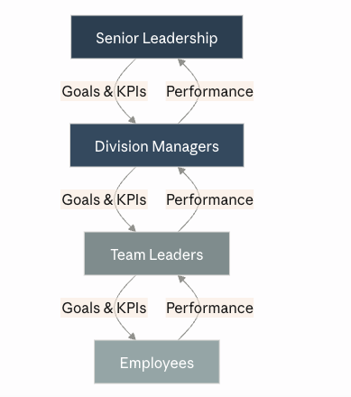

1.4 Performance management—a process
Purpose
Performance management systems involve a series of components that interlock to manage performance. The act of performance management should also be conceived of as a flow or cycle. In this activity, you explore a process (or flow) model of performance management.

Task
Step 1: A well-designed and executed performance management process has a flow-on effect from the employee to the manager, team, and ultimately the organisation. Look at the individual processes below, then click and drag them to the order that you think best fits a performance management process as a whole. In step 2, you will see the suggested correct order with explanations.
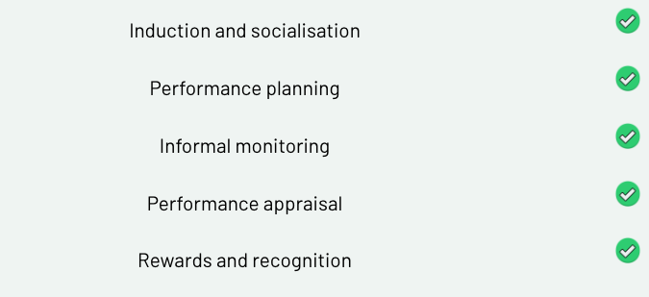

Step 2: Click below to see the appropriate order of the processes with an accompanied explanation.

Let’s explore these steps.
Induction and socialisation—This happens in the first few days, weeks and months of a new employee joining an organisation and workgroup/team. It involves informal and formal elements. Formal elements usually include a sit-down meeting with an employee’s line manager, where broad expectations and organisational supports are outlined. Informal engagement comes in the form of interactions with peers and observations by the employee of other workers, where they figure out the work culture or how things get done in their new context. Induction and socialisation are important for setting the scene and orienting the employee to the written and unwritten rules of the place.
Performance planning—Performance planning is a regular, formal process that typically occurs between an employee and their line manager even though other workplace documents that stipulate performance benchmarks may also shape this process. In essence, a manager and employee decide on and negotiate specific goals for an employee to deliver on, then stipulate when these goals must be delivered. Performance planning might happen annually, every six months or perhaps even more frequently, depending on the work context. Noting again that, while this step involved the negotiation of goals, the power difference between an employee and their manager means that the process is open to abuse, coercion, corruption and unfairness. The fact that the process usually occurs behind closed doors can also lead to issues of inequity (i.e. where one employee feels that their targets are more insurmountable than those of their colleagues, even those who are paid more).
Informal monitoring—This step isn’t always conducted. However, there is a general expectation that managers will check in on their staff and monitor how they are progressing on their set goals. Of course, this can be done in a supportive, collaborative and positive way. It can equally be conducted through more malicious forms of surveillance and micromanagement. The latter actions have proven to be detrimental to employee performance, particularly because they strip employees of autonomy in deciding how their work gets done. Thus, informal monitoring can be a fraught step. If done incorrectly (even unintentionally), it can undermine the purpose for which it exists.
Performance appraisal—Every six or twelve months, an employee sits down with their manager and examines their performance against previously defined goals. This is necessarily a formal process, and, indeed, it can be subject to legal deliberations, so some account of the appraisal is generally recorded. There is much to unpack concerning to the performance appraisal process, and we will learn more about this specific process next week.
Reward and recognition—In some but not all work contexts, the performance appraisal process may be tied to specific rewards and recognition, particularly in retail contexts where bonuses may be ascribed based on performance. In roles where appraisals do not have an ascribed bonus structure, past appraisals may be tied to promotion opportunities, which generally also increase pay.
A Hidden Step—Career development
During a performance appraisal or separate from it, there is some expectation that managers will offer counsel to their subordinates on their career development. Noting again that the process involves a power imbalance, this role is fraught with tensions. For example, if the supervisor identified that the subordinate is excellent at their job, from an instrumentalist perspective, they have a conflict of interest in ensuring that the employee does not ever leave their division or work function. At the same time, a supportive manager would know that by guiding and positively influencing an employee in the potential next stages of their career and development, they can positively impact their motivation to undertake their current work.
"Bring us back to do"—Performance management is a cycle. When your work has been appraised, performance planning for the next performance cycle happens all over again and so on, until you leave an organisation.

Feedback
The purpose of reflecting on this process is to bring to the consciousness, that which has been unconscious. By exploring how organisational actions (formal and informal) have shaped our feelings, emotions and experiences, we can gain enhanced abilities in planning, strategising and improving our organisations. Thanks for the time you’ve spent reflecting on this.

1.5 Goal setting
Purpose
The purpose of this exercise is to examine goal-setting templates that are commonly used in organisations as part of their performance planning process.

Some context before you begin
There is a motivation theory called goal-setting theory, which states that people who set goals achieve goals, even if they don’t achieve the goals they set out to achieve. (Have a go at memorising that.)
Goal setting has become entrenched in standard organisational behaviour, particularly as it applies to performance management. Let’s explore this further.

Step 1: In every course, workshop or seminar that explores performance management, the topic of goal setting is always given narrow but explicit attention. Generally, it espouses the part of the performance planning process that includes the setting of goals between the supervisor and employee. Such goals should be SMART, an acronym that connotes that a goal should be:
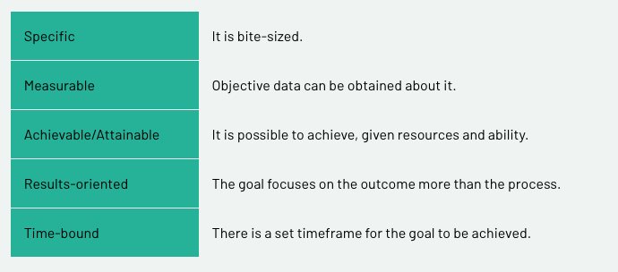

The figure below provides pointers on how SMART goals can provide parametres and eliminate guesswork when defining goals.

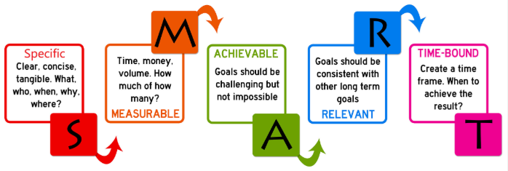

All of these things are true, but they are not the whole truth as to how work is conducted and how work performance is generated. To understand this last sentence, we must delve a little deeper into the critical perspective of performance management.

Step 2: Read through the following SAP article that suggests a breakdown of 10 Ways to Improve the Performance Management Process.Links to an external site.
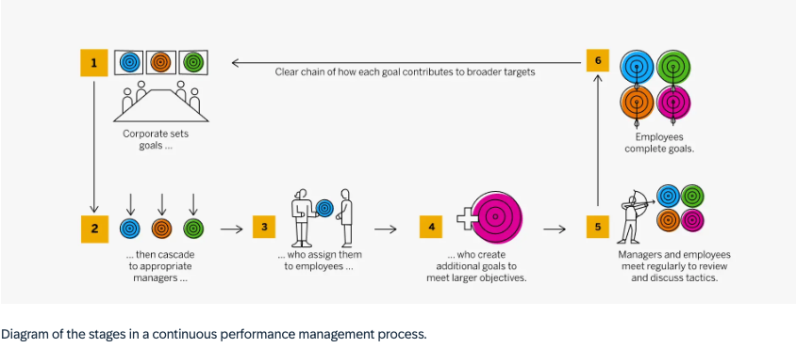
Article summary:
Performance management process (3 stages): plan/set goals → monitor performance → evaluate/recognise. Cycle repeats.
Key differences, continuous vs. traditional:
- Cadence: Traditional = quarterly/annual reviews only. Continuous = ongoing, real-time.
- Goal tracking: Continuous checks off goals as completed, in-system, visible to manager/team in real time — not saved up for a review.
- Cascading goals: Set at corporate level, broken down through functions to individuals; continuous systems let these be adjusted live if strategy shifts, rather than locked for the year.
- Documentation: Continuous captures achievements and 1:1s as they happen, so the annual review "writes itself" instead of a scramble to recall the year.
- Feedback: Continuous = ongoing coaching and feedback loops. Traditional = feedback saved for the periodic review.
Business impact per SAP: better retention, clearer internal mobility/promotion paths, higher productivity, and a more direct link from review to compensation planning — because the data's already there.
One caution from the article: don't jump straight from no process (or traditional) to full continuous overnight — it's a shift best made gradually.

Step 3: More and more, organisations are implementing app-based and computerised performance management systems, and goal setting is often a built-in feature of these. There are many competitor products, and, indeed, you may use such a product presently in your workplace, or you are likely to down the line.
But where do these notions of work, goal setting and performance come from, and are they a true reflection of how work happens?
To shed light on this question, watch the two following short video clips. First, watch Classical History of Management.
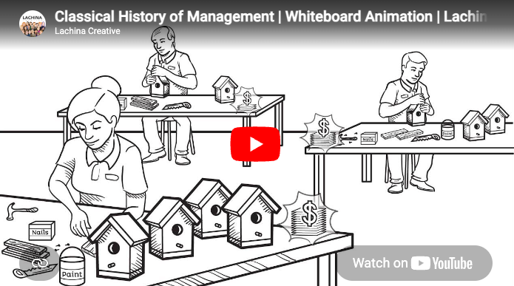
Source: Lachina Creative. (2016, October 12). Classical History of Management | Whiteboard Animation | Lachina Creative [Video]. YouTube. https://www.youtube.com/watch?v=kNrvxh8R1KULinks to an external site.

Now, watch Frederick Taylor | Scientific Management Explained.

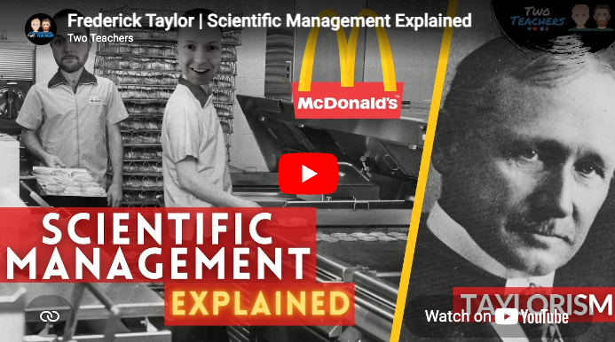
Source: Two Teachers. (2021, January 18). Frederick Taylor | Scientific Management Explained [Video]. YouTube. https://www.youtube.com/watch?v=6O9T7bqGAgILinks to an external site.

Step 5: By engaging with the above texts and videos, you’ve learned how goal setting and SMART goals are tied to a somewhat archaic notion of work, which is termed 'scientific management’ and often referred to as Taylorism. Taylorism has received a lot of criticism with perhaps the most discussed example being how it was applied to the US forces in the Vietnam War by then secretary of state, Robert McNamara. - Robert S. McNamara and the Evolution of Modern Management.pdf
There are many anecdotal examples of poor goal setting applied to work. An often-cited anecdotal example is bus drivers who were paid for arriving at each stop on time, but, in order to do so, decided not to pick up some customers. Another example is truck drivers who are paid for delivering their goods at a set time yet will dangerously race through traffic, drive while fatigued and, as a result, cause accidents.
Most of us will work or have worked in contexts where set goals or performance expectations seem counterintuitive to the actual function of work.
Has a relevant, personal experience come to mind? If so, hold onto that thought.

Step 6: With the notion of counterintuitive goals in mind and possibly some personal experiences that relate to this idea, read this blog post by Ben Taylor (2018) 7 examples of bad goals, and how to fix them.
Step 7: You’ve just read Ben Taylor’s blog, which discussed common mistakes when setting work goals. Did one or more of the seven mistakes resonate with you?
Article summary:
7 common goal-setting mistakes (and fixes):
- Picking numbers on a whim — base targets on past performance, not guesses.
- Ignoring other teams' dependencies — goals should be within your own team's control; if multi-team, agree on top-level objectives upfront.
- Missing a middle step — the path from step 1 to the end result needs to be as clear as the start and finish, not vague in the middle.
- Overly aggressive goals — can demotivate and crowd out other responsibilities; base goals on what's realistically achievable.
- Goals disconnected from org strategy — regularly check goals still align with what the wider business actually needs.
- Too many goals at once — focus on 1–2 big priorities at a time rather than juggling a long list.
- Skipping the review — don't just tick goals off; review what worked/didn't, since that makes setting the next round of goals much easier.

Feedback
Great work! We covered SMART goals in one, quick-action ‘band aid rip’. It is important to understand goal setting, but equally (and as we are about to learn) there are some gaping limitations to it as an approach. As Einstein said, ‘Not everything that counts, can be counted.’

1.6 Performance management—formality
Purpose
The purpose of this exercise is to explore the formality–informality paradigm as it relates to performance management.
Task
Step 1: Correctly identify the following actions as either being formal, informal, or either. Then click to see the explanations below.
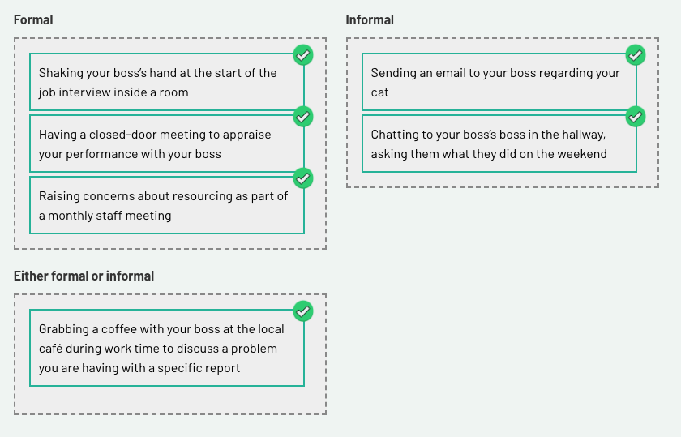

Shaking your boss’s hand at the start of the job interview inside a room
This is a formal process because it forms part of the formal recruitment process. Indeed, if the handshake was considered inappropriate (i.e. it was coerced and/or formed a basis of harassment), this could be used against the boss in legal proceedings. As job interviews are a formal process, all engagements associated with this should be considered formal also.
Grabbing a coffee with your boss at the local café during work time to discuss a problem you are having with a specific report
Generally speaking, having a coffee with your boss outside of a workspace may be considered informal. However, context counts, and, if you are raising issues of pertinent concern to the workplace (such as an ethical issue), it certainly could become a formal meeting. That said, asking your boss for advice, generally speaking, is not necessarily a formal process, particularly when done outside of a performance appraisal process.
Having a closed-door meeting to appraise your performance with your boss
Closed-door meetings and performance appraisals should be considered as part of a formal process of work.
Sending an email to your boss regarding your cat
Any email forms part of a workplace’s communication platform and should be considered a formal action—even if the tone and tenor of the email are lighter and/or informal. Emails can form part of legal or disciplinary proceedings against parties who violate laws or workplace policies regarding appropriate communication.
Raising concerns about resourcing as part of a monthly staff meeting
Any staff meeting, whether minuted or not, is a formal action.
Chatting to your boss’s boss in the hallway, asking them what they did on the weekend
Even if someone is higher than you in the workplace hierarchy, simply chatting to such people doesn’t make the process formal—though, perceivably you will be shaping your interaction according to the status of the other person. Thus, chatting to a superior or a superior’s superior in a social environment at work can be considered informal.

Step 2: The notion of formal and informal processes is likely not new to you, but remember that a given place of employment will generally be comprised of formal and informal processes.
Formal processes are those that may be written down, subject to legal proceedings and/or form part of the standard operations of a particular workplace. At work, a lot of the processes that are undertaken are formal.
Informal processes are those that are considered off the record and are potentially more social. These are essential to a good working environment. An important, humanising aspect of work is when employees feel that they have a voice to unofficially share ideas, concerns, happiness, pain, etc. without the fear that expressing such things would reflect badly on their measured performance.

Feedback
While the performance appraisal process is formal, good managers know that the secret to successfully promoting performance in the employees that they manage relies on setting up effective informal support and communication channels.

Optional Additional Reading
THE ROLE OF INFORMAL AND FORMAL NETWORKS. HOW PROFESSIONALS CAN BE INNOVATIVE IN A CONSTRAINED FISCAL ENVIRONMENT.pdf
Article Summary:
Study: 272 Australian engineers/asset managers (public & private sector) surveyed to test how workplace relationships affect access to resources and innovative behaviour.
Key idea: Alongside the usual formal relationships (supervisor–employee = LMX, employee–organisation = POS), the authors identify a third, informal relationship — ILMX (Informal Leader-Member Exchange) — a bond with a non-line senior manager, often built through shared professional networks outside the direct reporting line.
What they found:
- POS and ILMX both significantly predicted employees' perception of having adequate resources (staff, time, support).
- LMX (direct supervisor relationship) did not significantly predict resource adequacy — surprising, since it's usually the assumed driver.
- Resource adequacy strongly predicted a proactive culture (60.5% variance explained) and, together with that culture, explained 28.1% of innovative behaviour.
- No significant difference between public and private sector employees — the two sectors have converged, likely due to outsourcing and shared accountability pressures.
Practical takeaway: When your direct manager can't or won't unlock resources (due to bureaucracy, budget, or misaligned short-term goals), an informal ally elsewhere in senior management — someone who shares your professional values — can be just as, or more, effective at getting you what you need to be proactive and innovative. Organisations should recognise and support these informal networks rather than relying solely on the formal chain of command.

1.7 Performance management—a critique (part I)
Purpose
What if, in trying to measure an employee’s performance, we were, in fact, negatively affecting it? Does the action of measuring an employee’s performance and potentially assigning them a reward actually stimulate performance? Or is it an ethically ambiguous managerial action that can lead to negative outcomes of biblical proportions like the global financial crisis? The purpose of this topic is to navigate and review a critique of performance management.
Task
*Assessment
This topic requires engagement with three academic texts. The topic and the texts may be directly relevant for your third major assignment. As such, it is highly recommended that you take notes in your weekly learning journal, highlighting and adding written reflections on particular sections of the texts that may pique your interest.
Step 1: Access Qiu, et al (2015), which will provide the basis for the subsequent steps in this activity:
EMPLOYEES' PSYCHOLOGICAL OWNERSHIP AND SELF-EFFICACY AS MEDIATORS BETWEEN PERFORMANCE APPRAISAL PURPOSE AND PROACTIVE BEHAVIOR.pdf
Article summary:
Study: Qiu, Hu, Zhang & Li (2015), Social Behavior and Personality, n=512 Chinese employees.
Question: Does performance appraisal purpose (evaluative vs. developmental) affect employee proactive behavior, and what mediates this?
Key findings:
- Evaluative appraisal (past-focused, tied to pay/promotion) → no direct effect on proactive behavior, but hurts it indirectly by lowering psychological ownership.
- Developmental appraisal (future-focused, training/growth) → direct positive effect on proactive behavior, plus indirect positive effects via higher psychological ownership and higher self-efficacy.
- Self-efficacy boosts psychological ownership, which in turn drives proactive behavior (organizational, interpersonal, and personal types).
Practical takeaway: Appraisals framed around growth/development (not just scoring/ranking) build employees' sense of ownership and confidence, which drives initiative-taking. Purely evaluative, backward-looking appraisals can quietly undermine ownership even without an obvious direct hit to proactivity.
Caveats: Self-report data, single cognitive/individual-level lens, moderate model fit (CFI .882, RMSEA .064) — authors flag need for broader factors (autonomy, culture) in future work.

Definition:
Psychological ownership is a state in which individuals feel as though
the target of the ownership—material or immaterial in nature—or a piece of it,

Step 2: For those unfamiliar or less familiar with academic texts (i.e. most people), this paper will come across as particularly dry and potentially boring. Sorry! The truth is that there is some explicit analysis presented in it, which, if unpacked correctly, calls into question the value of evaluatively focused performance appraisals.
is theirs (Pierce, Kostova, & Dirks, 2001; Pierce, Rubenfeld, & Morgan, 2001).
Turning to the figure on page 1106, please enter the numbers that link the following variables:

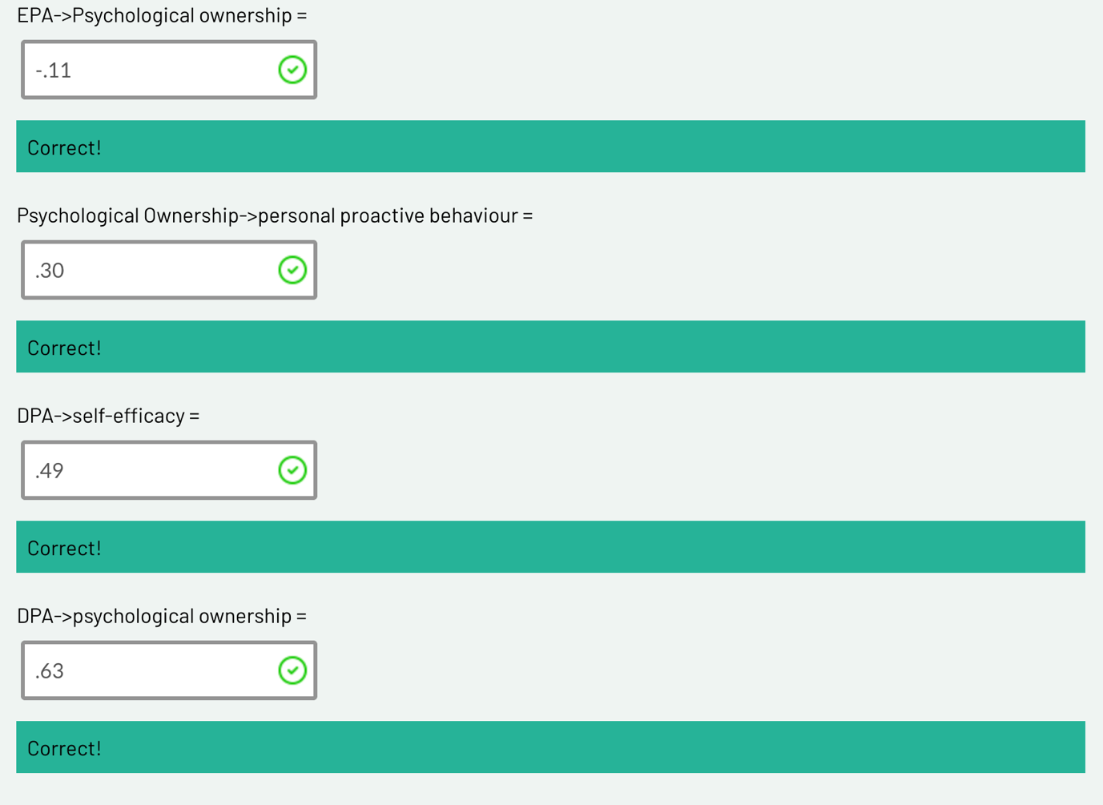

−.11**
This was the relationship linking EPA and psychological ownership. The asterisks mean it was statistically significant—put another way, 95 percent of the time there was a consistent trend present across the sample. The relationship was negative and can be interpreted thusly:
For every one-unit increase in evaluatively focused performance appraisals (i.e. when performance appraisals were more evaluative), there was an 11% reduction in the level of psychological ownership by the employee. In essence, the more evaluatively focused the appraisal, the less the employee/respondent felt that what the appraisal captured was a good reflection of the work they did. Instead, they felt that it measured other things.

.30**
This interaction, which links psychological ownership and personal proactive behaviour, may be interpreted as positive. When people felt psychological ownership over the performance appraisal, it made them more proactive at work, which is, of course, the desired outcome. However, a positive relationship just means that when one variable is high, so is the other variable; equally, if one variable is low, so is the other variable. Thus, if psychological ownership was low (as per the path from EPA), personal proactive behaviour would also be low.
.49**
The link between a developmentally focused performance appraisal and self-efficacy is interpreted as positive (.49 is a big deal in this kind of analysis). It may be understood that developmentally focused performance appraisals were correlated with increased feelings of self-efficacy (belief in one’s ability to achieve their goals).

Summary
This analysis shows us that, when an appraisal is evaluatively focused, employees tend to disassociate themselves from it (reduced psychological ownership). This is a really bad outcome, because psychological ownership is correlated with proactive behaviour, and, thus, a person will be less proactive as a result of their evaluatively focused performance appraisal.

1.8 Performance management—a critique (part II)
Purpose
This activity is a continuation of our research into critiquing performance management.
Step 1: Read the following article:
The Performance Management Revolution - the focus is shifting from accountability to learning. Harvard Business Review, 94(58), 58–67.pdf
Article Summary:
Cappelli & Tavis, "The Performance Management Revolution," HBR Oct 2016
Core argument: Companies are dropping annual appraisals in favor of frequent, informal check-ins — shifting focus from accountability to development.
History (accountability ↔ development pendulum):
- WWI/WWII: appraisals built for weeding out/ranking (military origin)
- 1950s-60s: McGregor pushed employee-led goal-setting; GE split accountability from development discussions
- 1970s-90s: inflation + Jack Welch's forced ranking + exec pay rules + "War for Talent" pulled focus back to accountability
- 2011+: Adobe, then Deloitte/PwC/Accenture/GE dropped annual reviews for frequent feedback
Three business drivers cited:
- Need for faster employee development (esp. professional services)
- Need for agility — goals set annually don't survive changing projects/markets
- Need for teamwork over individual ranking (e.g., Gap, Sears)
Persistent challenges:
- Aligning individual goals with fast-shifting company goals
- Still need a way to reward/differentiate performance
- Identifying poor performers without annual documentation
- Legal/discrimination risk without "objective" scores
- Feedback systems/tech not built for continuous input
- Some firms (Deloitte, PwC, New York Life) reintroduced a "third way" — informal feedback + periodic multi-dimension ratings, after going fully numberless caused problems
Bottom line: Not a fad — driven by real business need for speed and development — but full removal of ratings has proven hard to sustain; hybrid models are emerging.

This pairs well with the Qiu et al. study you shared earlier — that one gives the psychological mechanism (ownership/self-efficacy) for why developmental appraisal works; this one gives the industry trend and practical models companies are using.
Step 2: Cappelli & Tavis (2016) identify three reasons why evaluative performance appraisals have been dropped.
They are:
- a return of people development
- the need for agility
- the centrality of teamwork.
They also identify reasons why there is a temptation for evaluative performance appraisals to be retained, such as that the appraisals:
- align individual and company goals
- reward performance
- identify poor performers
- avoid legal troubles
- manage the feedback firehose.
Based on your reading of Cappelli & Tavis’ article as well as your experience, consider the reasons why performance appraisals have been dropped and if those explanations outweigh the reasons to keep them.

Step 3: Share your thoughts on the question presented in the debate board below. Engage in the discussion by commenting on one or more posts by your peers.
Step 4: Access the following reading:
How Does Performance Management Affect Workers - Beyond Human ResourceManagement and Its Critique.pdf
This is a big reading! If you are struggling, set yourself a goal of finishing up to the end of page 82, which is seven pages in—the essential stuff is in the first six pages. This review paper highlights limitations with research conducted on performance management, particularly the performance appraisal process.
Article summary:
Tweedie, Wild, Rhodes & Martinov-Bennie (2019, IJMR) — literature review on how PM affects workers, across three stages.
1. Mainstream HRM — three phases, each more socially aware but more organization-focused, not worker-focused:
- Phase I (1920s-90s): fixing rating accuracy (trait scales, MBO, BARS) — never solved
- Phase II (80s-90s): PM's "social context" — justice perceptions, fairness — but still to serve org performance
- Phase III: fully integrating PM into strategy/profit — worker wellbeing recedes further
2. Critical HRM (CHRM) — three theoretical lenses:
- Labour process theory (Marxist, Braverman) — PM as class control tool; theorists: Barlow, Newton & Findlay, Thompson
- Foucauldian theory — PM as discursive power that disciplines/subjectifies workers into "docile," self-monitoring subjects; theorists: Townley, Weiskopf & Munro (governmentality/biopower), Rose
- Conflicting rationalities (Habermas) — "relational" (communicative, consent-based) vs "transactional" (instrumental) PM; instrumental logic tends to "colonize" the relational; theorists: Broadbent & Laughlin, Townley et al.
3. Recognition theory (the paper's proposed advance) — two thinkers:
- Axel Honneth: three recognition types — love (self-confidence), rights (self-respect), esteem (self-esteem, tied to work). PM = proxy judgment of a worker's social contribution.
- Christophe Dejours: esteem from management/clients (usefulness) vs colleagues (quality/"beauty"); misrecognition → suffering, breakdown of collegial bonds, even linked to workplace suicides.
Core argument: HRM and CHRM both under-theorize worker wellbeing as an end in itself — HRM subordinates it to org performance, CHRM focuses on power but not psychic harm. Recognition theory fills this gap by giving vocabulary for how (mis)recognition damages/sustains self-identity through work.

Quick connection across your three uploads: Qiu et al. gives the psychological mechanism (ownership/self-efficacy) for developmental appraisal's benefits; Cappelli & Tavis gives the industry trend; this Tweedie et al. paper gives the theoretical scaffolding (including a critique that even developmental/social-context HRM research, like Qiu et al.'s, still frames worker wellbeing instrumentally in service of org goals — that's literally the critique in their Phase II section).

Step 5: In reflection on the previous reading, make the following journal entry.
- Summarise the three phases of HRM research, looking at performance management (each phase summary should be about 120 words).
My notes:
1. Mainstream HRM:
Core question: Does PM help the Org?
This phase of HRM is more organisation focussed, not worker focussed. Research focusses on eliminating measurement error, understanding PM’s social context, and integrating PM into org strategy.
HRM research considers workers perceptions and experiences, but simultaneously leans towards a performative lens.
Overall, worker wellbeing only matters insofar as it affects org performance, never as an end in itself.
2. Critical HRM research:
Core question: Does PM exert power/control over workers?
Applies PM as a disciplinary, coercive or inequitable management device. Generally, ignores employee well-being or employee development.
Critical HRM and PM looks at perceived shortcomings of HRM. CHRM is overwhelmingly qualitative and is viewed as anti-performative.
The three influential critical approaches are, Labour process theory (PM as class control where managers use it to extract more effort from workers), Foucauldian Theories (PM as discourse that shapes workers into “docile”, self-monitoring subjects), and Notions of conflicting rationalities (Distinguishes “relational” PM from “Transactional” PM).
  - Recognition Theory:
Core question: Does PM protect or damage the workers basic sense of self?
Acknowledging (or not) workers contributions, and how this affects their well-being at the level of self. Seen as an overarching aid to prior models.
Authors argue that being properly acknowledged for your woek is essential to psychological wellbeing. Not just a “nice to have”.
Honneth’s Version:
Three types of recognition, each tied to a different part of self:
1. Love (close relationships) = self-confidence
2. Rights (legal/civil equality) = self-respect
3. Esteem (work) = self-esteem

At work, esteem = having your specific contribution acknowledged as valuable. Performance appraisals are essentially judgements about this.
Two sub-types: Appreciation (for loyal service and Admiration (for skill/talent).
Dejours’ version:
Work is inherently a struggle against resistant reality, which causes stress. Esteem is what makes that stress bearable and turns it into growth instrad of harm. Two sources:
- Management/clients recognise usefulness
  - Colleagues/peers recognise quality – only people who do the same work can really judge if it’s good
The core risk: “Misrecognition” – when PM systems failt to see or value real contribution (e.g, a call centre only measuring call times, ignoring actual customer care) – can cause genuine psychological harm, not just dissatisfaction. Dejours links this to serious outcomes like burnout and even workplace suicides.
- Define labour process theory and explain why performance management is seen as a coercive control deployed by managers on workers. (80 words)
My notes:
Labour process theory is a Marxist approach to work in organisations. It sees workplaces as sites of class struggle over control of labour.
Applied to PM, Managers use it as a control mechanism to extract effort and maintain dominance over workers – not just through direct oversight, but by getting workers to monitor and regulate their own behaviour and making workers output more visible so it’s easier to monitor and control.
Real world example: Amazon warehouse workers.
Amazon tracks pick rates, scan times, and “time off task” per worker, minute by minute. Under labour process theory, this is coercion:
  - Visibility – every action is tracked, leaving no room to work at your own pace.
  - Self-regulation – workers speed up on their own to avoid flags, without a manager standing over them.
  - Extraction – the system squeezes maximum output, and workers who fall short get warnings or fired.

The theory would say this PM system exists purely to serve the company’s efficiency/profit goals – not t help workers develop or feel valued.
- Based on the third phase of the HRM research exploring performance management, what is pleasing about this development relative to the previous two phases? (80 words)
My notes:
Phase 3 invites the worker into the process by seeking feedback (procedural justice). Individual performance data is linked directly to firm-level metrics like profitability.
Less about the rating tool and more about does aggregating everyone’s performance move the business numbers.
- With such an emphasis on the organisation, why do you think HRM scholars have paid scant attention to an employee-centric model of performance appraisals (i.e. Why are we primarily concerned with employees as a means for organisational outcomes rather than good and fair employee performance as a result of a wellbeing-conducive work environment?) (80 words)
My notes:
HRM was primarily a performance function designed to ensure workers are performing, with initial models taken from World Wars were performance meant life or death.
Org growth was the primary goal at Executive level, so anything not attributing to that goal was seen as wastage that could be removed – a replaceability culture.

Feedback
You survived! Well done. The purpose of the final activity was to see that, although there are strong criticisms of performance management, it does serve as a necessary evil in organisations. The truth is less absolute—performance management that is too evaluative and in the wrong context can be disastrous. But a none-at-all approach also poses problems.

Week Two

Week 2 Introduction
The performance appraisal and bias
We left last week’s content by exploring broad issues related to performance management and paid particular attention to the failings of evaluative performance appraisals relative to developmentally focused performance appraisals. We will now pick up where we left off last week and build specific capabilities in critiquing, utilising and navigating performance appraisals. This week’s topic is built around providing the necessary skills and knowledge for progression through the first and second assessment items.

Learning objectives
After successfully completing the tasks this week, you should be able to:
- Examine different elements of performance appraisals
- Explore top-down, multi-user and balanced scorecard feedback platforms
- Critique common verbal and written feedback frameworks
- Examine the issue of user and rater bias as it applies to performance appraisals.

2.1 The performance appraisal
Purpose
The purpose of this exercise is to immerse yourself in the features and components common to performance appraisals
Some context before you begin
In this unit, a lot of attention is paid not only to performance appraisals but also to the general aspects of work. At the end of the day, the actual performance appraisal itself is typically underwhelming to look at.
Let’s dive right in.

Task
Step 1: Identify some of the features from a performance appraisal form by analysing this template which was taken from 13+ Performance Review Form Examples – PDF.
Performance appraisal forms share some generic features. Below are some example statements of some of these features.
Complete the sentences below by dragging each missing phrase into its designated space.
Accessible Interactive Instructions: These interactive uses mouse drag and drop and is not accessible to other navigation methods.
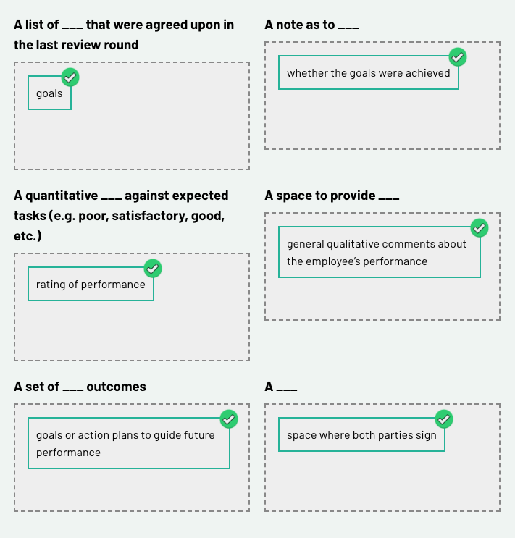

Resource: 11+ Performance Evaluation Form Examples to Download

Step 2: Read on to gain a deeper understanding of what performance appraisals involve.
Use the arrow keys to navigate between slides. After selecting a slide, use the Tab key to move to the slide content.

Let’s go deeper into the elements of a performance appraisal.
Slide 1 of 3
Besides the common generic features that we saw in the previous step, performance appraisals may also have a few other features. For example, there may be a space where an overall rating is given. Also, if an employee works in a context where rewards, commissions or bonuses are given, this may be listed on the performance appraisal.
Furthermore, performance appraisals generally account for a combination of qualitative feedback (i.e. written/verbal or open-ended) and quantitative metrics (e.g. output, profit, tangible or ratings) to capture both workplace output and/or workplace behaviour.
Let's not forget the sign-off. Performance appraisals generally include a sign-off section at the end of the document, where both the reviewer and the employee need to add their signatures. This makes the document a formal document, which can be subject to legal proceedings.
Behavioural elements
Slide 2 of 3
Remember that in Week 1 we learned that sometimes behavioural elements might have nothing to do with actual performance or output, such as being punctual, having tattoos, looking the part, deportment and communication style, which is a euphemism for appropriate or professional communication. Yet, these elements can shape the tone of a performance appraisal. Still, it is important to balance these statements against empirical facts.
In 2019, French, Mortensen and Timming published a paper in Human Relations titled ‘Are tattoos associated with employment and wage discrimination?’ It turns out, following their massive analysis, broken down by gender, ethnicity, role and educational background, that tattoos, whether offensive and visible or not, have no correlation with wage. The authors convincingly argue that the role of such behavioural elements in shaping workplace discrimination is more of a case of myth versus reality. That doesn’t mean that it doesn’t happen; rather, it just happens more rarely than we might think. The authors also note that in some work contexts having tattoos is a sign of fitting in and isn’t necessarily a bad thing.
Quantitative elements
Slide 3 of 3
In performance appraisals, particularly those that use Likert and rating scales (e.g. one to five for overall performance, where five is exceptional and one is very poor), quantitative elements are also common. Last week, we learned that Taylor’s scientific management method encouraged managers to rate employees against each other and ascribe pay accordingly. Overall performance rankings are a residual product from such times and can be subject to rater bias, which we will learn about in subsequent activities.
Step 3: It's time to share. Many of us will have had experiences (good and bad) with performance appraisals. In the discussion board below, please share a 100-word reflection using the prompt below.
Step 4: Access the following reading:
The dilemma of performance appraisal.pdf
Article notes:
Prowse & Prowse (2009), "The Dilemma of Performance Appraisal" — literature review, Measuring Business Excellence.
Core argument: Despite huge adoption (80-90% of US/UK orgs use appraisal), research has ignored the critical success factor — line manager interpersonal/interviewing skill (the "Bradford Approach") — while theory stays stuck and underdeveloped.
History of appraisal methods:
- 1800s: Robert Owen's factory — coloured wood blocks signalling performance
- Early 1900s: Taylor's scientific management
- 1930s: psychological tradition — trait/graphic rating scales
- 1940s: behavioural methods (BARS, BOS, critical incident)
- Post-1945: Management by Objectives (MBO) — targets, deadlines, rankings
- 1960s: self-appraisal, discussion-based interviews
- 1990s: 360-degree appraisal (peer/multi-rater); pay-for-performance emerges
Two critiques of appraisal:
- Orthodox critique — appraisal has built-in conflicting purposes: motivating/developing vs. judging past performance for reward. Creates bias: central tendency, halo/horns effect, recency effect, political manipulation (managers protecting self-interest), gender/ethnicity bias.
- Radical critique (Foucault-based, Townley, Newton & Findley) — appraisal is covert managerial control/surveillance, not genuine development.
Proposed fixes and their limits:
- 360-degree appraisal — meant to reduce bias/power imbalance, but 5-year study (Walker & Smither) still found subjectivity persisting.
- Interpersonal skills training for appraisers — under-researched despite being critical.
Performance-related pay section:
- Merit pay increasingly linked to appraisal (UK civil service, NHS, banking) but evidence is largely negative — demotivating, encourages gaming/narrow target focus, reduces honest self-disclosure (employees won't admit weaknesses if it hits their pay).
Conclusion: Appraisal remains "muddled" — good outcomes hinge heavily on relationship quality with line manager. No one has proposed a viable alternative that still delivers feedback, motivation, and reward justification — so organizations keep using, revising, and periodically abolishing appraisal systems rather than replacing them.

Journal entry
Skim read pages 69-77 of The dilemma of performance appraisal, looking for answers to the following questions. In your own words, note down answers to each question.
- What are the three questions for quality of feedback in performance appraisals?
- What is conflict avoidance?
- What is a recency effect?
- What mechanisms have been deployed to increase objectivity in performance appraisals?

2.2 Feedback sources
Purpose
In this activity, we will explore top-down, multi-user and balanced scorecard feedback platforms.
Some context before you begin

The most typical form of performance appraisal occurs between a line manager and one of their staff members. It is a formal event, and the completion of the paper document typically occurs alongside a face-to-face meeting where verbal feedback is given.
As explored in the last activity, feedback usually consists of the manager's perspectives on the employee’s performance in addition to (in some cases) objective performance data, which is collated and provided in the performance appraisal.
To restate, this is the most common form of performance appraisal, partly because it is somewhat efficient (certainly more so than multi-rater appraisals).
Task
Step 1: There are other kinds of performance appraisal platforms that may extend beyond (or not even include) a review from one’s line manager. While not broadly applicable, another common feedback platform is 360-degree feedback.
Read the background review What is 360 Degree Feedback? which supports a particular 360-degree feedback product (commercial).
Definition:
360 Degree Feedback is an assessment system or process in which employees receive confidential, anonymous evaluations from the people who work around them. This typically includes manager, peers, and direct reports.
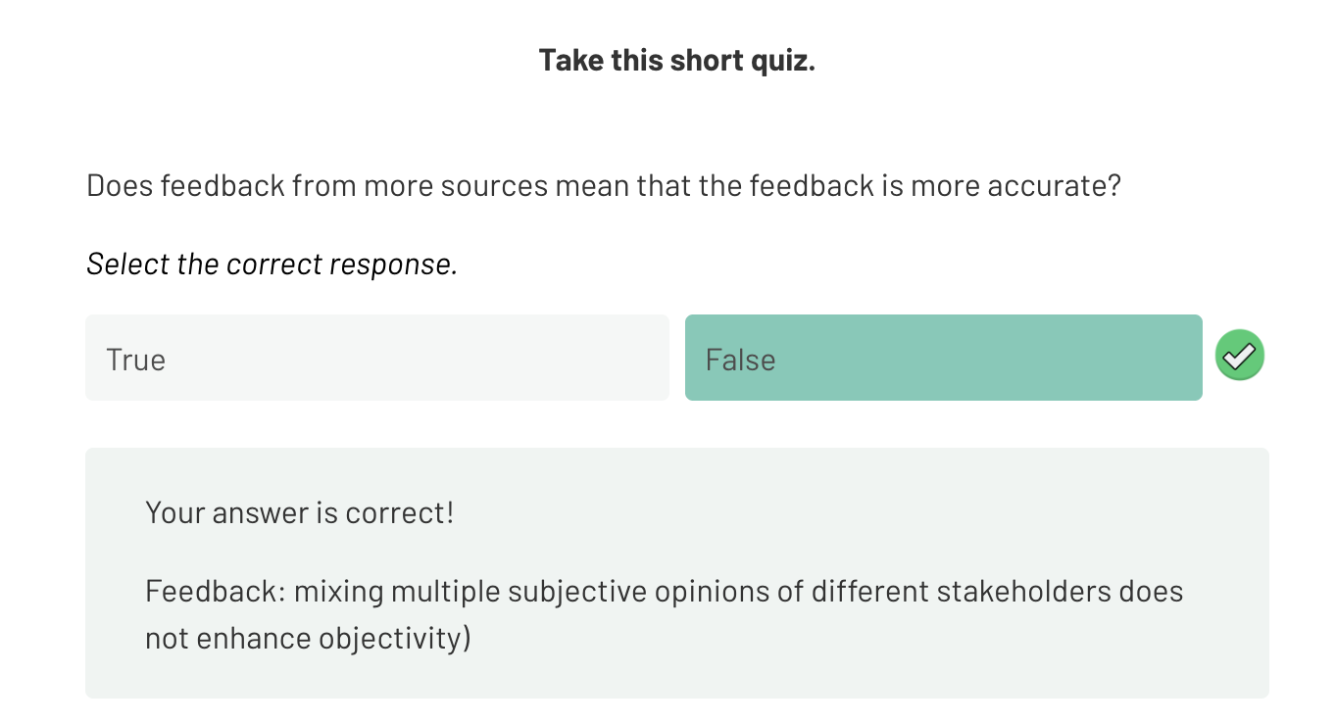
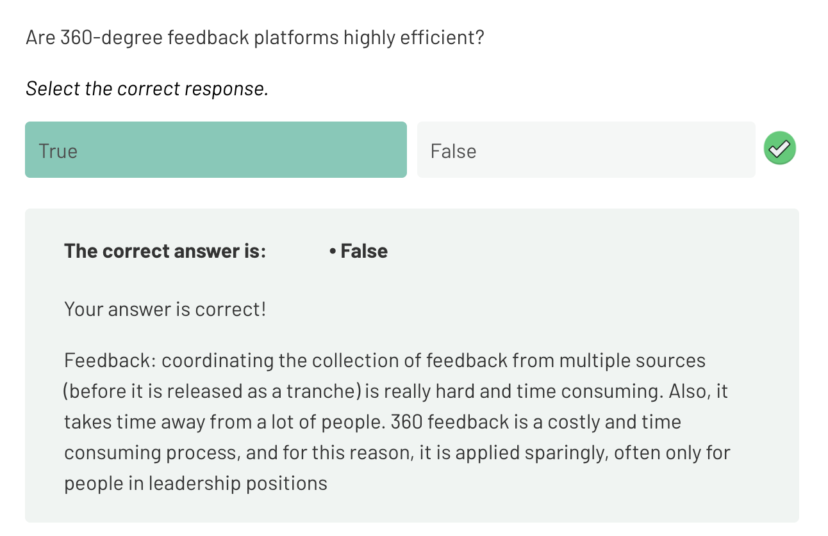
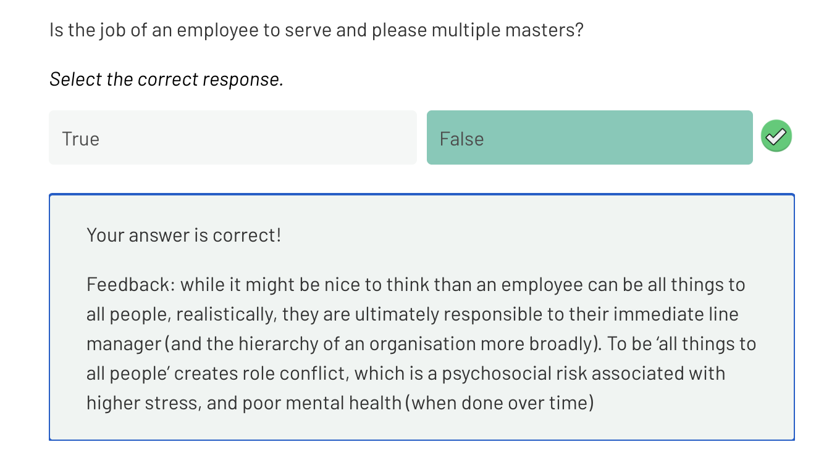
Step 2: Have you ever called customer service (e.g. for electricity, water, Centrelink, banking, products, etc.) and been asked at the end of the conversation to provide a rating for the call? Sometimes the rating goes from 1-10 or 1-5. More and more, we use the internet and social media platforms to check the star rating of particular restaurants or subcontractor/service providers in our local area.
If you use ride-sharing platforms, you will see embedded star ratings as part of the service. In some regions of China, citizens are rated as part of a social credit system. Like it or not, reductionist forms of performance evaluations are slowly creeping into all aspects of our lives, and, accordingly, these shape our decisions. Equally, if you are a telemarketer who has received several bad ratings from customers, these form part of your performance appraisal.
Definition:
Reductionist rating system
A reductionist rating system condenses complex, multi-dimensional information into a single, easily digestible score, metric, or label. While highly useful for quick decision-making, it often strips away vital context, nuances, and the interconnected dynamics of the subject being evaluated

Step 3: Amanda Roosa’s blog post, The Psychology of Ratings touches on some salient good and bad elements that ensue as a result of using reductionist rating systems.
Read through the blog and consider the potential pros and cons of rating systems for people.
Article summary:
"The Psychology of Ratings" by Amanda Roosa (Medium, 2019)
Not academic — a general-interest piece on rating systems (social, consumer), but relevant analogies to appraisal bias.
Key points:
- Social credit systems (China) reward/punish citizens based on trust behaviour — an extreme, formalized rating system with real consequences (travel bans, school access).
- People rate too leniently. On platforms like Uber, raters avoid giving low scores even after bad experiences, because they don't want to harm someone's livelihood — this is social/emotional bias overriding accuracy, similar to managers avoiding negative appraisal ratings.
- Ratings tend to be "all or nothing." YouTube found people rated 5-stars or 1-star, rarely in between — leading YouTube to abandon stars for thumbs up/down.
- Explaining a rating changes it. A study found that when people had to justify their score, positive experiences got rated lower and negative experiences got rated higher — explanation moderates emotional extremes toward the middle. Yelp uses this by requiring a written review with every star rating.
- Ratings carry real economic weight — 85% of people trust online reviews like personal recommendations; a one-star increase can raise revenue 5-9%.
Relevance to your PM reading: This mirrors two things you've already covered — the "central tendency" and "halo effect" biases from Prowse & Prowse, and the reluctance to give critical feedback that McGregor and others describe in formal appraisal. It's a plain-language, real-world echo of the same rater psychology problem, just from consumer platforms instead of workplaces.

Step 4: Create a journal entry for the blog post 'The Psychology of Ratings' and complete the following task.
Please identify five good things about rating systems and, equally, five bad things/downsides to using them. Organise your response in bullet points, with a sentence for each good and bad element of rating systems.
My notes:
Good things:
  - Rating systems are quick and efficient for consumers to complete. Anything more complex or time consuming would result in even less participation.
  - They can contain valuable feedback from the consumers perspective where there are genuine holes in the business’s process that need to be addressed.
  - When done electronically, data can be easily sorted and processed without manual intervention by company staff
  - In the case of public services like Uber, rating systems can serve the social system by keeping people safe if a driver is behaving in a unsafe way.

Bad things:
- Rating systems are a reductionist system, so they do not cater for context and other factors that influence a rating. They are black and white, which can be frustrating for the employee/business if the ratings impact their development and finances.
- They are biased. One person’s good or bad experience is likely to be different to another’s. Asking questions like “rate your experience” is quite global and will be answered subjectively.
- They have become commoditised. Every business asks for a rating of some sort, and they have become annoying, or seen as spam communication, which devalues the process.
- They can be seen as the be all and end all if a company has no other way to get consumer feedback. This lacks diversity and exacerbates they reductionist issue.

Step 5: The next source of feedback we shall explore is a system that organisations use to focus on strategy and improve performance. It is called the balanced score card.
Watch the short video The Explainer: The Balanced Scorecard (2.40).

The video by the Harvard Business Review on the balanced scorecard might seem a bit out of place—this is because the balanced scorecard applies to company performance rather than employee performance.
However, the video is good because it gives a bit of context as to why performance appraisals today have more financial performance metrics nested within them and use a range of different qualitative and quantitative assessment tools. Kaplan and Norton developed the balanced scorecard framework in the early 90s, and, since then, it has been applied to multiple contexts where performance exists. For example, think of your report cards from school if you studied in the 90s, 00s, or before when it was more metric- and results-driven.
While most performance appraisals used today look and feel different to the balanced scorecard model of 1993, many have elements that track employee performance against the financial, customer, internal (work behaviour) and learning and growth perspectives.
2.3 The feedback sandwich
Purpose
In this activity, you will critique common verbal and written feedback frameworks.
Task
Step 1: The feedback sandwich method is the most espoused method for giving feedback. The approach is simple—start with something positive, deliver the critical substance, which may be negative, and then finish with something positive.
To gain further and quick insight into this method, watch What is a Feedback Sandwich | Explained in 2 min.›
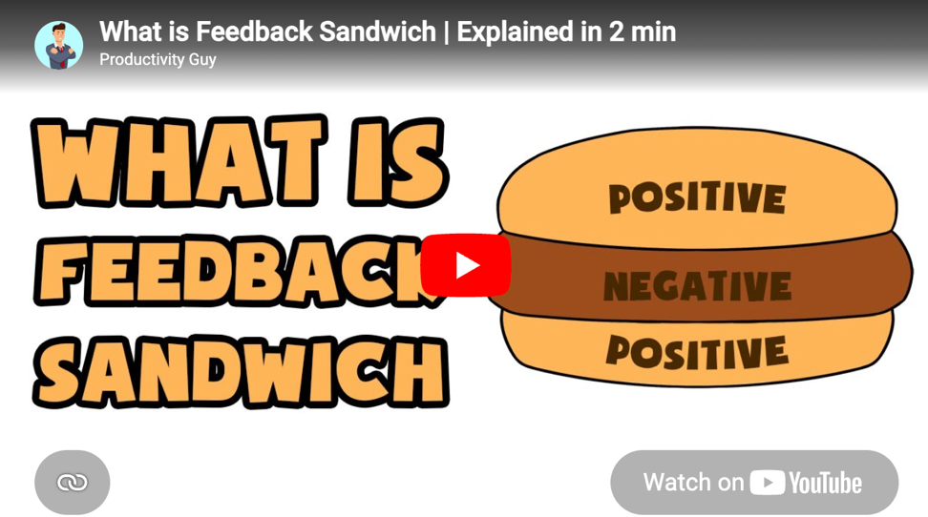
https://www.youtube.com/watch?v=hDNde-Eub_A

Step 2: Answer the question below with a response of 50-100 words.
In your opinion, or in your experience, is the ‘feedback sandwich’ method useful for correcting or enhancing performance? Why? Why not?
My notes:
Yes, I think starting with a compliment or positive feedback acknowledges the effort that has been put in thus far. Jumping straight to negative feedback can leave someone feeling discounted. Like anything, if overdone the process can become scripted and the positive feedback de-valued. So, it does need to be applied at the right times and genuinely.

Step 3: Read the abstracts only in the following two academic papers and make notes on the potential effectiveness of the mentioned feedback. Refer to these notes in the following journal activity.

  - Should You Order the Feedback Sandwich? Efficacy of Feedback Sequence and Timing
https://www.tandfonline.com/doi/full/10.1080/01608061.2015.1093057
Abstract
This study sought to investigate the efficacy of feedback sequence—namely, the feedback sandwich—and timing on performance. Undergraduate participants performed simulated office tasks, each associated with a feedback sequence (positive–corrective–positive, positive–positive–corrective, corrective–positive–positive, and no feedback), presented in a counterbalanced fashion. Half of the participants received individual verbal feedback delivered privately by the researcher immediately after each session, and the remaining participants received the same type of feedback immediately before each session. The aggregate data suggested no feedback was the most efficacious for participants who experienced feedback prior to performance, and the corrective–positive–positive sequence was the most efficacious for participants who received feedback following performance. Differences in feedback timing were not significant except for the no feedback condition. These results document that the feedback sandwich was not the most efficacious sequence, despite claims to the contrary.
Simple explanation:
Researchers tested whether the classic "feedback sandwich" (positive → corrective → positive) actually works best.
Setup: Students did office tasks and got feedback in different orders — sandwich, corrective-last, corrective-first, or no feedback at all. Some got feedback before doing the task, others got it after.
Results:
- If feedback came before the task, giving no feedback at all worked best.
- If feedback came after the task, corrective first, then two positives worked best.
- The classic "sandwich" method wasn't the best option in either case.
Bottom line: The popular feedback sandwich technique isn't actually supported by this data — despite being widely recommended.

  - How empathic concern helps leaders in providing negative feedback: A two-study examination
https://bpspsychub.onlinelibrary.wiley.com/doi/10.1111/joop.12184

Abstract
The role of leader empathic concern is examined in the context of negative feedback delivery. We argue that leader displays of empathic concern decrease negative affect and increase positive affect following negative feedback, resulting in more positive evaluations of the leader's feedback-giving effectiveness and improving the leader's promotability. In a video-based online experiment (Study 1) using a US sample (n = 177), both conditions experienced a decline in negative affect over the course of the feedback episode; however, participants exposed to leader empathic concern experienced a significantly greater increase in positive affect and evaluated the leader's behaviour as more effective than those in the control condition. In a field-study (Study 2) using archived multisource data on a sample of organizational leaders (n = 306), the positive relationship between leader negative feedback quality (subordinate-rated) and (boss-rated) promotability was strengthened by subordinate perceptions of leader empathic concern.
Practitioner points
- Leaders should show empathic concern when delivering feedback to subordinates.
- Leaders should be trained in how to recognize subordinates’ emotional reactions and to communicate their understanding and concern for subordinates’ well-being during the provision of performance feedback.
- Organizations should reward leaders who demonstrate empathic concern for their subordinates when providing feedback.
- Leaders should be educated about the career-related benefits associated with demonstrating high-quality negative feedback and empathic concern.
Simple explanation:
this study looks at whether a leader showing empathy while giving negative feedback makes a difference.
Two studies:
- Video experiment (177 people): Everyone felt less negative after receiving criticism, but only those whose leader showed empathic concern also felt more positive afterward — and they rated the leader as more effective at giving feedback.
- Field study (306 real leaders): Leaders who gave good-quality negative feedback got rated as more promotable by their boss — but only when subordinates also felt the leader showed empathy. Good feedback alone wasn't enough; empathy amplified its career benefit.
Bottom line: Empathy isn't just "nice to have" when delivering hard feedback — it measurably improves how the feedback lands emotionally and boosts the leader's own career prospects.
Practical takeaways for managers:
- Show genuine concern when delivering negative feedback, not just the content
- Get trained to read and respond to the other person's emotional reaction
- Organizations should actively reward this behaviour, since it benefits both the employee and the leader's career

Step 4: Open your journal and prepare a page for the following entry.
Write an account of the evidence that supports the feedback sandwich as an effective tool for delivering criticism.
- Please note the following line for your account:
'We found that the ‘Corrective-Positive-Positive condition produced the highest aggregate mean’ (Henley & DiGennaro Reed, 2015).
- Finally, respond by reflecting on your thoughts as to why you think the feedback sandwich might not be the most effective framework for delivering criticism.
My notes:
The evidence did not support the Feedback sandwich process (Positive-corrective-positive) as being effective. The more effective process was Corrective-positive-positive.
My thoughts is that by delivering negative feedback first, followed by two doses of positive reinforcement, allowed the subjects the Psychological space to recover from any negative impact of the corrective feedback, and re-appraise the meta-feedback as being more balanced and constructive.

Step 5: So if the feedback sandwich has limitations for delivering feedback, what alternative strategies might managers use to deploy critical evaluations of their employees?
Recent research informed by advances in positive psychology has emphasised the role of emotional intelligence and empathy in shaping interactions between managers and their staff.
Read the following Forbes article and watch a short video on Understanding Empathy: How EQ Can Improve Your Career Impact.
Take notes on ways to employ empathy and emotional intelligence in feedback to use in the next step.
Article summary:
"Understanding Empathy: How EQ Can Improve Your Career Impact" by Chris Westfall (Forbes, 2021)
Core argument: Empathy is a career-boosting leadership skill, not just a "soft" nice-to-have — especially valuable when people are stressed or burned out (written during the pandemic).
Key points:
- Empathy ≠ sympathy. Sympathy is feeling for someone and can lead to excuses or cutting corners. Empathy is understanding someone's situation as it is, without losing your own perspective — which lets you actually help them take action.
- Empathy ≠ ego. It means focusing on others' experience rather than your own goals, identity, or need for recognition.
- "Cognitive compassion" = sensing someone's emotional state without being overwhelmed by it — essentially another name for emotional intelligence (EQ). Citing HBR, EQ has 12 components including self-management and social awareness.
- EQ is career fuel. Leaders who genuinely acknowledge where people are ("I see you," "I feel you") build trust and unlock better outcomes — because you can only move a team forward from where they actually are.
- Restaurant analogy: A great waiter who catches a nut allergy before you order isn't intruding — that's high-level service driven by attentiveness and care. The article frames empathetic leadership the same way: proactive, attentive service, not passive niceness.
Bottom line: In leadership, empathy is a practical skill that drives trust, team performance, and personal career impact — distinct from simply being nice or feeling sorry for people.

Step 6: This discussion board post will be a collective process.
Discussion board
- Construct a list of actions that a manager should do to effectively deploy empathy and emotional intelligence when giving critical feedback to staff.
- Try to come up with a collective list of about 10-20 tangible actions that should underpin the effective delivery of critical feedback through the lens of emotional intelligence and empathy.
You may need to do some further reading on empathy and emotional intelligence, and the article from Forbes (step 5) lists several Harvard Business Review articles that, if read, will advance your knowledge of these elements.
My Notes:
- Create rapport with the employee immediately. Resistance can emerge when there is no rapport in a relationship, so stablishing rapport is a key first step to an empathetic approach.
- Manage your own state before others. Ensure you are in an uptime state when going into the discussion. This involves switching on all your senses so you can detect the employees’ emotional shifts during the discussion and check in on the shifts.
- Access a second-person perspective. This is the perspective of empathy as you are removing your own subjectivity from the perspective and applying the other persons worldview. What are they thinking, what are they feeling, what do they want me to understand?
- Apply sacred listening skills. Listen with an open heart and an open mind. This is listening without judgement and simply perceiving what the other is saying.
- Apply communication loops in the discussion. This means, repeating back what you think you have understood to ensure it matches what has been communicated. When done effectively, creates a deep level of accurate understanding in communication and leave the other person feeling heard and understood.
- Frame the conversation effectively. Gain an agreement upfront for how the discussion will go and the desired outcome. If both parties agree, this sets the foundation for a constructive and balanced discussion without surprises.
- Check in with the employee throughout the discussion. Ask if you have missed anything so far, is there anything they would like to add.

Feedback
Remember, the list of considerations for providing critical feedback for staff that you co-developed with your peers and facilitator in the discussion board, should be used to inform the development of your Assessment 2 response.

2.4 Rater and method bias
Purpose
The purpose of this activity is to examine how performance reviews are shaped by implicit biases.

Task

Assessment 2
Notes that you take in your journal activities will relate directly to Assessment 2. You may want to have another look at the assessment to see how your notes on bias may be used.

Step 1: Bias will occur when, rather than being neutral, you have a preference for or aversion to a person or people. These preferences or aversions are indicative of implicit bias, also referred to as unconscious bias.
In this first step, conduct a self-assessment to detect notions of implicit bias.
Go to: Implicit Association Test,
Read and scroll to the bottom then click:
- I wish to proceed
- select gender
- click here to begin (take the test)
- continue (when prompted in the dialogue box)

Step 2: Reflect on your result from Harvard’s implicit bias test in your journal.
My notes:
My results are shaped by my upbringing and values.

Step 3: Read over the HRD Connect article 10 performance review biases and how to avoid them. You will see a definition and prevention strategy for each bias.
Note: In this next reading task you will need to register for free.
Open your journal and prepare a page for the following entry.
Article Summary:
"10 Performance Review Biases and How to Avoid Them" — Kevin Campbell, Culture Amp (HRD Connect, 2019)
Core premise: everyone is biased (citing Kahneman), so good performance review design must actively counter it. Ten biases + fixes:
- Recency bias — over-weighting recent events. Fix: collect feedback at multiple points through the year, not just at review time.
- Primacy bias — first impressions dominate. Fix: same as above — multiple data points over time.
- Halo/Horns effect — one trait (good or bad) colours the whole rating. Fix: rate on 2-3 distinct dimensions, not one overall impression.
- Central tendency bias — everyone rated "middle of the road." Fix: remove the neutral middle option on scales.
- Leniency bias — inflated ratings across the board. Fix: redesign the scale so "average" isn't the top label — reserve top ratings for genuine standouts.
- Similar-to-me bias — rating people like yourself higher. Fix: agree on assessment criteria before evaluating, reducing reliance on stereotypes.
- Idiosyncratic rater bias — you rate others harshly on skills you're weak at, generously on skills you're strong at. Fix: frame questions around concrete intentions/decisions (e.g. "I would hire this person again") rather than vague traits.
- Confirmation bias — seeking evidence that confirms your existing view of someone. Fix: actively look for evidence that contradicts your initial impression.
- Gender bias — women get personality-focused feedback, men get behaviour/achievement-focused feedback. Fix: structured feedback forms (not open text boxes) that prompt for specific situations/behaviours/impact.
- Law of small numbers — judging someone's rank based on a too-small comparison group (e.g. best on a strong team ≠ best company-wide). Fix: company-wide talent calibration sessions to standardize what "above average" means.
Bottom line: People can't reliably self-detect their own bias — so the fix has to be structural (better scales, criteria, timing), not just awareness.

Definition:
Talent Management
Talent management is the systematic process of identifying a vacant position, hiring A suitable candidate, developing the skills and expertise of that candidate to match the position and retaining them to achieve long-term business objectives.
https://www.hrdconnect.com/2019/09/06/how-to-develop-your-talent-management-strategy/
Definition:
Talent Calibration
Talent calibration is an HR practice where managers and leaders align employee performance evaluations against shared standards. While intended to reduce individual manager bias and ensure fairness, Harvard Business Review (HBR) research warns that unstructured sessions can inadvertently introduce new biases, like favouritism or uneven discussion times.
https://sprad.io/blog/talent-calibration-guide-how-to-run-fair-evidence-based-rating-sessions-templates-inside

Step 4: Read the following article and then reflect in your journal.
How Gender Bias Corrupts Performance Reviews, and What to Do About It.pdf
Article Summary:
Cecchi-Dimeglio (2017), "How Gender Bias Corrupts Performance Reviews, and What to Do About It" — HBR
Core finding: Annual performance reviews are highly subjective, which lets gender bias creep in. Based on content analysis of individual reviews at professional services firms.
Key data point: Women were 1.4x more likely to receive critical subjective feedback (vs. positive or critical objective feedback).
Double standards observed — same behaviour, different spin depending on gender:
- Woman lacking client confidence → "needs to be more self-confident" (personal flaw)
- Man with same issue → "needs to develop his natural ability" (framed as a skill to build)
- Woman's careful deliberation → "analysis paralysis"
- Man's same deliberation → "hesitant but thorough, works out alternatives"
Other patterns found:
- Women got vaguer feedback overall (consistent with Stanford research by Correll & Simard)
- Women's success was more often attributed to luck or long hours rather than skill/ability — so they got less credit for actual competence
- General rater biases (leniency, halo effect) also distort ratings for everyone, compounding the problem
Proposed fix — frequent, structured, multi-source feedback (tested via field experiments):
- Replace annual reviews with real-time, weekly feedback from 2-6 reviewers (supervisors, peers, clients) — ~15 min each
- Use gender-neutral, pre-agreed criteria rather than open-ended commentary
- Include client feedback as a data source
- Weight input by how much exposure each reviewer has to the person
Results of this approach:
- Subjective, personality-based criticism of women "disappears or significantly decreases"
- Better recognizes collaborative/participatory leadership styles (per Alice Eagly's research, more common among women) that annual reviews tend to overlook
- Gives managers more accurate, contextual, longitudinal data on all employees — not just women
Bottom line: The fix isn't more training on "bias awareness" alone — it's structural: objective criteria + frequency + multiple raters to reduce the room subjectivity has to operate in.
Feedback
Good work! This activity directly relates to your first assessment item. Ideally, you should use what you’ve learned about gender bias and other forms of bias to critique the performance appraisals nested within the Assessment 2 task.

Definition:
Gender Bias
Gender bias is the tendency to make decisions, form judgments, or treat individuals preferentially based on their gender or socially constructed gender roles. It can be explicit (conscious) or implicit (unconscious), frequently manifesting as unequal treatment, stereotypes, or structural disadvantages across society

Definition:
Constructive Feedback
Constructive feedback is specific, actionable information meant to improve someone's performance or behavior. Unlike destructive criticism, which is judgmental or personal, it is offered in a supportive manner to highlight strengths and provide practical, forward-looking solutions for growth

Week Three

Week 3 introduction
Employee motivation
Chumbawamba’s chart-topping 1997 hit, 'Tubthumping', provides an anthem for positive motivation and resilience with the lyrics "I get knocked down, but I get up again. You're never going to keep me down." Perhaps relatedly, in 1998, Martin Seligman chose positive psychology as his theme for his term as president of the American Psychological Association. This is important for us, because, while there are many (perhaps hundreds) of theories of motivation and a plethora of subsets that deal with motivation at work, the most significant, recent developments that have reshaped our understanding of employee motivation have occurred through the lens of positive psychology.
In this week’s activities, you will briefly cover the standard work motivation body of knowledge. This is all classical stuff, a lot of which has not held up under broader academic scrutiny. But it is important that we cover it because vernacular around a hierarchy of needs and hygiene factors at work is still commonplace in boardrooms and worksites across Australia and the world.
We will then move on to explore several work motivation theories that have stemmed from the positive psychology revolution and run through some activities to apply these to our own working lives.
We will conclude the week by examining a performance management case study and applying a positive psychology lens to understanding how systemic improvements can be made.
Learning objectives
After completing the tasks this week, you should be able to:
- define intrinsic and extrinsic motivation
- explore traditional, content and process motivation and work motivation theories
- examine the contribution of positive psychology to the field of work motivation
- apply a positive psychology lens to an analysis of a performance management system.

3.1 Extrinsic and intrinsic motivation
Purpose
In this activity you will explore the definitions of extrinsic and intrinsic motivation, and their influence in workplace dynamics.
Some context Before you begin

Extrinsic and intrinsic motivation are foundational concepts to cover when discussing work motivation. Grasping their meaning helps orient learning for more challenging concepts, such as distinguishing between process and content theories of motivation.
At the same time, the usability of extrinsic and intrinsic motivation in practice is somewhat overstated. Rarely is an organisation in a position to radically boost someone’s pay to drive their extrinsic motivation, and, equally, it is difficult to change an employee’s perspective to help them love the job for the sake of it, particularly if that employee is picking up garbage all day.

Task
Step 1: Watch this video on extrinsic vs intrinsic motivation.
As you watch this video make notes on what could be:
- possible workplace motivation for either extrinsic or intrinsic personality types
- potential pros and cons of intrinsic and extrinsic personalities in a workplace team dynamic.
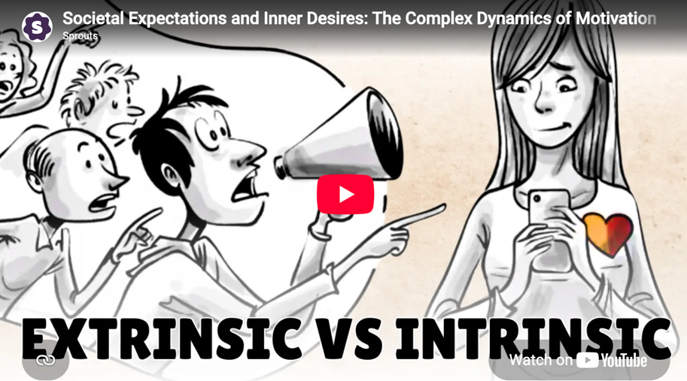
https://www.youtube.com/watch?v=HLiasZwWTjA

Step 3: In the video earlier, you were prompted to consider potential workplace motivation types for intrinsic and extrinsic personality types.
Check below to see if any of these workplace motivation types matched your earlier thoughts, then drag and drop to make the correct match.
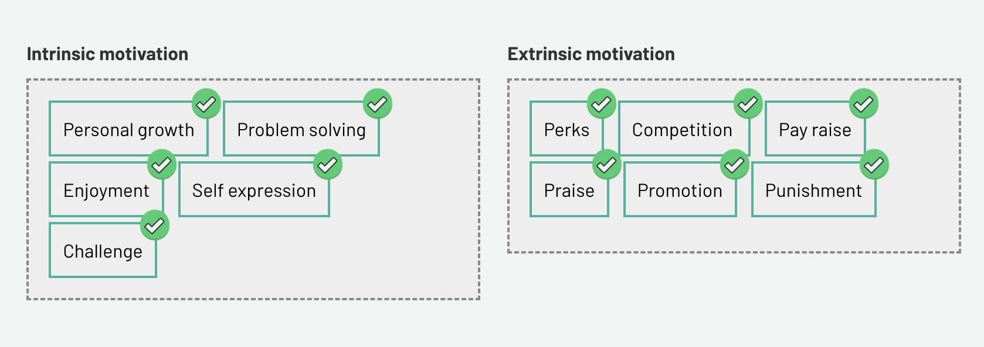
Step 4: Reflecting on what you have seen in the previous activities, add a response to the question below.
What are potential pros and cons of intrinsic and extrinsic personalities in a workplace team dynamic?
Intrinsic:
Pro: An intrinsically motivated employee will apply their attention to what fills their intrinsic needs. If met, they can be very productive and fulfilled.
Con: Paying no attention to extrinsic forces can mean little or no adherence to systems, processes, or frameworks that exist to keep the workplace operating. This becomes an opposing force for the employee and could lead to wellbeing issues.
Extrinsic:
Pro: They will respond positively to competition, incentives, external validation which in a workplace with this dynamic can work well.
Con: The employee may be missing their underlying intrinsic needs and end up masking their personality.

Feedback
Well done. You have correctly identified different states as being either extrinsic or intrinsic. While doing this activity, you might have realised that the list was a bit simplistic. Humans are complicated beings, and, in frankness, our brains hold multiple and sometimes conflicting perspectives over certain things.
That is a diplomatic way of saying that most of us have shades of extrinsic and intrinsic motivation when we do any one thing. It is rare that we do anything for money alone or because we love it—often both intrinsic and extrinsic drivers are at play.

3.2 Psychology and the mind
Purpose
Develop a background on what psychology is and how it is different to neuroscience.
Before you begin
If you have a strong background in psychology, you may want to skip Activity 3.2.
The activity gives a very high-level overview of psychology. For those with a specialist degree, the activity will come across as quite general. However, for those with little or no background in psychology, it will scaffold important foundational knowledge that will be built on in later activities.
Step 1: As an introduction to this activity, watch this short clip.

https://www.youtube.com/watch?v=pUwH-P3Iz0Y

Step 2: Read through the two slides below that explore the difference between the brain and the mind.
Mind and brain
Slide 1 of 2
You’ve just watched an early pilot clip of one of the most successful shows of all time, The Simpsons. In the clip, Bart Simpson is struggling to go to sleep because he is contemplating the difference (broadly speaking) between the brain and the mind.
This is an important distinction for our study of work motivation because psychology is the study of the mind, whereas neuroscience is the study of the brain.
We know a lot about the mind. We’ve had more than 120 years (depending on what school of thought you belong to) of dedicated study into how the mind works or how the mind influences human behaviour.
Before those 120 years, we’ve had nearly 3,000 years of debate, deliberation and dialectic about how and why humans exist and behave.
Psychology was born out of the scientific method applied to human behaviour.


Theories of the mind
Slide 2 of 2
While we have developed a lot of theories about how we think and feel, our actual understanding of the mechanics of the brain (i.e. neuroscience and, to an extent, neurology), particularly regarding how thoughts and feelings correspond with chemical reactions within the brain, remains nascent.
There has been a huge development in neuropsychology, the interaction between the brain and the mind, in the last two decades, but, before that, most of our studies of the brain and its interaction with human behaviour were based on atypical or pathological scenarios (i.e. where damage to the brain had occurred and affected behaviour or where a brain was significantly different to the norm).
If you are interested in reading a contemporary account of neuropsychology, A.C. Grayling’s The Frontiers of Knowledge (2021) provides an extended set of chapters on the interaction between thought and the brain.


Step 4: Modern psychology would not be what it is today without the contributions of the six psychologists pictured below.
Click on the images for a brief overview of each psychologist.
Sigmund Freud
Often touted to be the father of modern psychology, Sigmund Freud developed a set of theories based on observations about how the mind works, particularly minds that appear to suffer from certain behavioural problems, which he often referred to as neurosis and hysteria. Freud treated many female victims of sexual abuse in Vienna, Austria, from the 1890s onwards.
Through his somewhat gendered observations of atypical patients, he developed a series of theories about how the mind works and developed a therapy known as psychoanalysis, which uses hypnosis to put a patient in a state whereupon they can, in some instances, recall and rationalise traumatic events of the past.
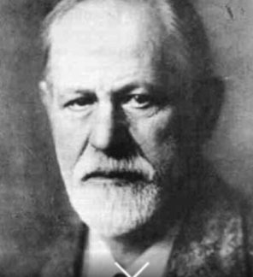

Carl Jung
Carl Jung, who, like Freud, was also interested in psychoanalysis, expanded our collective understanding of the function of dreams in our thought processing.
He also examined how interactions with others, the collective, shapes our conscious and subconscious processing.
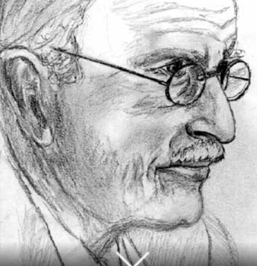

Lev Vygotsky
Carl Jung's work was picked up by Lev Vygotsky in the Soviet Union, who laid the foundation for social psychology and our understanding of childhood development of thought as impacted by the social, familial, and parental environment they are nested within.
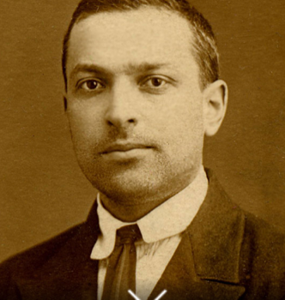

Jean Piaget
Another Swiss psychologist, Jean Piaget, was influential in unpacking normal cognition (as opposed to atypical cognition, such as Freud’s concept of neurosis) and developed the schema theory, which explains how we learn and how that learning builds on prior learning.
Schema theory has been a bedrock in helping us understand neuropsychology (i.e. the physical and chemical brain mechanisms involved in thinking).
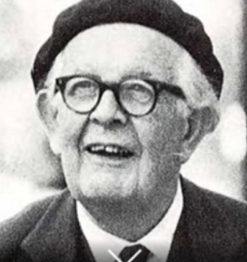

Alfred Adler
Another Austrian foundational figure of modern psychology is Alfred Adler, who was a contemporary of Freud and championed individual psychology, which sought to explain the drivers of why we do what we do for the typical population.
Individual psychology has as a central tenet, the idea that humans strive to be self-actualised and powerful as well as happy.
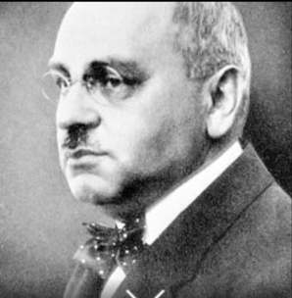+

Ivan Pavlov
Ivan Pavlov, another Russian foundational figure of modern psychology, focused on conditioning behaviour, such as how particular behaviours can be encouraged or discouraged through incentives or punishment.
Pavlov’s work would be considered extreme and potentially unethical by today’s standards, but it formed the basis of cognitive behaviour therapy, which remains the mainstay of psychological treatment because it is efficacious relative to other forms of psychological therapy (e.g. psychotherapy and psychoanalysis).
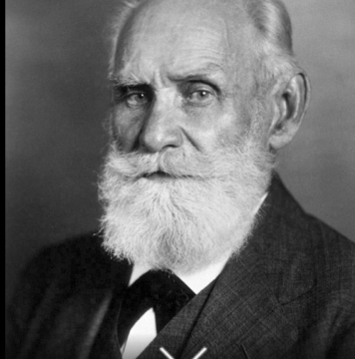

Step 5: Freud, Jung, Adler, Piaget, Pavlov and Vygotsky are the men that exclusively dominated the developments of early-modern psychology. We still touch on their theories today, though, in many cases, these have been disputed and/or disregarded in place of a more nuanced understanding of how we think and why we behave as we do.

Feedback
Well done! You have skimmed over the surface of the history and development of modern psychology. While it might not seem directly relevant to the assignment, so much of our contemporary understanding of work motivation is based on the ground-breaking work of these seminal theorists.
Having a sense of the origins of key ideas is important.

3.3 Content and process theories of motivation
Purpose
This activity reviews the two foundational principles of motivation, process and content theories. It is important that we are familiar with these theories, as they form the backbone of much of what we know about why employees do what they do and how they might be stimulated to perform at work. That said, things have moved on since these theories, and we will cover more recent developments after we know about process and content theories.
Some context before you begin

Friends, sorry to say, but this is hard! The truth is that there are many theories that underpin human behaviour and motivation (or why we do what we do), and, indeed, there is an additional lexicon of these that relate to why we do what we do at work (theories of work motivation).
There’s no way that we can get close to visiting all the stars in the human motivation galaxy in one activity. It would take years of dedicated study. In later activities, we will home in on one particular galaxy of work motivation theories, but, for now, we are going to focus on tracking through the developments of content and process theories of work motivation.

Task
Step 1: Content and process theories of motivation have been used as delimitators, portioning the lexicon of theories of motivation.
- Type 'content and process theories of motivation' into a search engine.
- Scroll through two or three of the resulting hits on the first or second page, then, in your own words, define content and process theories of motivation and
- Explain how they are different.
(Approximately 80-100 words in total)
You can enter your findings in the table below. Export your notes before leaving this page as they won't save.
My notes:
Content theories - explain what drives behavior
Process theories - explain how behavior is directed and sustained.

Content theories focus on the specific needs, desires and incentives that get people to take action. These needs could be intrinsic or extrinsic.
Key theories in this field are Maslow's Hierarchy of Needs, Herzberg's Two-Factor Theory and McClelland's Theory of Needs.

Process theories focus on the mental mechanisms and cognitive processes that people use to choose specific behaviours and sustain them over time. Key theories in this field are Vroom's Expectancy Theory, Adam's Equity Theory and Locke's Goal-setting Theory.

Step 2: Correctly identify the following theory as being a content theory or a process theory of motivation.
You may use the internet to find out more about each theory.
Accessible Interactive Instructions: This interactive uses mouse drag and drop and is not accessible to other navigation methods.
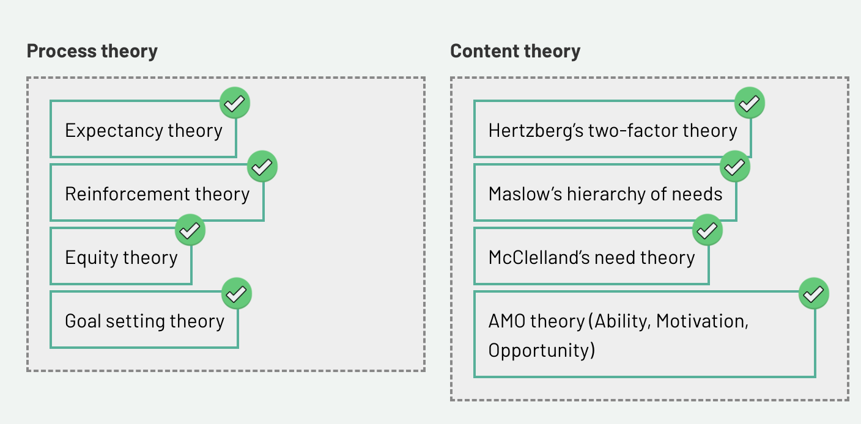
Step 3: Select one of the theories above. It can be one that interests you or another work motivation theory that you have come across that interests you.
My notes:
Maslow’s Hierarchy of Needs
This theory proposes that human needs are arranged in a five-level hierarchy:
Physiological needs (food. Shelter, sleep)
Safety needs
Belonging and Social Connection
Esteem
Self-Actualization
The premise is that lower level needs must be met before higher-level needs become motivating.
In practice, the model helps managers recognise that different employees may be operating at different levels at any given time. Providing job stability addresses safety needs; building team cohesion addresses belonging; offering recognition and advancement addresses esteem and self-actualisation.
The aim is that by satisfying employees basic needs can produce meaningful gains in productivity and retention.
Where the theory has been criticised, is that the model is too rigid as it prioritises a linear progression as the only way people have their needs met. Critics argue that people often pursue and satisfy multiple needs simultaneously rather than strictly checking off one level to reach another.
Examples in the workplace can include employees willing to tolerate low pay and poor job stability (Safety/Physiological needs) because they are deeply motivated by a passionate mission or creative freedom (Self-Actualisation).
Definition:
Content and Process Theories of Motivation
The separation of theories of motivation in the workplace into what motivates people (content), and how motivation occurs through cognitive processes (process).
Practical application section.
Motivation theories split into two families — content theories (what motivates people — the needs) and process theories (how motivation happens — the mechanism/decision process). Here's how each shows up practically in HR.
Content Theories — "What" motivates
Maslow's Hierarchy of Needs
- Basic pay/benefits meeting physiological & safety needs
- Job security policies, safe working conditions
- Team-building events for belonging
- Recognition programs, promotions for esteem
- Stretch projects, creative autonomy for self-actualization
Herzberg's Two-Factor Theory (hygiene vs. motivators)
- Hygiene factors (prevent dissatisfaction, don't motivate): fair pay, safe conditions, job security, good policies
- Motivators (drive real engagement): meaningful work, recognition, achievement, growth opportunities, responsibility
- Practical use: don't assume a pay rise will boost motivation — it just removes dissatisfaction. Use recognition, autonomy, and growth to actually motivate.
McClelland's Acquired Needs Theory (achievement, affiliation, power)
- Assign high-achievers to goal-driven, measurable projects
- Give affiliation-driven employees team-based or client-facing roles
- Offer power-motivated employees leadership tracks or committee roles
- Used in role-fit and career pathing decisions
Alderfer's ERG Theory (Existence, Relatedness, Growth)
- Similar to Maslow but non-hierarchical — used in flexible reward systems that let employees choose what matters most to them (e.g., flexible benefits menus)
Process Theories — "How" motivation happens
Vroom's Expectancy Theory (Effort → Performance → Outcome)
- Clear, achievable KPIs (effort will lead to performance)
- Transparent link between performance and reward (performance will lead to outcome)
- Rewards that are actually valued by the individual (the outcome must matter to them)
- Practical use: commission structures, clear promotion criteria, personalized incentives
Adams' Equity Theory
- Pay transparency/benchmarking to ensure perceived fairness vs. peers
- Consistent, criteria-based performance ratings (avoiding bias — ties back to the Cecchi-Dimeglio and rater-bias papers you've read)
- Addressing "quiet quitting" as an equity-restoring behaviour when input/output ratio feels unfair
Locke & Latham's Goal-Setting Theory
- SMART goals — specific, measurable targets outperform vague "do your best" goals
- OKRs (Objectives and Key Results) — widely used in tech companies
- Regular goal check-ins rather than annual-only reviews (ties to the Cappelli & Tavis shift toward frequent feedback)
Skinner's Reinforcement Theory
- Spot bonuses / immediate recognition for desired behaviour (positive reinforcement)
- Performance improvement plans as a structured consequence system
- Gamified recognition platforms (points, badges) — instant reward tied to behaviour

Feedback
Good work! To be clear, many units that explore performance management and motivation usually stop at content and process theories. For the last 30 years, these have been the bedrock theory from which practical performance management techniques were developed. Thus, it was important for you to explore these. However, the world has thankfully moved on from these dated and sometimes disproven theories. We explore the latest developments next.

3.4 Positive psychology
Purpose
Students explore the concept of positive psychology and examine how it is deployed in relation to work motivation.
Task
Step 1: Have you ever been completely immersed in an activity where you felt such enjoyment that nothing else mattered at that time? Has this ever happened at work?
If you have answered yes, you were likely in a state of flow.
Watch FLOW BY MIHALY CSIKSZENTMIHALYI | ANIMATED BOOK SUMMARY to get more insight.
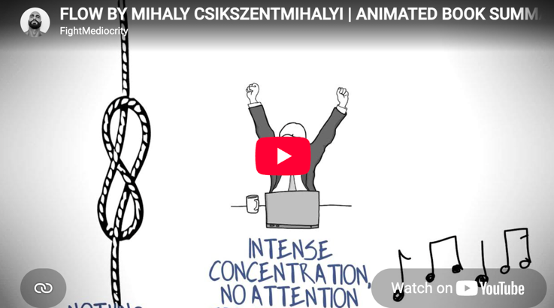
https://www.youtube.com/watch?v=8h6IMYRoCZw

Step 2: To help contextualise this further, please read through the slider notes.
Mihaly Csikszentmihalyi
Slide 1 of 4
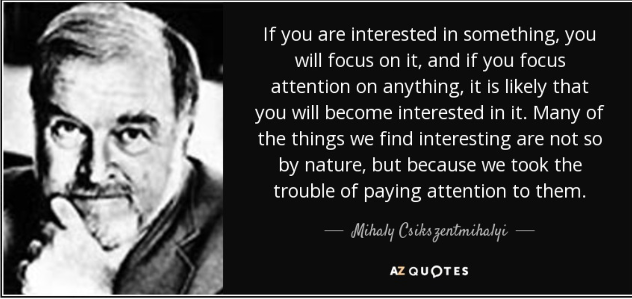

Flow theory
Slide 2 of 4
Csikszentmihalyi's theory of flow is an important theory within the subfield of positive psychology, a term which we will soon explore further. Flow is an amazing theory, and probably most of us when watching the video thought about times when we have been in flow.
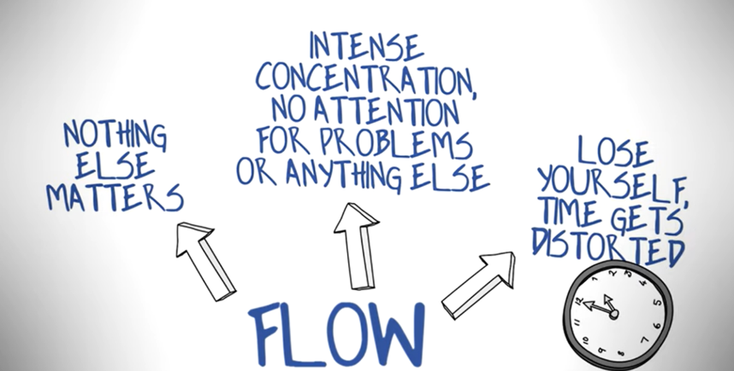

Slide 3 of 4
From a work motivation perspective, flow is revolutionary. This is because we’ve previously conceived of work as a set number of hours per week during which one undertakes a set number of tasks. This latter perspective of hours and tasks is part of work design theory.
Indeed, Australia’s Fair Work Act enshrines the typical number of hours that full-time work encapsulates, being an average of 38 hours each week.
Flow theory creates a natural tension in the way we have traditionally conceived of work, because, according to flow, given the right circumstances, a person can be more productive and could do what would usually be eight hours of work in two hours.
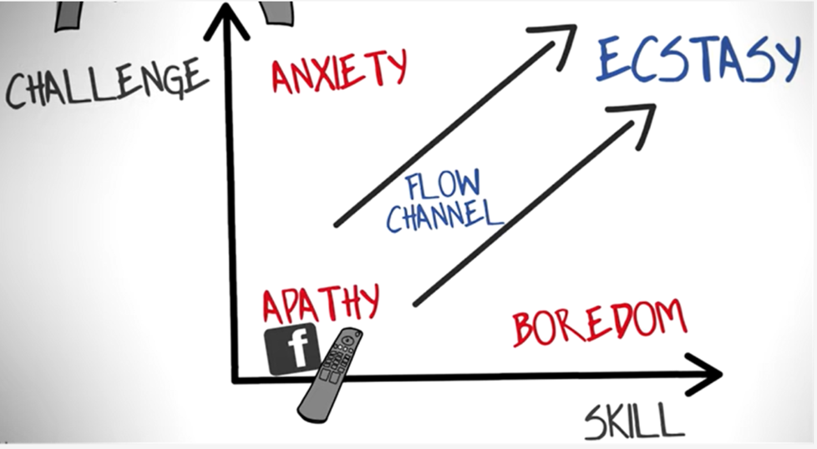
Slide 4 of 4

Has the light switch been turned on yet?
Over the last five years, there has been a lot of media attention around the four-day working week, flexible work and whether transit to and from work should be included as part of work hours.
If we dig deep enough, all of these issues are prompted by flow theory, which says that we can be more productive if we stop thinking about work as a 9am-5pm activity at a particular office, but rather as something that should be done as efficiently as possible, given the right set of circumstances.
Step 3: Let's reflect and share on the discussion board.
Share an example of where you were able to work in flow and how being in flow made the outcome better, faster and of a better standard than would otherwise have been achieved.
Note the conditions under which the flow state occurred for you. For example, when studying for my undergraduate degree, if I worked from 5am-9am on a Sunday morning, I could get more work done than if I studied the whole day from 9am-5pm. This is because I consumed a lot of coffee, I didn’t have any other distractions, and I didn’t feel any anxiety or pressure about other things I needed to achieve on that day.
My notes:
A recent experience of Flow has been working on a work project where I have been able to flex my creativity skills and have full ownership. These came from my intrinsic motivation needs to fully express myself.
The flow state was also induced by some extrinsic motivation of realising both financial reward and recognition from superiors that I had done a good job.
When in the state, I felt full focus and drive where nothing could distract me from the task. I found myself to be far more productive in work output when in the Flow state.

Step 4: Next, we are going to delve into the concepts of Positive Psychology.
Read until the blog posts What is Positive Psychology & Why is It Important? by Ackerman (2019).
Please use your learning journal to reflect on important aspects of this text.
Article Notes:
"What Is Positive Psychology & Why Is It Important?" by Courtney E. Ackerman (PositivePsychology.com)
Definition: Positive psychology is the scientific study of what makes life most worth living — it studies strengths rather than weaknesses, and building the good in life rather than just fixing what's broken.
Founder: Martin Seligman, who'd earlier developed the "learned helplessness" theory tied to depression. Frustrated that psychology only focused on illness, he pushed a new sub-field when elected APA president in 1998; the foundational paper was published in 2000 with Mihaly Csikszentmihalyi.
Key model — PERMA (Seligman's framework for wellbeing):
- Positive emotions
- Engagement (losing yourself in something you enjoy)
- Relationships
- Meaning
- Accomplishment
Key concepts:
- Flourishing — the state of hitting all five PERMA elements; a process, not a fixed trait
- Flow (Csikszentmihalyi) — intense absorption in an activity, occurring when challenge and skill are both high
Practical applications: gratitude journals, gratitude letters, strengths-based coaching, wellbeing therapy, positive psychotherapy.
Criticisms addressed:
- Some findings overstated/hyped
- Too reliant on self-report survey data
- Cultural/Western bias in the research base
- Too individualistic — under-attends to teams, organizations, systemic issues
- Sometimes dismissed as shallow "Pollyanna" positivity — though the author argues this critique is weakest, since the field also studies negative emotions' value
Bottom line: A legitimate scientific field (not self-help) aimed at understanding and building thriving, not just treating dysfunction — with real, if contested, applications in therapy, coaching, education, and the workplace.

Definition:
Learned Helplessness
Learned helplessness is a psychological state where an individual repeatedly faces uncontrollable stressors and eventually stops trying to change their circumstances, even when opportunities for escape arise. Coined by psychologists Martin Seligman and Steven Maier in the late 1960s, it often stems from past trauma or chronic failure, leading to deep-seated passivity, low motivation, and a persistent belief that one's actions are entirely futile.

Step 5: Our next research task continues with positive psychology. Read over the following article, paying particular attention to the discussion section:
Evaluating Positive Psychology Interventions at Work. A Systematic Review and Meta-Analysis.pdf
Article notes:
Donaldson, Lee & Donaldson (2019), "Evaluating Positive Psychology Interventions at Work: a Systematic Review and Meta-Analysis"
What they did: First meta-analysis of workplace Positive Psychology Interventions (PPIs), pooling 22 studies (52 effect sizes, ~6,000 participants across 10 countries).
Five intervention types tested:
- Psychological Capital (PsyCap) — self-efficacy, optimism, hope, resilience
- Job crafting — employees reshaping their own job demands/resources
- Employee strengths — identifying and using character strengths
- Employee gratitude — structured gratitude practices at work
- Employee well-being — PERMA-based programs
Headline results:
- Overall small-to-moderate effect on work outcomes (g = .31)
- Bigger effect on reducing bad outcomes (stress, burnout, incivility: g = -.34) than on boosting good outcomes (g = .25)
- Significant improvement in: well-being, engagement, and "other" outcomes (trust, leadership, organizational virtue)
- No significant effect on job performance itself (or negative performance) — a notable gap
By intervention type: No statistically significant differences between the five theories, though gratitude and strengths interventions had the strongest individual effects on desirable outcomes; PsyCap had the strongest effect on reducing undesirable outcomes.
By delivery method: Group interventions were somewhat better for boosting good outcomes (likely due to social/collaborative benefits); individual interventions worked best for reducing bad outcomes — possibly since they mirror one-on-one positive psychotherapy techniques.
Important caveat: Publication bias was detected (tested via Fail-Safe N, Egger's test) — meaning the true effects may be smaller than reported, since studies with null results are less likely to get published.
Bottom line: Workplace positive psychology interventions do work, modestly — particularly good at reducing stress/burnout/negative behavior, less proven at directly lifting job performance. This challenges the "toxic positivity" critique of the field: focusing on the positive doesn't ignore the negative — it may actually be one of the more effective ways to address it.

Based on your reading of the paper and any subsequent searching, undertake the following task:
- Define each of the following terms with one sentence: psychological capital, gratitude, job crafting and employee strengths.
- Based on Table 4 of the paper, interventions focused on the individual level appeared to be more efficacious concerning the p-value/significance level than those focused on the group or via an online forum. Given what you have learned about positive psychology and some of the criticisms observed in the reading in Step 3 of this activity, why would individually focused positive psychology interventions at work do better than those focused on the group level? (2-3 sentences)
My notes:
Working individually allows the space and care to surface an individuals personal strengths and apply them to a specific problem. It’s a tailored, personal approach that may target an Indumal’s specific sources of stress than a generic group or workshop can.
- The meta-analysis does show support for a positive effect linking positive psychology interventions and work performance, but there is an even stronger effect in reducing undesirable work outcomes. Why might the mitigating effect on undesirable work outcome be stronger?
Hint: there is some discussion of this on page 129 of the paper, just above the 'limitations' section.
My notes:
The authors point to PPT’s logic that rather than attacking a problem or deficiency, PPI’s surface a person’s existing strengths and build plans to use them more. It can be easier to neutralise a negative stress by strengthening something positive than it is to add extra positivity on top of an already adequate baseline.
Definition:
Psychological Capital
PsyCap is a positive psychological state of development defined by four core resources, often remembered by the acronym HERO: Hope, Efficacy, Resilience, and Optimism.
Rooted in Positive Psychology and Organisational Behavior, PsyCap goes beyond standard human or social capital. Unlike fixed personality traits, PsyCap is malleable – meaning these states can be actively developed and trained.
Definition:
Job Crafting
The process of proactively redesigning your own work to better align with your individual passions, strengths, and values.
The concept involves three primary areas of adjustment:
1. Task Crafting
2. Relational Crafting
3. Cognitive Crafting

Feedback
Well done. You’ve done a deep dive into positive psychology and how this field of psychology is evolving our understanding of work performance. We are going to do one more deep dive into a related theory, conservation of resources, before applying all that we have learned about positive psychology and motivation to a case study.

3.5 Conservation of resources theory
Purpose
This activity encourages students to take a deep dive into conservation of resources theory, which, coupled with positive psychology, provides a robust framework to understand why individuals are drawn to perform or not perform at work.
Before you begin
Accessible Interactive Instructions: Use the arrow keys to navigate between slides. After selecting a slide, use the Tab key to move to the slide content.
Read for context
Slide 1 of 3
As we’ve discussed, there are many theories that seek to explain why employees perform at work or why they don’t.
Noted in the former activities, the concept of wellbeing has gained increasing focus over the last 20 years as a result of research through the lens of positive psychology.
Increasingly, wellbeing is being seen not as a desirable outcome of work but, rather, as an important consideration to maintain in order to boost employee performance. The distinction of wellbeing as an outcome or as a kind of input or hygiene factor might seem semantic. Does it really matter? In truth, it does.



The concept of wellbeing
Slide 2 of 3
Employees feeling good about themselves and their work used to be conceived of as nice-to-have but not essential.
Building work and a work environment that are conducive to wellbeing is costly. People need to behave nicely to each other; employees need to be sufficiently resourced; and there need to be mechanisms where people feel valued and can share concerns or ideas if they have any then have these acted on.
To build such an organisation requires a significant investment and commitment, and, for this reason, the wellbeing narrative as it applies to work was traditionally sidelined or considered to be a cost rather than an investment.
Because of the research prompted by the positive psychology revolution, we have a much more detailed and evidence-based understanding of wellbeing, and the research supports the broad notion that, if employees have wellbeing, they will perform more. To put it bluntly, yelling at an employee to ‘finish that report’ is less efficacious than supporting the employee to finish the report. Also, the act of yelling at an employee is likely to reduce the quality of their performance, as it increases their performance anxiety and leads to emotional blocks.
Wrapping up
Slide 3 of 3
Reading over the last two slides, we’ve covered a lot about how our understanding of work is radically shifting to suit the knowledge economy.
When you needed employees to "just build that railway … how hard is it?! Hammer the thing into the thing," it didn’t seem to make a lot of difference whether you were mean or supportive when asking them to do it (though in truth, the research we have now would suggest that it is always better to be supportive).
Now that work requires less mechanical effort and instead requires the deployment of more complex and creative problem-solving skills, providing a foundation of support guided by the wellbeing of the employee is shown to be much more effective in getting a better result quicker. Why? Let’s find out.

Task

Assessment 3
Content covered in this activity can be used in your third assignment for this unit.
Step 1: To start we will watch 'Why we conserve energy: the conservation of resources theory' (3:10).
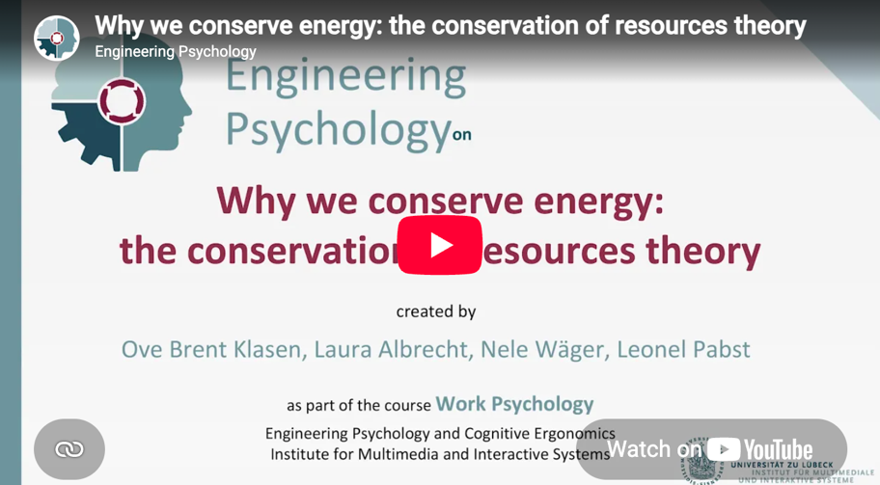
https://www.youtube.com/embed/8Exq1ZDFzPI
Definition:
Conservation of Resources Theory
Developed by Dr. Stevan Hobfall in 1989, is a psychological stress model stating that humans are fundamentally motivated to protect, retain, and build their valued resources. Stress and burnout occur when these resources are threatened, actually lost, or when investment fails to yield expected resource gains.

Step 2: The Conservation of Resources (CoR) theory by Hobfoll is quite a technical theory that has a lot of beauty and explains a lot about employee behaviour at work.
One particularly salient component is how the impact of a resource loss on an individual is significantly stronger than a resource gain.
For example, when a manager yells at you about your work, it is likely to have a much more pronounced and negative impact than if you received some praise.
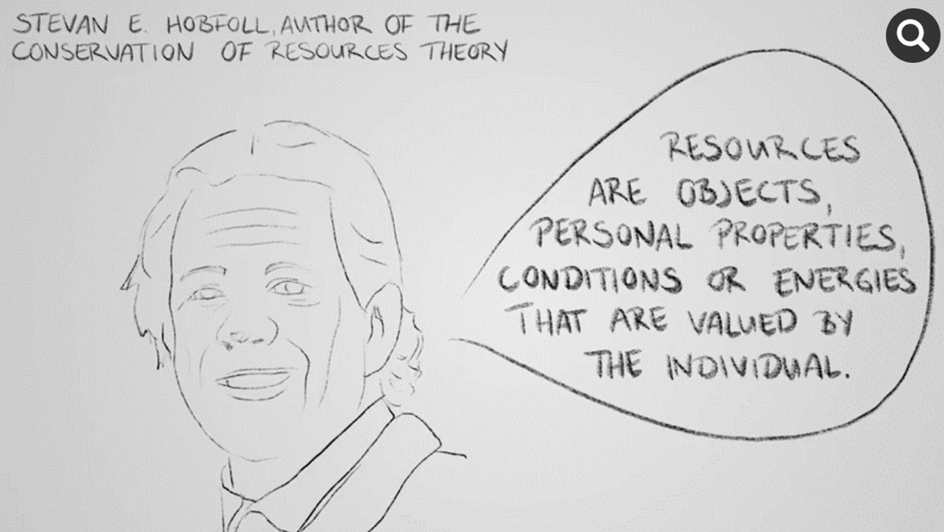
Step 3: Create a new journal entry.
CoR theory has two principles and four corollaries. Using an internet search engine, locate and identify these principles and corollaries and record them in your learning journal.
My notes:
The theory relies on two central principles:
  - The primacy of loss: Losing a resource is psychologically much more painful and impactful than the joy of gaining an equivalent resource.
  - Resource investment: To prevent loss and recover from stress, individuals must invest their existing resources to build more reserves.
Four primary resource types:
1. Objects: Physical items like housing, tools, or clothing
2. Conditions: States of value such as employment, martial status, or good health
3. Personal characteristics: Internal traits like self-esteem, optimism, or skills.
4. Energies: Means to attain other resources, such as time, money, or knowledge.

Feedback
Well done! As part of your third assignment for this unit, you may choose to adopt a CoR lens and apply the two principles and four corollaries to evaluate a performance management system and its effect on staff.

3.6 Application of positive psychology to a performance management system
Purpose
Explore an application of positive psychology to a performance management process.
Task

Assessment 3
The journal activity was designed to assist you in preparing for your third assessment item.
Step 1: Access the Frontiers in Psychology article and read the following:
Before you start reading, refer to the questions in the journal activity below to get an idea of key information to look for.
The Effect of Strengths-Based Performance Appraisal on Perceived Supervisor Support and the Motivation to Improve Performance.pdf
Article Summary:
van Woerkom & Kroon (2020), "The Effect of Strengths-Based Performance Appraisal on Perceived Supervisor Support and the Motivation to Improve Performance" — Frontiers in Psychology
Core question: Does focusing on employee strengths (rather than deficits) in performance appraisal boost motivation to improve — and does this depend on how good/bad the person's rating was?
Theoretical basis: Self-Determination Theory (SDT) — specifically the need for relatedness (feeling connected/supported by others). The idea: a strengths-based appraisal makes employees feel supported by their supervisor, which then fuels their motivation to improve (MTI).
Method: Surveyed 422 consultants at a Dutch IT firm right after their annual appraisal; linked survey answers to their actual official performance ratings.
Three hypotheses, all supported:
- Strengths-based appraisal → higher motivation to improve (direct positive relationship)
- Perceived Supervisor Support (PSS) mediates this effect — strengths-based appraisal boosts how supported employees feel by their supervisor, and that feeling of support is what drives the motivation boost (not just the appraisal content itself)
- The effect is stronger when the performance rating was relatively low — this is the key finding. When someone gets a mediocre/low rating, a strengths-based approach matters more for preserving their sense of supervisor support and keeping them motivated, compared to when the rating was already good.
Why low ratings matter more: A low rating threatens someone's self-view and can trigger defensive withdrawal from the supervisor relationship. Since strengths-based appraisal focuses on "you at your best" rather than ranking you against others, it helps buffer that blow — supervisors can convey competence and care even while delivering disappointing news, preventing damage to the relationship.
Practical implications:
- Organizations reluctant to abandon performance ratings altogether (many are) should still train supervisors in strengths-based conversation techniques — tools like Strengthsfinder, reflected-best-self exercises, feedforward interviews, or a 3:1 positive-to-negative feedback ratio
- This is especially valuable for employees receiving disappointing ratings — it's a way to soften the blow without abandoning ratings entirely
Limitations:
- Cross-sectional design (can't prove causation) — future research should test this with real experiments manipulating strengths-based vs. traditional appraisal
- Sample skewed toward already high-performing employees (people with low ratings were underrepresented)
- Single company, single industry (IT) — limits generalizability
- Only tested the "relatedness" need from SDT, not autonomy or competence
Definition:
Self-Determination Theory
A psychological framework exploring human motivation and personality. It posits that people are driven by an innate desire to grow. To achieve optimal functioning and well-being, three fundamental psychological needs must be met:
1. Autonomy
2. Competence
3. Relatedness
Practical application section.
Practical applications: Self-Determination Theory
Here's what each need looks like when it's being met (and unmet) through observable workplace behaviour:
Autonomy
When met:
- Proposes their own approach to a task rather than waiting for instructions
- Pushes back respectfully on a process they think is inefficient
- Shows initiative — starts things without being asked
- Expresses ownership language: "my project," "I decided to..."
When unmet:
- Waits passively for direction on everything
- Follows process exactly even when it's clearly not working
- Disengagement or quiet compliance — doing only what's asked, nothing more
- Frustration when micromanaged ("just tell me what you want and I'll do it")
Competence
When met:
- Seeks out challenges slightly above their current skill level
- Talks about progress/mastery ("I've gotten so much better at X")
- Enters flow states — loses track of time, deeply focused
- Confidently offers opinions or solutions in their area of expertise
When unmet:
- Avoids tasks that risk exposing a skill gap
- Anxiety or defensiveness around feedback
- Repeats the same safe tasks rather than trying new ones
- Expresses self-doubt ("I don't think I'm good at this")
Relatedness
When met:
- Builds genuine relationships with colleagues, not just transactional ones
- Mentors others or seeks mentorship voluntarily
- Speaks positively about the team, uses "we" language
- Comfortable sharing struggles openly with a manager or peers
When unmet:
- Isolates from the team, works independently even when collaboration would help
- Guarded or transactional communication with manager
- Doesn't seek help when struggling
- Cynicism about team culture ("no one here actually cares")
Self-Determination Theory (SDT) centers on three psychological needs: autonomy, competence, and relatedness. Here's how HR practically applies each:
Autonomy
- Flexible work arrangements — choice over hours, location, or how tasks get done (not just what gets done)
- Job crafting — letting employees reshape parts of their role to fit their strengths/interests (like your Sarah dual-lead example)
- Goal-setting input — employees co-create their own KPIs/OKRs rather than having targets imposed top-down
- Minimal micromanagement — giving discretion over how to complete tasks, checking in on outcomes rather than process
Competence
- Stretch assignments matched to skill level (not too easy, not overwhelming) — this is essentially the "flow" zone
- Developmental (not just evaluative) feedback — feedback that builds capability, e.g. strengths-based appraisal (van Woerkom & Kroon)
- Mastery-oriented training — skill-building programs tied to visible progress, not just compliance training
- Recognition of growth, not just outcomes — praising improvement and effort, not only final results
Relatedness
- Mentoring and buddy systems — like Sarah mentoring Sam
- Team-based projects with genuine collaboration (not just co-location)
- Manager check-ins focused on genuine support — this is literally what van Woerkom & Kroon found: perceived supervisor support mediates motivation
- Psychological safety practices — normalizing open discussion of struggles without fear of punishment
Common HR Programs Built on SDT
- Google's 20% time — autonomy over how to spend part of the workweek
- Netflix's "freedom and responsibility" culture — high autonomy, paired with high accountability
- Feedforward interviews (Kluger & Nir) — future-focused, competence-building instead of past-deficit-focused
- Job crafting interventions (Wrzesniewski & Dutton; also in the Donaldson et al. meta-analysis you read) — structured programs where employees redesign their job demands/resources

Step 2: Open your journal and create a new section for this activity.
- Table 3 identifies the maximum R2 effect of the moderated mediated model on "motivation to improve as" .38 (or 38 percent increase). In your own words, interpret what this means (hint: reward hypothesis 3).
My notes:
Nearly two-fifths of the difference between employees in how motivated they felt to improve their performance can be accounted for by whether they experienced a strengths-based appraisal and how supported they felt by their supervisor.
When an employee got a bad performance rating, a strengths-based conversation helped them still feel supported by their manager, so they stay motivated to improve instead of shutting down or getting defensive.
- The discussion section of the paper identifies about five substantial findings that result from this paper. In your own words (about 150 in total), please summarise the paper’s contribution.
My notes:
1. Strengths-based appraisal boosts motivation to improve. This happens partly because it increases how supported employees feel by their supervisor.
2. The effect is strongest when the performance rating is relatively low. SBA is particularly valuable for helping employees cope with a disappointing rating without damaging the supervisor relationship.
3. Social/relational aspects of the appraisal matter. Not just the content, discussing an employee’s unique qualities invites active participation and signals a developmental (not just evaluative) purpose, leading to more positive views of the supervisor.
4. Contribution to SDT. The study is among the first to treat the performance appraisal interview itself as a social context that can support (or hurt) the basic psychological need for relatedness, and angle prior SDT research has largely overlooked.
5. An unexpected age effect. Age was negatively associated with performance ratings, PSS, and MTI, suggesting older workers may benefit less from current appraisal approaches and highlighting room to better support them.
- The paper speaks a lot about "strengths-based performance appraisals." Using the paper and doing some further research of your own if time permits, describe in around 150 words what a strengths-based performance appraisal looks like in practice (i.e. What language would be used to give feedback? What might a performance appraisal template look like?)
My notes:
In practice, a SBPA is made up of four sections:
1. Preparation
Manager reviews the employees peak moments over the past year. Identifies tasks where the employee showed strengths.
Employee completes a self-assessment focused on what they felt where their most successful achievements, which strengths they used, and how they want to grow the strengths.
2. Meeting structure
Follows a flow where roughly 80% of time is on strengths and 20% is on managing risks.
- Success Analysis: Manager asks open-ended questions to dissect a recent win. “You project was flawless. Which of your strengths did you rely on to keep the team on track?”
- Future alignment: The conversation focuses on building world-class expertise rather than incremental improvement. “Since you excel at client relationship building, let’s pair you with our high-value accounts next quarter and get you advanced negotiation training.”
- Risk Mitigation: Weaknesses are only addressed if they block performance. They are reframed as blind spots, overdone strengths, or skills deficits to manage. “Your drive for execution is excellent, but it sometimes morphs into micromanagement. How can we use your strong communication skills to delegate earlier?”
3. Feedback phrases
Language changes from a traditional review:
- Traditional: “You need to work on your public speaking skills”
- Strengths-based: “Your analytical writing is incredibly clear. Let’s leverage that structure to help you build confidence when presenting your data to stakeholders.”
4. Action plans and goal setting
- Strength stretch goals: Setting targets that require the employee to apply their top talents to bigger, more complex organisational problems.
- Remediation, Not rehabilitation: For critical skills gaps, the plan focuses on workarounds; using technology, restructuring the role, or partnering with teammates who hold complementary strengths.
Google source
- How might you deploy a strength-based performance appraisal framework?
My notes:
Treat it as a cultural shift not a HR box-tick. Phase the rollout to secure buy-in. Select the systems and tools. Train managers on the framework.
Given that the third assessment item requires you to evaluate traditional performance management frameworks, can you identify three or four references from this paper that you might be able to use in your final assignment and that speak to broader issues related to criticisms of traditional performance management systems?
My notes:
• Culbert, S. A. (2010). Get rid of the performance review!: How companies can stop intimidating, start managing—and focus on what really matters. New York: Business Plus.
— Directly argues traditional performance review damages the supervisor-employee relationship.
• Adler, S., Campion, M., Colquitt, A., Grubb, A., Murphy, K., Ollander-Krane, R., et al. (2016). Getting rid of performance ratings: genius or folly? A debate. Industrial and Organizational Psychology, 9, 219–252.
— A full debate piece weighing arguments for and against abandoning ratings altogether; useful for presenting both sides.
• Murphy, K. R. (2019). Performance evaluation will not die, but it should. Human Resource Management Journal, 30, 13–31.
— Directly critiques the continued survival of performance evaluation despite its flaws.
- • van Woerkom, M., and de Bruijn, M. (2016). Why performance appraisal does not lead to performance improvement: excellent performance as a function of uniqueness instead of uniformity. Industrial and Organizational Psychology, 9, 275–281.
— Argues traditional appraisal's push for uniform standards actively works against improvement, since excellence is individual/unique.

Feedback
Wow! What a week! You can hopefully see how this last activity touched on all former activities related to psychology, CoR, positive psychology, etc., and sought to apply it to a performance management/appraisal approach.

Week Four

Week 4 introduction

Rewarding performance
"Money... Get away... You get a good job with more pay and you’re okay."
These lyrics are from the opening lines of Pink Floyd’s 1973 hit, 'Money,' from their The Dark Side of the Moon album.
In this week’s topic, we are going to do a deep dive into the topic of rewards, offering a specific critique of the role of financial rewards and intrinsic value at work. Activities will involve a lot of reading of the scholarly evidence related to performance-related pay. A lot of time and some guidance notes have been provided to help make this reading active, engaging and digestible. The purpose of so much reaching is to provide you with a very nuanced understanding of the impact of performance pay on different kinds of work performance.

Learning objectives
After completing the tasks this week, you should be able to:
- examine the question: Does money motivate?
- explore the impact of financial rewards on intrinsic motivation
- research the role of meaning as it applies to work
- examine non-financial rewards.

  - Performance-related pay

Purpose
The purpose of this topic is to take a deep dive into the complexities of performance-related pay as it applies to employment systems in Australian and non-Australian contexts.

Some context before you begin
Please read the notes in the slider below.
Accessible Interactive Instructions: Use the arrow keys to navigate between slides. After selecting a slide, use the Tab key to move to the slide content.

Performance-related pay (PRP)
Slide 1 of 4

Phew! We said it. Before we delve into this topic, there needs to be a product warning and disclosure section here. This is a contentious topic, and, if you look up any empirical research about PRP, it generally starts with "previous research highlights mixed results for PRP."
Sometimes, you find a paper that says, "most researchers agree that PRP can have a positive effect on performance." But you can also click on another paper that offers the opposite: "Most research agrees the PRP has little or no effect on performance."

What’s with all the mixed results and contention?
Slide 2 of 4

The big thing to realise when exploring PRP is that context counts. If you look at the research (and we will), studies that tend to show a positive relationship between PRP and performance are generally in production/manufacturing, sales and retail settings (i.e. where it is easy to measure work output).
In more knowledge-based industries where output is determined by the deployment of creativity and problem-solving skills on the part of the employee, results are more mixed.

The issue of context goes further.
Slide 3 of 4

Many studies (if not most) that explore PRP come out of the US. Although we in Australia like to think that we are very similar to the US (and some national comparisons like Hofstede’s cultural dimensions model make it seem that the two countries are nearly indistinguishable), a very key difference between the US and Australia relates to Australia’s social welfare system, which, despite criticisms related to the decoupling of unemployment benefits from inflation and cost of living, is much more robust than the equivalent provided by the US.
Moreover, Australia’s minimum wage is significantly higher than that of the US. Australia also has a tax system that, when compared to other countries, seeks to maintain a relative distribution of income across different societal classes. Relative doesn’t mean the same; it just means that the gap between rich and poor, while never perfect, is better in Australia than in other places, because the rich pay more in tax than the poor.

Tipping
Slide 4 of 4

In the US where tips are a culturally acceptable substitution for a poor minimum wage/salary, PRP and work incentives are also more the norm. Because they are more common, they can also be more successful in stimulating performance, something that is referred to in the literature as a sample bias. It will not be the first time you come across the acronym WEIRD (Western, educated, industrialised, rich and democratic), but most research findings, particularly in psychology, are derived from US-based, college-educated people, which in no way are representative of the rest of the world.

Task
Step 1: You will now read and critique academic literature related to PRP. As you read, please be mindful of the product disclosure statement, remembering that studies referred to may suffer from a biased sample, such as country, class or sector, and the results therein are likely influenced wholly or in part by this bias.

Access Lazear (2018) below. This is a big paper! Take your time and schedule about 45mins to an hour to read through it bit by bit.

Compensation and Incentives in the Workplace.pdf

Article notes:

Compensation and Incentives in the Workplace
Edward P. Lazear (2018), Journal of Economic Perspectives, Vol. 32(3): 195–214
Core argument: Compensation structure — not just level — drives worker behaviour. This is a personnel economics review (agency theory lens), summarising decades of empirical labour economics research.
Taxonomy of incentive pay (2×3 matrix):
- Input vs. output based pay
- Discrete, continuous, or relative structure
- e.g., hourly wage = discrete/input; piece rate = continuous/output; promotion tournament = relative
Key sections:
- Piece rates — Strongly effective when output is easily observed. Safelite Auto Glass case: switching from hourly to piece rate lifted productivity 44%. Works best where quality isn't hard to monitor (e.g., agriculture, sales).
- Team-based incentives — Solve the "won't help colleagues" problem of individual piece rates, but introduce free-riding. Works better in small groups (e.g., medical practices) or via broader mechanisms like employee stock ownership.
- Tournament theory — Promotions act like tournament prizes based on relative performance. Bigger spread between winner/loser pay → more effort, but excessive spread breeds sabotage, reduced cooperation, and more risk-taking (sometimes destructive, e.g., fraud).
- Career incentives (experience-earnings profiles) — Firms underpay young workers and overpay older ones to incentivize sustained effort and discourage shirking, since workers are protecting future rents.
- Nonmonetary incentives & intrinsic motivation — Acknowledges Deci's crowding-out effect (paying for previously voluntary acts can reduce intrinsic motivation) but argues intrinsic motivation is a marginal phenomenon in most paid labour markets — pay still does the heavy lifting.
- CEO/executive pay — Reviews the "overpaid CEO" critique vs. counterarguments (firm size complementarity, sorting effects, survivorship bias). Lazear is skeptical that CEO overpayment is as widespread/inefficient as critics claim.
Conclusion: Compensation structure has consistently demonstrable effects on worker motivation and productivity — the economic theory of incentives (agency theory, tournament theory) holds up well against a large body of field and empirical evidence.

Relevance to your coursework: This is a strongly orthodox/economic (agency theory) counterpoint to your Critical HRM and SDT-based readings (Tweedie et al., van Woerkom & Kroon). Useful if Assessment 3 wants you to contrast mainstream/economic rationalist views of motivation (extrinsic, incentive-driven) against psychological/critical perspectives (intrinsic, autonomy-supportive, recognition-based).

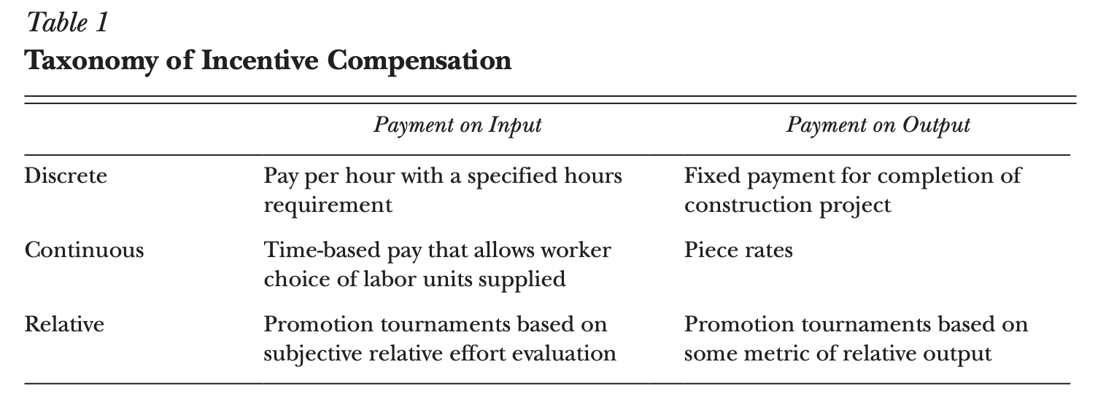

Definition:
Input and Output Pay
Input Pay = Compensation tied to the time or effort put in, not the result produced.
E.g, hourly wage, salary, pay per course taught.
Output Pay = Compensation tied to the result produced. E.g, piece rates (paid per unit made), sales commission, or fixed fee per job.

Definition:
Discrete, Continuous, Relative structure
Discrete = Pay is all-or-nothing, tied to hitting one exact target. E.g, a fixed wage for. Required 40-hour week, or a fixed fee for completing a construction job. No reward for exceeding, or subtraction for falling short.
Continuous = Pay scales with however much input or output the worker provides. E.g, a piece rate (paid per unit, however many you make), or flexibale hours where you’re paid per hour worked.
Relative (Tournament Theory.) = Pay depends on performance compared to others, not an absolute standard. E.g, promotion tournaments – you win based on ranking above your peers, not on hitting a fixed number.
Definition:
Piece-rate pay
A continuous, output-based pay scheme where workers are paid per unit of output they produce. A rate is set per unit, and pay scales directly with quantity produced.
Definition:
Team Based Incentives
Pay tied to the output of a group rather than the individual. Often used to solve the problem that pure piece-rate pay creates (individualism).

Step 2: Create a new journal entry for the reading Compensation and Incentives in the Workplace.

- Define piece-rate pay.
My notes:
Pay based on output and with a continuous structure. Worker pay scales with qty produced, and the agreed rate per unit/job.
- In Australia, what might be a problem switching from an hourly wage pay to a piece-rate pay, despite the likelihood of it increasing productivity?
My notes:
The trade-off is generally quality. Because there is a financial incentive for quantity, this can drive behaviour to preference job speed over quality. Also, workers may lean towards independent working over team-based worker which reduced collaboration, learning, mentoring and create a cultural shift.
- What are team-based incentives? Are they effective?
My notes:
Pay tied to the output of a group rather than the individual. Often used to solve the problem that pure piece-rate pay creates (individualism). Acording to the article, in a manufacturing setting which is output based, Team based pay was successful in increasing output.
In an input based setting (Law), it saw more delegation of work to junior staff where senior staff saw less incentive to put in effort themselves to increase earnings.
- How effective is relative pay in driving performance?
My notes:
The article states they key in relative pay is getting the spread right. Too small a gap in promotion pay jump does not motivate. Too large a gap can drive excessive risk taking and unethical actions.
- Lazear cites a theory stating that, as employees age, their relative productivity decreases. In your opinion, as employees age, what other benefits might they provide to an organisation that may be outside of traditional outputs?
My notes:
Generally, the longer an employee is at an organisation, the more knowledge they have of the organisation. Knowledge has become a critical resource as we have an aging population – more people retiring and taking all the critical company knowledge with them, leaving a knowledge deficit.
- How effective is intrinsic motivation in driving work outcomes? Where does it fall short?
My notes:
The article suggests intrinsic motivation is more effective at higher pay points where additional extrinsic financial rewards are not as motivating. It also also more effective in meaning based roles where workers are spiritually aligned with the work.
The article argues that intrinsic motivation is marginal in most labour settings, where pay/extrinsic motivation is what elicits more effort.

Feedback
Well done! You have just done a deep dive into performance-based pay. You have looked at some strong arguments and evidence for performance-based pay.

4.2 PRP and innovation

Purpose
In this activity, you are going to explore the effect of performance incentives on innovative behaviour.

Step 1: Access the following reading:
Is Pay for Performance Detrimental to Innovation.pdf

Article notes:
Is Pay for Performance Detrimental to Innovation?
Ederer & Manso (2013), Management Science, Vol. 59(7): 1496–1513
Central question: Standard economics says pay-for-performance boosts effort and productivity. But psychology research says financial incentives inhibit creativity and innovation. The paper asks: how should compensation be structured if you specifically want to motivate innovative behaviour, not just effort?
Method: Controlled lab experiment, 379 subjects, running a simulated "lemonade stand" business. Subjects choose location, ingredients, pricing — over 6 million possible combinations — creating a genuine trade-off between:
- Exploitation — fine-tuning the existing (inherited) strategy
- Exploration — abandoning it to search for a better, unknown strategy (i.e., innovation)
Three core pay conditions compared:
- Fixed wage — flat pay regardless of performance
- Standard pay-for-performance — a fixed % of profits, every period
- Exploration contract — tolerates failure in the first half of the experiment (no performance penalty for experimenting early), then rewards performance in the second half. This mirrors real-world tools like stock options with long vesting periods.
Key findings:
- Subjects on the exploration contract found the best strategy 80% of the time — far outperforming fixed wage (60%) and standard pay-for-performance (40%)
- Standard pay-for-performance backfired for innovation: those subjects mostly tweaked the existing strategy rather than searching for a new one — only 50% strayed from the default location, vs. 80% under the exploration contract
- Fixed-wage subjects explored a lot, but haphazardly/unsystematically (only 55% tracked their choices carefully, vs. 82% under the exploration contract) — exploring without discipline is inefficient
- Risk aversion mattered: more risk-averse subjects performed worse specifically under standard pay-for-performance, since it punishes early failed experiments
Termination/job security findings:
- A threat of termination (getting fired for poor early results) sharply reduced innovation — only 45% found the optimal strategy
- A "golden parachute" (a payout if terminated) largely offset this — 65% found the optimal strategy, close to the exploration-contract baseline
Bottom line / contribution: Standard pay-for-performance isn't bad per se — it's good for effort on routine tasks but bad for innovation, because it punishes early failure and pushes people to exploit what already works. The fix isn't removing incentives (a fixed wage isn't the answer either) — it's redesigning them: tolerate early failure, reward long-run success. Practices often criticized as "rewarding failure" (golden parachutes, long-vesting options, entrenchment protections) can actually be functional for innovation when combined with genuine long-term upside.

Relevance to your coursework: This is a strong empirical bridge between the "mainstream" pay-for-performance literature (Lazear) and the psychological/SDT critique (Deci, Frey) — it doesn't reject incentives outright but shows contract design (not incentives vs. no incentives) is what determines whether pay helps or hurts creative/innovative work. Useful if Assessment 3 wants nuance rather than a binary mainstream-vs-critical stance.

Step 2: Open your learning journal and create an entry for this activity.

Read through the article and add answers to the following questions and prompts:
- Based on the cited studies by McGaw (1978), McCullers (1978), Kohn (1993) and Amabile (1996), why is performance-based pay not an effective motivator?
My notes:
They shared the finding that performance based pay should not be used for creativity and innovation because tying pay to performance narrows focus towards safe, proven strategies rather than novel ones that can result in innovation.
- How would you define innovation?
My notes:
Doing things differently to get a different result.
- How would you define an exploration contract?
My notes:
A contract designed to motivate innovation as opposed to routine effort.
- Summarise the design of the experiment that the authors used.
My notes:
The lemonade stand experiment was designed to test which of the three performance-based pay structure drove the most innovation from the stand holder.
- Summarise the results of the experiment.
My notes:
The participants on an Exploration contract found the best strategy for the stand, 80% of the time. Far outperforming fixed wage and pay for performance.

Step 3: On the discussion board, please post a response of no more than 100 words on the following topic.

In your work context:
- Could you ever see a benefit for the deployment of an exploration contract structure? Why or why not?
- If you could see the benefit, what roles will the contract type be limited to?

Feedback
Keep it up! After engaging with the text by Ederer and Manso (2013), you have seen that performance-based pay can be detrimental for roles that involve problem-solving, failure and creativity. But you’ve dug deeper. Specifically, you have tracked through some evidence on a kind of hybrid exploration contract, which may not be appropriate in all settings but combines some of the good things of a wage with a piece-pay structure that occurs over time.

4.3 PRP in the public sector

Purpose
We are going to do a deep dive into the latest evidence about performance-related pay (PRP) as it applies to the public sector, and then we will have a debate on our discussion board!

Some context before you begin
A lot of professionals in Australia work for the public sector. In recent years, there has been a lot of criticism of performance-based pay being applied to public sector contexts in Australia.
You may recall scandals, such as Watchgate, where Australia Post’s Chief Executive, Christine Holgate, was pressured to resign as a result of rewarding her senior managers with luxury watches after they achieved significant performance outcomes.

Task

Assessment 3
The readings explored in Steps 2 and 3 should be useful for Assessment 3, particularly if you are reviewing the effectiveness of a current performance management system.

Step 1: Access the following reading:

Crowding-in or crowding-out the contribution of self-determination theory to public service motivation.pdf

Article Notes:
Corduneanu, Dudau & Kominis (2020), "Crowding-in or crowding-out: the contribution of self-determination theory to public service motivation" — Public Management Review
Core question: Do performance-related pay (PFP) and other extrinsic rewards undermine ("crowd out") or enhance ("crowd in") Public Service Motivation (PSM) — the intrinsic drive to do good for others/society that characterizes public sector workers? The literature has been contradictory for decades; this conceptual paper uses Self-Determination Theory (SDT) to reconcile the mess and propose a research agenda.
Why this matters: Under New Public Management (NPM) reforms, public sector workers are increasingly paid based on performance metrics — but if this erodes their underlying motivation to serve the public, it could backfire on the actual delivery of public value.
The contradictory evidence:
- Crowding-out camp: Performance bonuses reduced service quality among Chinese physicians (Qian & He 2018); PFP undermines professionalism/pride (Wynia 2009); high extrinsic rewards reduced intrinsically motivated people's willingness to even take public sector jobs (Georgellis et al. 2011)
- Crowding-in/compatibility camp: Federal employees expecting merit pay actually performed better regardless of PSM level (Alonso & Lewis 2001); PFP was linked to higher job satisfaction, especially for high-PSM employees (Stazyk 2013); "love of money" strengthened the PSM–job satisfaction link in Chinese public servants (Liu & Tang 2011)
The SDT-based resolution: The relationship isn't fixed — it depends on moderating factors, split into two categories:
1. Contextual moderators
- Managerial autonomy support — when rewards are delivered in a supportive, autonomy-encouraging environment (positive feedback, self-initiation, minimal control/pressure), they're perceived as informational (signalling competence) rather than controlling (coercive). Informational rewards support autonomy; controlling rewards undermine it.
- Colleague autonomy support — support from peers adds further to this effect, particularly relevant given how collaborative public sector work often is.
2. Person-specific moderators
- General causality orientations — individual differences in how people generally interpret motivational cues (autonomous vs. controlled orientation)
- Intrinsic/extrinsic reward values — people's own values around what rewards mean to them
- Integrated vs. non-integrated money motives — Thibault Landry et al. (2016) found money motives integrated into one's identity (pride in achievement, fair compensation, ability to give to charity) support wellbeing and need satisfaction, while non-integrated motives (impulse spending, overcoming self-doubt, social comparison) undermine it
Five key propositions put forward (for future empirical testing), including:
- P1: Basic need satisfaction (autonomy, competence, relatedness, and beneficence — a PSM-specific fourth need, doing good for others) mediates the relationship between performance-contingent rewards and PSM
- P5: For employees with intrinsic aspirations/integrated money motives, performance-contingent rewards will have a less negative relationship with basic need satisfaction than for those with extrinsic aspirations/non-integrated motives
Key theoretical contribution: The paper adds a fourth need — "beneficence" (doing good for others) — to SDT's traditional three (autonomy, competence, relatedness), specifically because ordinary SDT doesn't fully capture the prosocial, other-oriented dimension central to PSM.
Bottom line: Whether performance pay helps or harms public service motivation isn't a fixed effect — it depends on how the reward is delivered (autonomy-supportive vs. controlling context) and who receives it (their personal orientation toward money and reward). This reframes decades of contradictory findings as a moderation problem rather than a simple yes/no question.

Relevance to your assignment: This is a strong addition to your Assessment 3 critique of traditional PM frameworks — it directly extends the SDT lens you've already built around Sarah's case to the specific, well-documented problem of pay-for-performance schemes, and gives you a nuanced "it depends" argument rather than a blanket "PFP is bad" claim.

Step 2: Open your learning journal and create an entry for this activity.

Read through the article and add answers to the following questions and prompts:
- How have the authors defined intrinsic motivation?
My notes:
The authors explain intrinsic motivation through the lens of SDT, and meeting the three psychological needs of autonomy, competence, relatedness.
- What is meant by the terms crowding-in effect and crowding-out effect?
My notes:
Crowding in – Where performance related pay enhances the intrinsic drive to do good for others/society.
Crowding out – Where performance related pay undermines the intrinsic drive to do good in a public service role.
- Summarise the mixed findings related to the motivational impact of performance-contingent rewards.
My notes:
The article documents contradictory evidence on whether PFP/Extrinsic rewards crowd out or crows in Public Service Motivation. There was evidence produced for both. Their conclusion was that the answer must lie at the Psychological level in how rewards are subjectively experienced.
- Define public service motivation.
My notes:
The motivation to work in the public sector where efforts will result in benefits to the immediate community or greater society rather than self.
- In your own words, describe self-determination theory.
My notes:
A Psychological theory to explain the inherent needs for human motivation. Autonomy, Relatedness and Competence.
- Corduneaunu et al. offer a model whereupon extrinsic rewards that are strategically conceived can be positive and even boost public service motivation. They offer Figure 1, which conceptualises this, but then they expand on it in the text. Can you summarise their principles in your own words, noting under what conditions performance-contingent rewards advance public service motivation?
My notes:
1. Contextual factors – how the reward is delivered.
- Managerial autonomy support.
- Colleague autonomy support
2. Person-specific factors – who is receiving the reward
- General causality orientations, Autonomy-oriented or Controlled-oriented
- Intrinsic/extrinsic reward values. What rewards mean to them
- Integrated vs non-integrated money motives
The overarching principle
Performance-contingent rewards advance (rather than undermine) PSM when they satisfy the four basic psychological needs — autonomy, competence, relatedness, and beneficence (doing good for others) — rather than threatening them. This happens specifically when:
- The reward is delivered within an autonomy-supportive management context (not controlling)
- The employee has an autonomy-oriented personality disposition (not purely controlled-oriented)
- The employee's motives for wanting the reward are integrated with their sense of identity and values, rather than externally imposed or insecurity-driven
In plain terms: it's not the reward itself that determines the outcome — it's the psychological meaning the reward carries for that person, in that context. The same bonus scheme can crowd in motivation for one employee/manager pairing and crowd it out for another, depending on whether it feels like recognition of competence or like external control.

Step 3: Open the ABC News article Australia Post chief executive Christine Holgate resigns 'with immediate effect'.
As you read, consider the reasoning that Ms Holgate gave for her means of rewarding executives and the public's perception.

“I appreciate the optics of the gifts involved do not pass the ‘pub test’ for many.”
  - Christine Holgate - former Australia Post Chief Executive

Step 4: Take a position and debate on board below.
Write 80-100 words on why you are either for or against, and, when possible, try to use at least one academic reference that we’ve explored this week in justifying your response.
Please take the time to constructively and respectfully respond to one of your peer’s posts, either to provide a supportive, affirming response or a contrasting and constructive response.

Are you FOR performance-contingent pay in the case of Australia Post and Ms. Holgate; or AGAINST and feel that the Prime Minister made the right call in criticising the scenario?

My Notes:
I am for performance-contingent pay in the case of Australia Post and Ms. Holgate. I think that a CEO/Board has the right to reward it’s most high-performing employees.
Aus Post is a Government owned business however it operates as an independent business and does not receive funding from the Government.
Personally, I would trust that the CEO and Board of a Government owned enterprise have considered that the benefit the enterprise is receiving from the work far out-ways the expense of the gift, and therefore is in the interest of the Australian public to drive more benefits.

Feedback
Well done! We can see that pay for performance can sometimes be a good thing, but it very much depends on a whole bunch of stuff. Review the peer responses in the debate and make a note of any interesting points presented.

4.4 Meaning at work

Purpose
"I don’t care too much for money. Money can’t buy me love!" So far in this topic, we have spent a lot of time talking about money as a motivator. But, of course, most of us don’t only go to work because of the money. The money is important as a hygiene factor, but it’s not the only reason.

Task

Step 1: We don’t just go to work to get money. For most of us, work defines who we are. Watch Aaron Hurst's video 'How to find a meaningful job, or find purpose in the job you already have' (4:51).

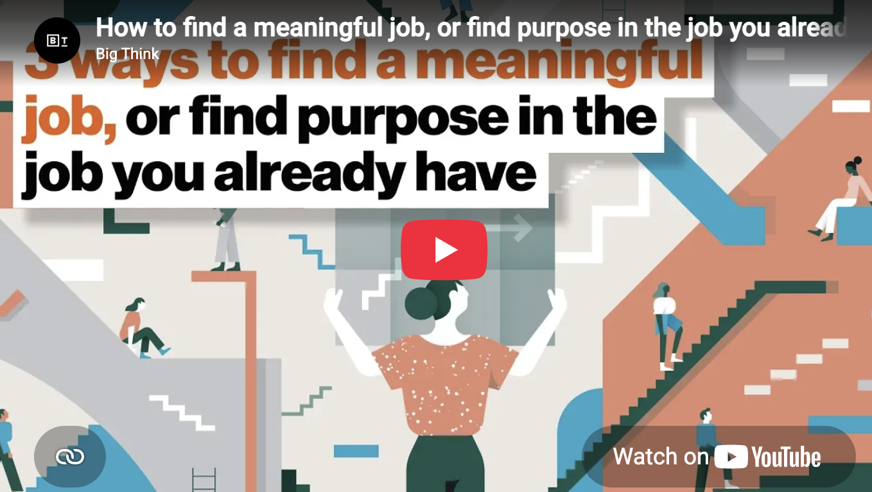

https://www.youtube.com/watch?v=H54vh7UI3_I

Video Transcript:
Remove time stamps
There's a lot of talk about purpose: What is your purpose as an individual?
0:06
And, really, it puts a lot of pressure on us to figure out what is our purpose, a sort
0:11
of grandiose idea.
0:12
And it's scary to enter that.
0:14
What we've found, actually, in studying individual purpose is that it's much simpler than that,
0:19
especially as you get started on that journey.
0:21
And I just want to share with you one question for you to really reflect on to help you think
0:25
about how to make purpose more accessible to you.
Elevation of Meaning
0:29
What we've seen in our research is that we're wired to find meaning in different ways at
0:33
work.
0:34
We don't all get a sense of purpose from the same things.
0:36
And that doesn't mean different causes.
0:38
It actually has to do with the elevation of meaning in your work.
0:42
So let me explain what that means.
0:43
For about a third of the population, they get the most meaning at work when they can
0:47
directly see their work impacting other people.
0:49
They need to have that visceral sense that their work actually made an impact in someone's
0:53
life.
0:54
No matter what the impact is, if they don't see that visceral connection, they don't feel
0:58
a sense of purpose.
0:59
Think of a doctor, right?
1:00
A doctor sees patient after patient.
1:02
If they didn't get a sense of meaning from each patient, that job wouldn't be fulfilling.
1:06
It wouldn't be one that they would find purpose in most likely.
1:09
I think of myself.
1:10
I actually asked my doctor once, you know, "How the hell do you listen to person after
1:13
person come in with the same issue after the same issue?
1:16
Don't you just want to be like, look, I've already seen this one before.
1:18
Go see another doctor.
1:19
I've already treated this issue."
1:20
And he said, "No, actually, I see each person as like a unique opportunity to make an impact."
1:25
So for about a third of people, that is the primary lens for thinking about impact.
1:29
And you don't have to be a doctor to do that.
1:31
There's a lot of ways for that to show up.
1:32
It could be your co-workers.
1:33
It could be customers.
1:35
It could be clients.
1:36
There's a lot of ways to think about how to make that direct impact.
Organizational Meaning
1:39
We then have about a third of the workforce who gain much more meaning from working at
1:43
an organizational level.
1:44
They say, it's great to help people, but, ultimately, I want to build a more sustainable
1:48
impact by helping build teams, to build organizations, to build institutions that can make a longer,
1:54
sustained impact on the world.
1:55
And when I see, you know, helping a given patient, you know, that's meaningful, but
1:59
I'd rather help 1,000 doctors serve a million patients and be part of that equation, and
2:04
that's what's really going to get me fired up.
2:06
Whereas a person at that individual side might be like, "That that sounds like bureaucracy.
2:09
Why would you want to be in medicine and be a hospital administrator?
2:12
That sounds like torture."
2:14
But to the person who's driven by that organizational change, that is exactly where they need to
2:18
get that meaning.
Team Meaning
2:21
For people who really get a lot of meaning from that organizational team level, there's
2:25
so many ways to do that.
2:27
But at the core, it's about building teams, building organizations.
2:29
And you can do that in any industry.
2:31
You can do it as an athlete.
2:32
You can do it as a doctor.
2:33
You can do that, you know, inside a startup.
2:35
You can do it inside a large company.
2:36
You can do it in government.
2:38
There's so many ways to be part of taking the few and turning them into the many.
Society Meaning
2:43
The final elevation when it comes to purpose is what we call at a societal level.
2:49
Some people say it's great to help a patient, they definitely need it.
2:52
It's great to build hospitals, and we definitely need hospitals.
2:55
But at the end of the day, if we can't reduce the cost of health care, if we can't address
2:58
cancer, if we can't address some of the systemic issues, are we really moving the needle?
3:02
I need to see -- even if it's in a very small way -- I need to see that my work rolls up
3:06
to something bigger than any one person or organization.
3:10
And this doesn't have to be about solving climate change or addressing world hunger,
3:14
it could just be about bringing the latest trends in your industry into your organization
3:17
or helping to advance trends in your industry.
3:19
It can be about things that are simply connecting what you're doing to something bigger than
3:24
any one person or organization.
3:26
And for this person, which is, again, about a third of the workforce, they need to see
3:29
their work that way.
3:31
What's interesting about these three elevations of impact is they enable us to find meaning
3:35
in any job if we approach it the right way.
3:38
And it shows how accessible purpose can be when we take responsibility for it in our
3:42
work and start to think about, OK, I'm an organization-level person.
3:45
I'm in this job.
3:46
How do I optimize around that?
3:48
And as I reflect on my work, how do I look for examples of how I'm making that impact?
3:53
Whereas the person who is individually driven might be doing the same job, but looking for
3:56
different signals and appreciating and having gratitude for different things.
Hierarchical Meaning
4:00
And that's not to say also that purpose is hierarchical.
4:02
What we found is that there are people who start their career at a societal, individual,
4:06
or organizational level, and they generally stay in that level.
4:08
It's not a question of going from individual, to org, to society; it's not a graduation
4:12
process.
4:14
That's actually how we're wired.
4:16
Where we find meaning actually ties back to the patterns that we see in the world, how
4:20
our brain works, the level of intimacy and connection that we want with people based
4:24
on our profile and a lot of other variables that actually are why we gain meaning from
4:28
one thing, where someone else doesn't.
4:30
So I encourage everyone to take a few minutes and really just reflect on what elevation
4:35
do you find the most purpose at?
4:36
I'm sure you find meaning at some level on all three levels, but where do you find the
4:40
most meaning?
4:41
Redesign your identity and your job around that.

While watching, please make some notes in your learning journal about:
- Aaron Hurst identifies "individual, organisational and societal connections which drives a sense of purpose at work." Can you define these three driving levels or elevations of meaning?

My notes:
Individual level – Making an impact person by person in a unique and intimate way.
Organisational level – Making an impact by building organisations that can have a sustained impact at a larger scale.
Societal level – Making an impact by addressing meta issues that impact society systemically. Patterns, trends, policy.

Step 2: Access the following reading and refer to it as you complete the journal activity.

Finding Meaning at Work, Even When Your Job Is Dull.pdf

Article Notes:
Hansen & Keltner (2012), "Finding Meaning at Work, Even When Your Job Is Dull" — HBR
Core premise: Meaning at work isn't the same as "meaningful work" — the latter refers to the task itself, but meaning can come from many other sources beyond the actual content of what you do. Drawing on organizational behaviour and psychology literature (need-based, motivational, status, power, community theories), the authors identify eight sources of meaning, grouped into four categories:
Purpose
- Contributions beyond yourself — feeling your work helps others or serves a broader mission (e.g., Kiva's micro-loans). Most jobs lack an obvious social mission, but even ordinary companies (e.g., Danone reframing itself around "healthy foods") can infuse some purpose if employees genuinely feel their work benefits others.
Self-realization
- Learning — work as a vehicle for skill acquisition and personal growth (e.g., MBA grads flocking to McKinsey/GE for the training)
- Accomplishment — pursuing mastery and being recognized for it drives satisfaction, confidence, self-worth (e.g., the sushi chef Jiro's pursuit of perfection — intrinsically meaningful even without a grand social mission)
Prestige
- Status — the social credibility that comes with a job title/employer name; provides worth and recognition for some people
- Power — the ability to acquire and exercise power/influence is meaningful for those drawn to it (referencing Lawrence & Nohria's Driven)
Social
- Belonging to a community — the workplace as a source of friendship and connection, especially valuable in a society where other community ties are eroding (e.g., Southwest Airlines' culture)
- Agency — feeling your ideas are heard and your contributions genuinely affect outcomes; real involvement in decisions creates meaning
- Autonomy — freedom from being told what to do, and control over your own work (citing Dan Pink's Drive) — a major draw for people who start their own businesses
Key takeaways:
- Different people are drawn to different sources — there's no universal hierarchy
- More isn't necessarily better — deeply experiencing even just one of these can be enough
- The real problem is experiencing none of them — that's when work feels empty

Relevance to your coursework: This is a nice complement to SDT — autonomy and agency map directly onto SDT's autonomy need; belonging maps to relatedness; learning/accomplishment maps to competence. But this framework adds dimensions SDT doesn't fully cover — status, power, and purpose/contribution beyond yourself — which could be useful if you want to show a broader view of motivation sources beyond SDT alone in Assessment 3.

Definition:
Meaning at Work
A persons experience of something meaningful, something of value, that work provides.
That is not the same as “meaningful work” which refers to the task itself.

Based on the reading, answer the following:
- In your own words, define meaning at work.
My notes:
Where a job/role/company provides purpose and fulfilment.
- Define the following terms as they are explored in the reading: purpose, self-realisation, prestige and social.
My notes:
Purpose – Contributions beyond yourself
Self-realisation – Learning and accomplishment
Prestige – Status & power
Social – Belonging, agency and autonomy
- Based on these factors that you’ve explored, what drives your meaning at work?
My notes:
I am driven by self-realisation and prestige.

Thanks for completing Michael Steger’s work and meaning inventory. Share your score in text box below and add whether you feel the score is an accurate reflection of your meaning at work. In sharing your response, please reflect on the Big Think video by Aaron Hurst. Which level (individual, organisational or societal) drives your purpose? You will also be able to see your peers' responses.

Assessment 3
This final activity will help you engage and build your critical reasoning skills as well as your deep knowledge of the topic, which will assist you in completing your third assessment.

Step 4: You’ve done a lot of reading about money and meaning as they apply to work.

A criticism of traditional performance management systems is that they are too focused on a transactional framework and lack an authentic appraisal of the employer-employee relationship. This was touched on in the further reading in Activity 2 in which Deloitte offer a suggestion around performance pay changes based on a shift to more authentic and informal performance management systems.

Choose a topic below and write approximately 100 words. In your post, state your choice of either question one or two.

How can performance management systems and the elements within them appropriate meaning over transactions?
My notes:
Shifting the purpose of performance management from evaluative to developmental as the foundational layer to meaning over transactional. This would immediately shift PM to forward looking and growth focused.
Incorporate SDT to satisfy employee’s psychological needs by supporting autonomy, competence, and relatedness.
Include meaning-based assessments such as Michael Steger’s work and meaning inventory to asses whether employee’s are finding meaning in their work.
Replace annual transactions with frequent, human dialogue where conversation can be about meaning rather than scores.

Week Five

Week 5 introduction

Work design
"My baby takes the morning train.
He works from nine to five and then
He takes another home again
To find me waitin’ for him."

Goodness, how times have changed since Sheena Easton released her 1981 hit, '9 to 5 (Morning Train)'!
This week we explore the concept of work design (also known as job design). As part of this, we explore the job characteristics that are conducive to employee performance, with a particular focus on flexible work and autonomy as drivers of employee productivity.

Learning objectives
After completing the tasks this week, you should be able to:
- explore the concept of work design
- examine the impact of work design elements on employee performance outcomes
- explore the job demands and resources across different sectors
- explore the issue of underperformance.

5.1 Introduction to work design

Purpose
This activity will introduce you to the concept of work design.

Some context before you begin

Work design, also known as job design, is a classic HRM concept, and most textbooks dedicate a highly detailed section to the topic. Arguably, one of the problems of such an established and largely theoretical concept is that it can lack practical meaning.
However, as we are about to explore, work design can be highly practical and, indeed, provides the foundation for exploring how the particulars of a job (e.g. where it happens, for how long, how regularly, involving which tasks) can be crafted to shape particular positive or negative work outcomes.
Positive outcomes are things like employee engagement, performance, work-life balance, career satisfaction and well-being. Negative outcomes include things like work stress, work-life conflict, poor physical and mental health outcomes, etc.

Step 1: Read the following article by Parker et al. (2017):

One hundred years of work design research. Looking back and looking forward.pdf

Article notes:
Parker, Morgeson & Johns (2017), "One Hundred Years of Work Design Research: Looking Back and Looking Forward" — Journal of Applied Psychology's 100th anniversary review
Purpose: A "big picture" retrospective on the entire field of work design research, mapping how it evolved, assessing the Journal of Applied Psychology's (JAP) role, and evaluating the field's broader impact.
The Five Historical Perspectives (identified via scientific/citation mapping)
- Sociotechnical Systems & Autonomous Work Groups (1950s onward) — sparked by Trist & Bamforth's (1951) coal mining studies. Found that replacing self-managing, multiskilled small teams with mass-production "longwall" mining methods caused psychological and social harm — showing work design itself (not just individual factors) causes sickness/dysfunction. Led to interest in autonomous work groups/teams.
- Job Characteristics Model (JCM) (Hackman & Oldham, 1975/1980) — the most dominant, highly-cited perspective. Identifies five core job characteristics (skill variety, task identity, task significance, autonomy, feedback) that drive motivation, satisfaction, and performance. Rated by expert judges (Miner, 2003) as one of only eight OB theories simultaneously high in scientific validity and practical usefulness.
- Job Demands-Control Model (Karasek, 1979) — focused on health/strain rather than motivation. Core claim: high demands + low control = highest strain; control buffers the negative effects of demands. Karasek & Theorell (1990) later added social support as another buffer.
- Job Demands-Resources (JD-R) Model (Demerouti et al., 2001) — extended Karasek's model by broadening "resources" beyond control/support (e.g., rewards, security) and adding a dual-path structure: demands primarily drive strain/burnout (health impairment path), while resources drive engagement/performance (motivational path). Widely applied but criticized as more descriptive than explanatory — it doesn't say why these relationships hold, and needs borrowed theories (SDT, Conservation of Resources, Social Cognitive Theory) to explain mechanisms.
- Role Theory — traces to Kahn et al. (1964) on role conflict/ambiguity/overload as distinct stressors, predating Karasek. Later expanded via job crafting (Wrzesniewski & Dutton, 2001) — the idea that people actively reshape their own roles to create meaning, and role orientation/proactivity research (Parker), showing autonomous job design promotes flexible role-taking and better performance.
Key Argument
The authors note these five clusters are historically distinct but "convenient rather than substantive" — meaning the boundaries between them are more a product of academic history/citation patterns than genuinely separate phenomena. They call for more integrative, multilevel models that bridge individual-level theories (JCM, JD-C, JD-R, role theory) with team/system-level theories (sociotechnical systems).
JAP's Role & Broader Impact
- JAP has published a disproportionately influential share of foundational work design articles (6.4% of articles, but ~19% of citations)
- Work design research spans far beyond psychology — nursing, ergonomics, economics, engineering, industrial relations, sociology (17,000+ articles across disciplines)
- Nearly half of recent Harvard Business Review articles had work design relevance, even without using the term explicitly — showing the topic's practical reach, even if not always labelled as such
Future Directions Proposed
- More multilevel research connecting individual, team, and organizational levels
- Better attention to social, relational, cognitive, and physical aspects of work (not just traditional "motivating" characteristics)
- Considering curvilinear effects — e.g., Warr's (1984) "vitamin model": some traditionally positive job characteristics (like complexity) show diminishing or even negative returns at very high levels
- Addressing contemporary changes: electronic monitoring, emotional labor, remote/virtual work
Closing note: The paper ends by echoing a 1917 quote from JAP's very first issue calling for work to preserve human dignity ("every man should be more of a man... for having worked a day") — bookending the article with the field's century-long moral purpose.

Relevance to your coursework: This paper gives you the job design half of the puzzle to complement everything you've read on performance management. It connects directly to your JD-R references (in the Job Demands-Resources chapter you likely also have) and gives historical grounding for concepts like job crafting and autonomy that keep recurring across your SDT/motivation material — useful for showing breadth in Assessment 3 if you want to argue traditional PM frameworks fail partly because they ignore how the job itself is designed, not just how it's evaluated.

Step 2: Create a new journal entry and complete this task.

Drawing from the paper and/or further internet searching, complete the following tasks:
- define the term ‘job characteristics’

My notes:
Skill variety, task identity, task significance, autonomy, feedback. Aspects of a job.

- define the job demands-resource/control model

My notes:
Focusses on health vs strain rather than motivation. It claims high demands + low control = highest strain. Whereas control buffers the negative effects of demands.

- How has work design impacted management thinking?

My notes:
It has shaped how managers think about talent, engagement, flexibility and org structure.
Definition:
Job Characteristics
(Hackman & Oldham’s Job Characteristics Model (JCM)) The specific design elements of work that drive motivation, satisfaction and performance.
1. Skill Variety
2. Task Identity
3. Task Significance
4. Autonomy
5. Feedback

Feedback
Well done! You just absorbed a chunk of scholarly material focused on work design. The material, while important, is not overly practical. In the next activity, we launch from this one to explore the job demands-resources model in more detail.

5.2 Job demands and resources

Purpose
We will gain practical insight into work design through the lens of the Job Demands–Resources Model (JD–R).

Task
Step 1: To get started on this topic, read through the slides below.

Accessible Interactive Instructions: Use the arrow keys to navigate between slides. After selecting a slide, use the Tab key to move to the slide content.

Slide 1 of 3
Some of us work in shifts, sometimes at night; some of us work underground, or our work is mostly conducted in dark settings; others of us have to sit for hours on end, behind a computer; others of us are bound to the seat of a car or a truck as we drive around, making deliveries for customers; and some of us need to stand for hours on end, delivering classes to school children, chasing after toddlers, or doing the rounds on patients of elderly residents.


Slide 2 of 3
How is it possible to compare all of the types of physical or knowledge-based roles that make up our labour force?

Moreover, how can we cater the work environment so that irrespective of whether the job is based in a vehicle, a house, an office, a ward, a street etc., it is conducive to performance?


Slide 3 of 3

The answer to these questions is the Job Demands-Resources (JD-R) model.
The JD-R model is a framework that allows us to examine work, whatever form that might take, and examine whether physical, emotional and cognitive demands of the job are balanced out by organisational, managerial and individual resources local to the worker.
Demands are those things that, left unchecked, drain or deplete the ability of an employee or worker to perform at their job.
Job resources are those things that mitigate the strain caused by work demands, or provide energy or capital to overcome the strain.

Step 2: Now that we have touched on the idea of job demands and job resources, let's check that we are clear with the concepts. Read over the below scenarios in the blue boxes then drag them to match either a job demand or job resource.
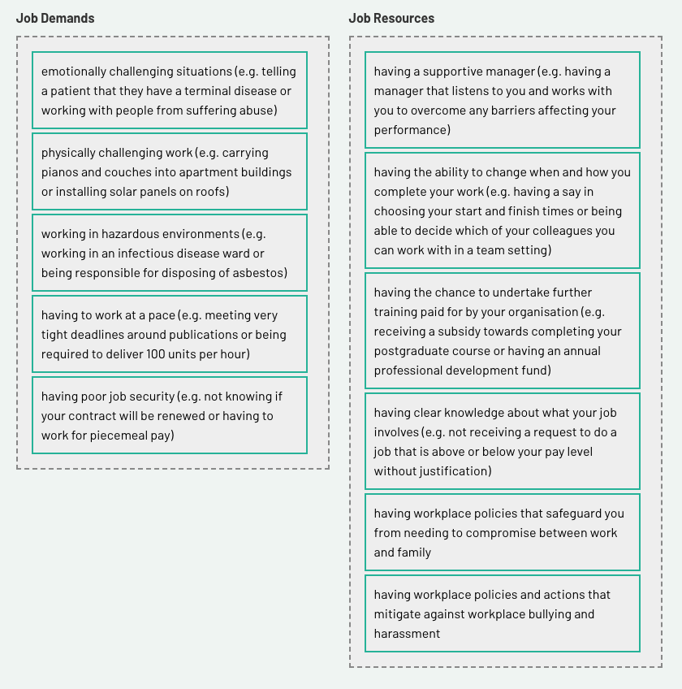

Step 3: Thinking about your work history, what examples of job demands have you experienced that you would like to share? Add them to the question box below.

Step 4: Create a new journal entry for this activity.

Choose any job demands from the list above, bearing in mind this will be a growing list, and add them to your journal entry along with your ideas of what may serve as mitigating job resources.

My notes:
Additional customers to manage – Additional resources that could buffer that demands of managing more customers that initially required in a job role could be; travel compensation or a work vehicle to visit more customers, additional pay given the extra responsibility, tools to manage more customers such as digital systems.

Feedback
Good work! You’ve correctly identified job demands and resources. As you were progressing, did you realise that if some things that are a job resource weren’t available, a demand would be there instead? For example, if instead of having a supportive boss, you had a boss that bullied, surveilled and micromanaged, you would be detracted from your ability to perform.
There are no hard and fast rules about what a demand is and what a resource is—it can be subjective. There are some cases where an individual might have a resource that helps them from considering something present in their work context as a demand. In our next activity, we’ll explore how demands and resources are measured.

5.3 Doing more with less

Purpose
In this activity, the JD–R model is explored against the backdrop of contemporary workplace logic, which centres around doing more with less.
The impact of this logic on the diminished potential for employee performance and worse is explored. You will also explore the COPSOQ tool for JD–R accountability, so you will be able to administer or interpret results using the tool.

Task

Step 1: Have you ever heard your boss or their boss talk about the need to do more with less?
This is a commonly touted phrase in workplaces, and some of you have probably heard it at least once this week or perhaps just once this month. The first task for this activity is for you to think about the last time that you heard someone use this phrase in a workplace context and share a description of what they were referring to when using the phrase (without identifying them, with an air of respect and without judgement).

Step 2: What can be the cost of doing more with less? Read through the slides below.

‘Doing more with less’
Slide 1 of 6
This is a phrase that has become particularly, but not exclusively, synonymous with working in the public sector. Indeed, the phrase is not new – is has increased as a workplace ‘logic’ (i.e. a dominant framework for how things get done) since the 1970s, and was particularly influenced by Thatcherism and subsequently, neoliberalism.
Thatcherism, from the British Prime Minister – Margaret Thatcher, believed in ‘small government’ – and that the role of the public service was to be as absolutely lean as possible; should people wish to pull themselves up from the bootstraps, that was on them.
Neoliberalism is a broader ideology, also strongly associated with former American President Ronald Reagan, which touts that as the private sector is much more efficient than the public sector, the role of governments should be to outsource or privatize as much as possible, so as to provide value.


Slide 2 of 6
You’re probably wondering what this has to do with rewards and performance… don’t worry – we’re nearly there!
‘Doing more with less’ become such a popular logic in the public sector, it developed its own name – called ‘New Public Management’ (you might want to google it if you ever do an assignment looking at work motivation in the public sector).
New public management is the deliberate under-resourcing of public sector departments and services, by senior managers, bureaucrats and Governments. Because the public sector cannot generate more profit (it is by definition not-for-profit), its only ability to remain efficient is to reduce input costs. Thus, public sector departments and organisations are often subject to efficiency targets (where budget inputs are reduced each year), or regular program cuts.
It might be fair to say that there is a motivational logic that sits behind this, something akin to ‘treat them mean, keep them keen,’ – a kind of misguided managerial thought that by underfunding operations, you essentially motivate employees to work harder to achieve workplace goals. Of course, the evidence does not support this – and instead forcing employees to work in circumstances where they are under-resourced is just likely to make them stressed.

Slide 3 of 6
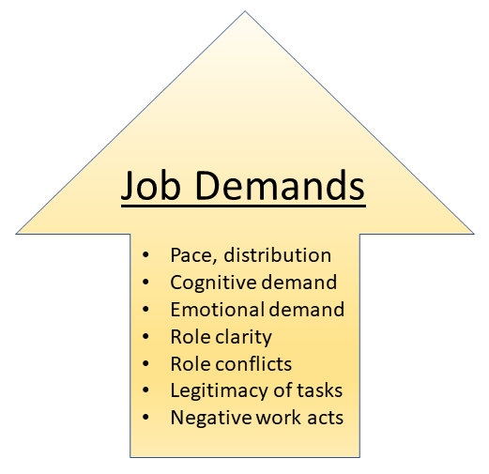
When employees are asked to ‘do more with less,’ their demands increase.
Generally, this means that they have to work at a faster pace across more functions, having to undertake tasks with a higher level of cognitive or emotional demand.
Being spread across multiple roles (perhaps to fill in for staff who have left, or can’t be re-hired), creates unpredictability, and issues with what one’s role actually entails.
Staff are asked to compromise and prioritize (unreasonably), thereby creating conflicts as to which task needs to be undertaken first. Having worked with this level of intensity, staff may also be asked to undertake illegitimate tasks (those which are beneath their pay grade, or a poor use of their time). Given a climate of austerity and the flow-on effects of stress, staff may also be bullied, manipulated, or coerced into doing work – all classic ‘negative work acts’, which over time, degrade mental health.

Slide 4 of 6
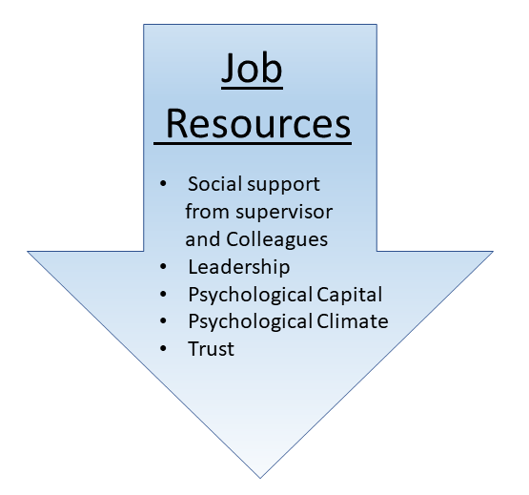
When staff are asked to ‘do more with less,’ they may be provisioned with less tangible and intangible resources, and not receive pay commensurate with their work.
Moreover, they may not receive any social support from their supervisor or colleagues (who may also be too stretched to provide support). Leaders, being constantly stressed at working without the necessary resources, may be tired, lacking inspiration and the necessary strategic capability to drive better outcomes for employees.
Employees might lose their ability to cope, with lower levels of resilience, hope and optimism ensuing. There may be a curt psychosocial climate, where people’s personal wellbeing is not a priority. And there may be low levels of trust, as the appetite for any risk is so low, employees are encouraged to stay within very strict lines of control.

Slide 5 of 6
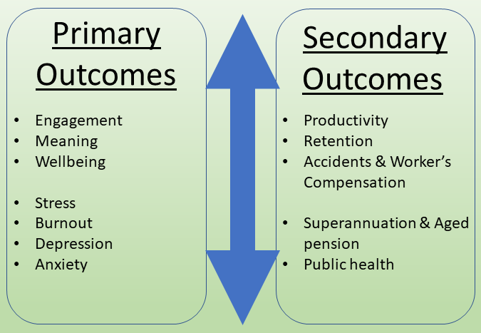
Over time, if employees are forced to work continuously in a climate of ‘doing more with less,’ very negative health and wellbeing outcomes can ensue.
The method (doing more with less), which was meant to boost overall financial performance, will begin to have the opposite effect, and end up costing (potentially lots).
The individual, primary impacts on employees can range from reduced engagement at work (drive, energy, flow), a loss of meaning, and low wellbeing. Increased exposure to cognitive stress can start to take physical hold in the body, reducing one’s ability to sleep, increasing their blood pressure and heart rate. People can suffer burnout, and have negative mental health outcomes.
Over time, people will want to leave, and this can create further costs trying to source replacement (particularly for fairly undesirable roles).

Slide 6 of 6
When these negative outcomes happen on masse, it starts to affect economic-wide productivity (think of the aged care sector; or the healthcare sector during the COVID pandemic).
In turn, this economically depressed sector starts to affect other sectors (remember how hard it was to book a doctor’s appointment during the pandemic? Everything became stretched).
Working under these conditions increases workplace risks, and potentially accidents also – which can have further costs associated with workers compensation.
When people en masse aren’t receiving sufficient income for their role, they also aren’t receiving sufficient superannuation – and this increases collective economic burden for all, down the line. Such people, unable to pay for their own healthcare owing to the poor pay they received while working, and the relative strain of their work history, means that the cost and duty associated with providing healthcare to such people, falls to the public.

Step 3: Well done! You have just read through a very long section of text that describes, step by step, the impact of doing more with less. The text was important to read for understanding that an employee’s performance at work to be true and fair needs to account for the job demands and resources that they are exposed to.
To solidify this learning, your next step is to personalise it. Your task is to reflect on a work context that is familiar to you and talk about your performance (good or bad) and the kinds of demands and resources that have shaped that experience for you.

Feedback
Review your peers' discussion board posts to help broaden your awareness of demands and resources in today's work environment.

5.4 Measuring job demands and resources

Purpose
This activity introduces you to a conceptual and measurement framework to examine work design issues in practice.

Some context before you begin

Most of us who have worked in corporate environments have been exposed to workplace culture surveys. For some of us, we receive an anonymous link once or twice a year to an online survey by a third party or our manager and go through the 15–20-minute process of answering questions about how we feel about our current work environment, rating our feelings on a Likert scale.
Workplace culture surveys are affiliated with performance management systems, particularly in high-performance work environments (i.e. where there is a lot of pressure on employees to deliver), and are common models used in financial, professional, public administration and other corporate settings. Indeed, sometimes results of these are reported against leaders' and/or managers' performance appraisals. But they are also used to get insight into what might be stifling employee productivity and performance.
We are going to do a deep dive into a freely available workplace culture survey in the activity below. You will read some information about a culture survey package and then review the questions used in the free survey.
Finally, on the discussion board, you are going to share an example that you see, where questions used in this survey might be similar to ones you have been exposed to in your professional working life.

Task
Step 1: The COPSOQ is used for researching and assessing psychosocial conditions and health promotions at workplaces.

Access the COPSOQ III network guidelines and questionnaire Skim through the document to get an idea of its contents. You will refer to it in the next step.

Article Notes:
COPSOQ III — Guidelines and Questionnaire (Copenhagen Psychosocial Questionnaire), International COPSOQ Network (2019)
What is COPSOQ?
An international, standardized instrument for assessing and improving psychosocial working conditions — developed by Tage Kristensen & Vilhelm Borg at the Danish National Research Centre for the Working Environment (1995–2007), now coordinated globally by the International COPSOQ Network.
- Widely used and validated: cited in hundreds of indexed journal articles, referenced by the WHO, ILO, and recognized as good practice by the EU Occupational Safety and Health Agency
- Available in 25+ languages, enabling cross-country comparison
- Theoretically integrative — operationalizes multiple established work environment theories in one tool, including demand-control-social support, effort-reward imbalance, job demands-resources, work-family conflict, social capital, the vitamin model, and sociotechnical systems theory (i.e., it draws together most of the theories from the Parker, Morgeson & Johns paper you just read)
- Generic — usable across any industry, sector, or workplace size, and allows benchmarking against general population reference values
Structure
Three versions, all built from a shared item bank:
- CORE items — mandatory in every national version, ensuring international/longitudinal comparability
- MIDDLE and LONG items — added depending on version length
- Short/Middle versions — for workplace risk assessment and organizational development (can also be used for research)
- Long version — primarily for research, allows deeper national adaptation
National teams adapt and validate their own country's version but must always include CORE items and should maintain only one validated version per country/language.
Guidelines for Use as a Workplace Risk Assessment Tool
1. Preventive/health-promoting purpose — it exists to identify and reduce psychosocial risk, not just measure it. Results should drive real organizational change.
2. Full participation — management, worker representatives, and staff must be involved at every stage (design, implementation, monitoring). Worker participation isn't optional — the tool's validity depends on genuine buy-in.
3. Anonymity and confidentiality — strictly mandatory; all data must comply with privacy/legal/ethical standards.
4. Non-modification — the wording and structure of the validated national questionnaire cannot be altered; CORE items must always be included as-is.
5. Ten "soft guidelines", including:
- Never start an assessment without genuine intent to act on results
- A response rate below 60% may signal lack of worker engagement
- Employees have the right to see and discuss results they contributed to
- No standard, one-size-fits-all solutions — interventions must be participatory and context-specific
- Distinguish clearly between what can and cannot be changed
- Repeat the survey 1–2 years after interventions to check if improvements were actually achieved
- Treat results as a tool for dialogue, not a verdict
- Position the whole process within a learning organization / continuous organizational development mindset
Guidelines for Research Use
- Must respect the exact wording/scoring of the validated national version
- Researchers should cooperate to avoid creating competing, non-validated versions in the same language/country
- Otherwise governed by standard human-subjects research ethics (e.g., European Charter for Researchers)

Relevance to your coursework: COPSOQ is a strong, evidence-based bridge between your PM/appraisal material and the JD-R and work design literature — it operationalizes the psychosocial risk side of JD-R (Schaufeli & Taris) directly into a practical measurement tool. For Assessment 3, it's a useful example of an alternative to traditional performance appraisal: rather than individually rating people's output, COPSOQ assesses the systemic, organizational conditions (job demands, control, support) that shape wellbeing and performance — a structural, participatory model rather than a top-down evaluative one.
Step 2: Create a new journal entry page.

Use the COPSOQ to answer the following questions:
- Define the term ‘psychosocial risk factor'.
My notes:
Something that exists in the work environment that poses a risk to an employee’s psychological health.
- What work environment theories are covered through COPSOQ?
My notes:
JD-R
Demand-Control, Social Support
Effort-Reward Imbalance
Work-family Conflict
The vitamin model
Sociotechnical Systems Theory
- What is the substance of the anonymity clause? Why is it important?
My notes:
Anonymity and data confidentiality must be guaranteed for workers active participation.

Step 3: Did any of the items in the COPSOQ question set appear familiar to you?

5.5 Comparing job demands and resources across different contexts

Purpose
This activity examines job demands and resources across different sectors.

Task
Step 1: People at Work is a tool and resource provided by the Queensland government for undertaking a job demands and resources analysis of different workplaces. This resource and tool is loosely based on COPSOQ, though scales that provide indicative measures of mental health are added to the COPSOQ questions, and provide a more detailed examination of workplace bullying.
The tool is available at https://www.peopleatwork.gov.au/
Step 2: In 2016, People at Work did a job demands and resources (psychosocial risk) audit of different workplaces across Australia.
The report is available at https://www.worksafe.qld.gov.au/__data/assets/pdf_file/0014/12317/paw-report.pdf
Open the People at Work report. Undertake the following actions:
Read the executive summary.
Read pages 67-69, the industry comparison, paying particular attention to Table 8.1.
Source: People at Work. (2016, May). Table [Image]. Work Safe QLD. An assessment of psychosocial hazards in the workplace. https://www.worksafe.qld.gov.au/__data/assets/pdf_file/0014/12317/paw-report.pdf

Step 3: From Table 8.1 above, select three findings that were surprising to you. For example, one finding might be the scores for emotional demands held by those in education and training and those in health care and social assistance were high. Likely, this is because of the degree of complex human interaction involved in these settings.

Discussion board
Post your three interesting findings and associated analysis (approximately 100 words in total).
Please answer why you think these scores have occurred.
Step 4: Scroll through submissions by your peers and comment on at least one other post that you found interesting.

Feedback
Good work! It might have seemed a bit tedious, but having access to a validated tool for assessing job demands and resources and workplace culture is a pretty handy thing to have, particularly when it is free. The last set of tasks that we are going to do before closing the topic of job demands and resources, is to review the COPSOQ in action.

5.6. Underperformance

Purpose
The activity explores the causes and solutions to employee underperformance.

Task
Step 1: What causes employees to underperform? To begin to unravel this question, let's take a look at three keywords that are easily associated with underperformance.
Click on each keyword to learn more.

Definitions:
Underperformance
We can consider two dimensions.
First, an employee can underperform because the quality or volume of their output is not up to standard.
The second dimension, which may or may not relate to the first, occurs when an employee’s work behaviour is not deemed appropriate. It may be, for example, that they have gone to work under the influence of alcohol or drugs or have sent inappropriate communications to colleagues or clients.

Blame
Generally speaking, we have traditionally put all of the blame for underperformance on the employee themselves.
Sometimes, this is appropriate, particularly when employees have operated under the second dimension of underperformance with the intention to derive a negative outcome for a workplace.
However, incompetence, which is more frequently associated with the first dimension of underperformance, is often not intentional.

Incompetence

This is the state whereupon an employee lacks the necessary skills/ability, motivation or opportunity to generate the desired outcome.
The Fairwork websiteLinks offers the following reasons as causes of incompetence:
- the employee doesn’t know what is expected of them because goals and standards are unclear
- the employee may not have the knowledge or skills to do the job
- the employee is unsure if they are meeting the requirements
- low personal motivation or confidence
- personal issues, such as family stress, physical and/or mental health problems or problems with drugs or alcohol
- low morale in the workplace and/or a poor work environment
- interpersonal differences or cultural misunderstandings
- workplace bullying.
The website offers helpful advice on how to address underperformance with staff in a way that fits legislation.

Step 2:We will use the Fairwork website as a helpful resource for managing underperformance.

- Click on the managing underperformance Links to an external site. page on the Fairwork website.

FWO Templates

- Identify the six considerations that need to be put into place before dismissing an employee for underperformance.
My notes:

- told them the purpose of performance meetings in advance and allowed them to prepare
- told them they could have a support person present
- clearly outlined the expected level of performance and the improvement that was required
- clearly warned them that their performance needed to improve
- gave them time and support to improve their performance
- told them that they may be dismissed if their performance didn’t improve.

Step 3: From our earlier activities this week, we have seen cases where organisations may be placing significant cognitive strain on employees and, at the same time, expecting them to perform. To explore this further, access the following reading:

Overloaded Circuits. Why Smart People Underperform.pdf

Article notes:
Hallowell (2005), "Overloaded Circuits: Why Smart People Underperform" — HBR
Core concept: Attention Deficit Trait (ADT) — a newly identified, purely environmentally-caused condition (unlike ADD, which has a genetic basis). ADT is brought on by chronic brain overload from modern work demands — constant multitasking, interruptions, and information overload. Symptoms: distractibility, inner frenzy, impatience, difficulty organizing, prioritizing, and managing time.
The neuroscience:
- The frontal lobes handle executive functioning (decision-making, prioritization, planning) — this works well under normal conditions.
- Beneath them, deep brain centers govern survival instincts and basic emotion. When overload hits — too many decisions, interruptions, unresolved tasks piling up — the brain treats it like a physical threat (a "tiger"), triggering fear and panic.
- This shifts control from the rational frontal lobes to the primitive survival brain — impairing flexibility, humor, creativity, and nuanced thinking exactly when they're needed most.
- Fear, not any diagnosable disorder, is identified as the most dangerous factor undermining performance.
Critical management failure: Organizations tend to view ADT symptoms through a moral lens — seeing struggling employees as weak or deficient, rather than recognizing a real neurological response to an overloaded environment. Hallowell describes a client with stellar performance reviews who was told to resign when he admitted he was overloaded — he later thrived elsewhere.
Case study — university chemistry department: A toxic, isolated, no-help culture led to a graduate student's suicide, explicitly blaming the department. After the tragedy, leadership responded structurally: multiple supervisors instead of one, biweekly social gatherings, redesigned open office space, mental health education, and confidential support. Result: performance stayed excellent, and the culture became far more humane.
Practical solutions offered
1. Promote positive emotions / human connection
- Fear-free environments where colleagues trust and connect activate brain pathways that support executive functioning, even under stress
- Isolation worsens ADT; regular face-to-face "human moments" (every 4-6 hours) counteract it
2. Take physical care of your brain
- Adequate sleep (rule of thumb: can you wake without an alarm?)
- Diet: stable blood glucose via complex carbs/protein, not sugar/white flour; omega-3s, multivitamins, moderate alcohol
- Exercise: boosts BDNF/NGF (brain health chemicals); even a quick walk resets focus
3. Organize for ADT
- Break large tasks into smaller ones
- Keep a clear workspace section
- Block off distraction-free time; set specific "email hours"
- End each day with a max 5-item priority list for tomorrow
- "OHIO rule" — Only Handle It Once (act, file, or bin — no piles)
- Work with your natural energy rhythms; use fidget tools/movement/music if it helps you focus
4. Protect your frontal lobes
- Slow down; don't rush through incoming information
- Use simple "mind-clearing" tricks when overwhelmed (rote tasks, unrelated writing, tackling the easiest part first) to quiet the panicked lower brain
5. Leaders: match skills to tasks
- Cited example: JetBlue's David Neeleman (who has ADD) openly discusses his weaknesses, delegates accordingly, and encourages managers to fit tasks to people's natural strengths rather than forcing uniformity — echoing the strengths-based approach from van Woerkom & Kroon.
Bottom line: ADT is a real, named, manageable phenomenon — not a character flaw. The most powerful lever for leaders is simply naming it, removing the moral stigma, and redesigning environments (connection, workload structure, skill-task fit) rather than expecting individuals to just push through.

Relevance to your coursework: This connects directly to your work design material (JD-R model — demands overwhelming resources leads to strain/burnout) and to SDT (competence — matching tasks to strengths, as Neeleman does, supports rather than undermines motivation). It's also a strong, human counterpoint to purely metrics-driven PM systems: a traditional appraisal focused only on output would likely punish someone struggling with ADT as "underperforming," when the real issue is systemic overload — reinforcing your Assessment 3 critique that traditional PM frameworks often misdiagnose structural/environmental problems as individual failings.

Week Six

Week 6 Introduction

The future of performance management
Goodness! Have we learned a lot or what? Perhaps it doesn’t seem like it, but over the last six weeks we have delved into the world of performance management and rewards, yet we must acknowledge ongoing inconsistencies in practice and theory.
Performance management is important for ensuring that employees are effective and efficient, and, at the same time, there needs to be an appropriate balance of job demands and resources.
We have discovered that rewards, including financial rewards, can motivate, but such rewards can also limit innovative thinking by employees. Over time, this can have a detrimental impact on work outcomes.
We have learned about bias and opportunity and how some people are more able or more likely to perform based on their adherence to company values and image, but that this overlooks some key contributors to performance.
Finally, we have outlined the specific components of performance appraisals and performance management systems.
The aim for this week is to circle back to debates presented in Week 1 and examine in detail how and why performance management is changing.
After completing the tasks this week, you should be able to:
review the breadth of learning in the content and relate it to the final assessment
explore cases of performance management systems that have become more informal and agile
explore the role of performance management in a crisis.

6.1 Bringing it all back home

Purpose
This task encourages students to recap their learning about the changing nature of performance management systems. It provides foundational learning for the comparison of different performance management case studies that occur in subsequent activities.

A recap of performance management
Slide 1 of 3
In the final activities of Week 1, we learned some salient facts. First, the study by Qui et al. (2015) provided some interesting findings. Namely, the authors found that performance appraisals that were evaluatively focused reduced an employee's sense of ownership of results, and they were less proactive.
In contrast, performance reviews that were developmentally focused stimulated proactive behaviour on the part of employees.
Of course, it is easy to conclude from the study that evaluative feedback = bad😞, and developmental feedback = good 🙂.
However, we know that there are very valid reasons for evaluating the performance of employees, and, therefore, not doing this also has drawbacks.

A recap of performance management
Slide 2 of 3
We also read the Harvard Business Review article by Cappelli and Tavis (2016), "The Performance Management Revolution: The focus is shifting from accountability to learning." This was a great article that offered a historical blow by blow of the development and morphology of performance management.
Towards the end of the article, the authors noted that performance appraisals and, generally, performance management systems are becoming more developmentally focused, with the impetus being on regular communication between managers and employees, rather than something that happens once a year.

A recap of performance management
Slide 3 of 3
Finally, we had a go at tackling the heavy reading by Tweedie et al. (2019), "How Does Performance Management Affect Workers? Beyond Human Resource Management and Its Critique."
This paper offered a very detailed and analytical review of performance management as a tool that elevates the power of management and diminishes that of employees and, hence, has a fundamental design issue that makes it rife for workplace problems.
In trekking over these three articles, you should have the complexity and contradictions of performance management fresh in your mind. For a person working in HR or managing staff, performance management, either formal or informal, has very real advantages, such as tracking an individual’s contribution to an organisation, and this can form intrinsic and extrinsic reward pathways.
But, to restate, this can also have the unintended consequence of reducing motivation, particularly when the process is perceived to be unfair.

Task
Step 1: Access the following reading:
6 Ways To Reinvent Your Company’s Performance Management.pdf
Article notes:
Mosley (2020), "6 Ways To Reinvent Your Company's Performance Management" — Forbes
Author's angle: Eric Mosley is CEO of Workhuman (a continuous performance management/social recognition software provider) — so this is a practitioner piece grounded in industry data, not academic research.
Starting problem: Annual raises and lump-sum bonuses barely work — a Workhuman study found any performance/engagement boost lasts only 3-4 weeks. Employee appetite for change is high: PwC found 60% of employees (72% of millennials) want feedback daily or weekly; Adobe found 80% want immediate, in-the-moment feedback.

The Six Strategies
1. Build a foundation of trust through authenticity and positivity
Trust is the precondition for everything else. Citing Joe Hirsch (The Feedback Fix): most people fear feedback because it feels like judgment — reframing it around growth/development, rather than judgment/retribution, makes people more open and receptive. Leaders should model vulnerability (e.g., asking their own team for feedback), shifting the dynamic from hierarchy to partnership.
2. Encourage employees to participate actively in their own success
Give employees tools/technology to proactively engage in real-time conversations about their own work and priorities — ownership over growth, not passive recipients of a verdict. Set goals collaboratively with managers, tied to strategic business objectives — this builds a sense of meaning and connection (citing an IBM study on employee experience).
3. Embrace the "3 C's": Continuous, Crowdsourced, Culturally aligned
Feedback shouldn't be locked into an annual review — it should flow continuously, draw on input from multiple people ("the crowd," not just the manager), and be tied to organizational values/culture, not just individual output.
4. Approach as a coach
Managers should aim to develop people over time, not just direct/evaluate/prove contribution. Hirsch's framing: be a "learn-it-all, not a know-it-all" — approach with humility and curiosity, since coworkers closer to the actual work often see things the manager can't.
5. Make weekly check-ins a top priority
Real-time feedback (as behaviour happens) beats delayed feedback. Data cited: employees with weekly check-ins are 2x more likely to trust their manager, 5x less likely to be disengaged, and 2x more likely to believe they can grow in the organization (Workhuman 2019 survey). Gallup: regular feedback correlates with 14.9% lower turnover risk.
6. Shift from high-stakes/low-frequency to low-stakes/high-frequency conversations
Annual reviews carry heavy stakes (pay, promotion, job security) — this creates anxiety and often means employees learn about a problem months too late to fix it. Continuous, casual, frequent conversations lower the stakes of any single interaction, making feedback feel normal rather than threatening — Hirsch: the best organizations have these conversations so often "they become as normal... as breathing."

Relevance to your coursework: This is a practitioner-level echo of Cappelli & Tavis's industry shift toward continuous feedback, but with more recent (2020) supporting data and a sharper focus on trust and psychological safety as the mechanism — directly complementary to your SDT material (autonomy-supportive, low-threat feedback contexts) and Corduneanu et al.'s point about informational vs. controlling delivery. Good practical-industry evidence to pair with your academic sources in Assessment 3 to show the theory-practice consistency across both literatures.
Step 2: Create a new journal entry.

Answer the following questions:
According to the Workhuman study, how long does the lift in engagement or performance last after an employee receives a raise or bonus?

My notes:
Only 3-4 weeks

What are the features of continuous performance management?
My notes:
Ongoing, frequent, causal conversations, sometimes planned and other times occurring more organically within the flow of work.

Define psychological safety.
My notes:
When an employee feels safe to speak their mind without fear of judgement from others.

Based on the reading, in your opinion, what happens when employees are able to set their own goals against company objectives?
my notes:
Employees feel empowered to have some control over their professional destiny. Employees are invited to understand how their individual contribution impacts the overall company objectives. Which drives meaning and purpose for the employee.

Step 3: In the Forbes article we just read, we learned that managers should start to approach their roles as a coach and opt for weekly check-ins, rather than a yearly formal review.
Consider the question below and add your thoughts to the question box. Click 'Reveal current ideas' to read your peers' responses.
What are some factors that could inhibit managers from adopting a coach-like mentality, and setting up regular, weekly check-ins?
My notes:
Their own personal resource could inhibit them:
- Understanding how to be a Coach instead of a Manager
- Self-belief in taking a Coaching role
- Their own job demands may inhibit the time and flexibility required to move to high-frequency touch points

Step 4: Elaborate on ideas listed in Step 3.

Feedback
Good work! We have spent a bit of time in this activity, massaging your brain's memory pathways and becoming comfortable with some aspects of performance management that remain uncomfortable, contradictory and unresolved.
In the final task, you reflected on some of the realities that inhibit change towards a more agile and responsive performance management system, and you also postulated some ideas on how this may be resolved.

6.2 Cases for changing performance management

Purpose
In this activity, you will explore two cases of organisations changing their performance management systems to be more agile and responsive. Use the cases to help calibrate your attention before your final assignment.

Task
Step 1: We will research a case study. Access the following reading:
A New Approach to Performance Management at Deloitte.pdf

Article notes:
Now I have the correct article. Note: this is actually a different piece than the classic Buckingham & Goodall HBR article — it's the Deloitte-authored companion case study from People + Strategy journal (which appeared as a source in your Tweedie et al. references list too).
Orlando & Bank, "A New Approach to Performance Management at Deloitte" — People + Strategy
The trigger: Partner Rob Massey described his old system bluntly: "1.8 million hours across the firm that didn't fit our business needs anymore" — once a year, looking back and slapping a label on people's work.
The pilot: 2,000 employees in Deloitte's tax business (later scaled to the full 70,000-person organization) trialed a redesigned system for 18 months, built on three components:
- Check-ins — frequent, informal conversations between team leaders and team members about the actual work (not a rigid script — conversations go wherever is most needed: current performance, project challenges, or growth/stretch opportunities)
- Performance snapshots — a reliable, frequent (minimum 4x/year, often 10+ per person) individual performance assessment — a four-question snapshot completed by the supervisor
- Pulse surveys — quick tools for team leaders to assess whether they are creating the conditions for high performance on their team
Philosophy shift — "analog, not just digital": The biggest leap wasn't the technology — it was making performance management fundamentally about conversations. Massey: "Today we're very forward-looking. It's about strengths and real-time communication." Rather than reviewing what happened, conversations ask: "Did you really like it? What kind of work inspires you?" — directly echoing the strengths-based, developmental appraisal logic (van Woerkom & Kroon, Qiu et al.) you've already covered.
Handling tough conversations: Massey shares the case of "Tim," a struggling employee who hadn't absorbed prior verbal feedback. When shown a scatter plot of his supervisors' data across the year, seeing his position visually finally landed — Massey deliberately frames this as "I wasn't asking him to leave. I was asking him to pay attention." Tim left the conversation "energized" rather than crushed, and improved afterward. This illustrates the system's core aim: give people enough transparency and time to self-correct, not just a final verdict.
Transparency debate: A genuinely contested internal question — how much performance data should be shared with employees? Considerations weighed:
- Risk that "seeing where you stand" could demotivate (people tend to have positively skewed self-views)
- Stress/performance research suggesting moderate "positive stress" from seeing your relative position can actually help performance if handled carefully
- Employee expectation of transparency, and international "sunshine laws" requiring access to one's own records
Change management: Nearly 200 internal "change champions" (senior managers, directors, partners) — not outside consultants — drove adoption through personal, often one-on-one communication, matching the relational philosophy of the system itself.
Results: Employee testimonials describe increased engagement and motivation (e.g., Andrea Schulz: "it's turned me into a better professional"). Deloitte was also able to use the new system to surface previously invisible organizational data — e.g., connections between feedback frequency and performance, and engagement and performance — strengthening the internal business case over time.

Relevance to your coursework: This is a valuable practitioner counterpart to your academic sources — it operationalizes almost everything you've studied: developmental (not evaluative) purpose (Qiu et al.), strengths-based framing (van Woerkom & Kroon), frequent low-stakes feedback (Cappelli & Tavis, Mosley), and even directly grapples with the rater-bias/subjectivity problem (Prowse & Prowse, Tweedie et al.) — while showing the real organizational tensions (transparency, change management) involved in actually implementing these ideas at scale. Strong evidence for Assessment 3 that these aren't just academic ideas — they've been tested and validated in a major professional services firm.

Step 2: Create a new journal entry.

Answer the following questions:
What are the features of Deloitte’s new performance management system?
My notes:
Check Ins, Performance Snapshots, Pulse Surveys, and Transparency

What are the quantitative elements of the performance assessment, and what are the discursive/qualitative elements?
My notes:
Quantitative = Performance snapshots, Pulse Surveys.
Qualitative = Check ins, talent reviews, Coaching.
In your opinion, how do the notions of transparency conflict with the claims by Tweedie et al. (2019) about performance management as a system of employee control and oppression? Is transparency, as it is referred to in the case study, referring to fair and democratic processes?
My notes:
Delloitte’s approach is to use transparency of performance data (Tim’s scatter plot) by facilitate awareness for the employee of their own performance compared to others. When Tim became aware, he made the decision himself to act – that is developmental.
I would not say Deloitte's approach is democratic, as it was not co-designed by the staff.
Based on the description of the case study, explain in 100 words or less why you would or would not like to work for Deloitte.
My notes:
I like Delloitte’s approach. Mainly based on the developmental coaching nature of employee development. I would thrive in the trust-based nature of my relationship with my manager, and feel like my growth and development would be in their best interest, and that of the organisations.
It would also motivate me to take self-directed action which would be more purpose driven, and mean more to me.

Step 3: Based on your knowledge of motivation theories and drawing from the case-study reading by Orlando and Bank (2016), comment in approximately 100 words on the following questions in the discussion board:

Feedback
Good work! We have looked at the first real case of an organisation that has updated its performance management system to be more responsive and active in motivating staff. There are some really positive features of this performance management system, not least is its inherent potential for motivating staff.
At the same time, there are elements of the performance management approach that likely come across as somewhat controlling, particularly through the lens of Tweedie et al. (2019). Let’s keep reading—there’s more to discover.

6.3 Getting rid of rankings

Purpose
In this activity you will build on the previous activity and examine the case of General Electric (GE) and how and why it has changed its performance management system.

Task
Step 1: Access the following reading:
https://qz.com/428813/ge-performance-review-strategy-shift

Article notes:
"Why GE had to kill its annual performance reviews after more than three decades" — Quartz, 2015
The core story: GE — the company most identified with rigid stack ranking — is dismantling its own legacy system, joining Microsoft, Accenture, and Adobe in abandoning formal annual reviews.
Historical background — Jack Welch's "vitality curve" / "rank and yank":
- Employees ranked against peers, boiled down to a single number
- Bottom 10% fired annually
- Paired with Six Sigma (manufacturing-style quality control) and a culture of "brutal candor," confrontation, and command-and-control leadership
- Welch himself never conceded the practice was flawed — as late as 2013 he defended it in WSJ, comparing it to grading schoolchildren, calling "differentiation" a positive, not "cruel"
- GE's own head of HR, Susan Peters, offers a more measured verdict: it "had become more a ritual than moving the company upwards and forwards."
Why the change now:
- Cultural/generational shift — "The world isn't really on an annual cycle anymore for anything" (Peters); millennial workers expect frequent, fast, mobile-enabled feedback
- Business shift — GE moving away from bloated industrial conglomerate toward high-tech/industrial focus; new "FastWorks" methodology (modeled on Silicon Valley/agile) replacing Six Sigma
- Leadership philosophy shift — from Welch's "command and control" to what Crotonville exec Raghu Krishnamoorthy calls "connection and inspiration"
The new system — PD@GE app:
- Employees set near-term "priorities"; managers hold frequent "touchpoints" — informal, logged conversations (text, photos of notes, voice recordings)
- "Insights" feature — employees can request/give feedback from anyone, not just their direct manager — addressing the "who tracks feedback down the next day" problem
- Feedback deliberately restricted to two categories only: continue doing / consider changing — explicitly designed to soften negative feedback into coaching language, because (per Peters) "humans don't really like to give negative feedback"
- Numerical ratings dropped entirely for some experimental groups (notably HR itself, testing it first)
- An annual "summary conversation" still occurs, but is now low-stakes — not tied directly to pay/promotion decisions the way the old formal review was
Supporting academic evidence cited: Bob Sutton (Stanford) found peer-reviewed research consistently showed bigger pay gaps between top/bottom performers correlated with worse organizational performance — directly undercutting the theoretical basis for stack ranking.

The unresolved tension — this is the most interesting part for your assignment
Despite the rhetoric, GE hasn't fully let go of ranking/differentiation:
- Peters explicitly states: "we will maintain our culture of meritocracy and differentiation... I don't know what the answer on that's going to be yet"
- The article raises the "shadow ranking" problem — companies claim to drop formal ratings, but informally recreate the same judgments in the background (this echoes exactly what Cappelli & Tavis described happening at New York Life and Deloitte's earlier iterations)
- The pay question is the real sticking point: consultant Paul Rubinstein notes ratings exist largely as a justification mechanism for pay decisions — "why did performance ratings come into existence? So there's some mechanism to force pay decisions." Early pilots at GE found no difference in pay differentiation without ratings, but this needs more longitudinal proof before full rollout.

Relevance to your Assessment 3: This is an excellent primary case study to pair with your Deloitte material — it shows the exact same industry-wide shift (Cappelli & Tavis's thesis, playing out in real time at the company most associated with the old model). More importantly, it gives you a concrete, honest example supporting Tweedie et al.'s critique: even GE's own HR chief admits she doesn't know how to fully escape "meritocracy and differentiation" — suggesting the underlying evaluative, comparative logic of traditional PM doesn't disappear just because the format changes. This is strong evidence for an argument that surface-level reform (dropping the annual form) doesn't necessarily resolve the deeper structural critique (that PM exists to sort and rank people for organizational/pay purposes).
Supporting module content:
Kill your performance ratings – Neuroscience shows why numbers-based HR Management is obsolete

The Case Against Performance Reviews

Revisiting the Norm of Normality of Individual Performance

Step 2: Create a new journal entry.

What are the features of GE’s new performance management system?

My notes:
GE’s new PM system is mobile first and enabled employees to set near-term priorities and have frequent touchpoints with their manager, which can be informal and logged via a mobile app.
What features of GE’s former performance management system were particularly harsh?

My notes:
Named Rank and Yank, GE’s historical PM system was a rigid system where employees were against their peers and given a single numeric rating.

Step 3: In the section ‘"A long time coming," Nisen notes that the former ranking system is not supported by neuroscience.
Do some further reading on this by accessing https://www.strategy-business.com/article/00275Links to an external site. to find out how your brain responds to performance rankings.
Article notes:
Rock, Davis & Jones (2014), "Kill your performance ratings" — strategy+business
Core argument: Neuroscience shows numerical rating/ranking systems are neurologically counterproductive — they trigger threat responses that impair the exact learning and reflection PM is supposed to enable.

Two core problems
1. Ratings trigger "fight or flight"
Any numerical label — even a good one — activates a threat response similar to facing a physical danger. Example: an employee rated 2/3 (meant to signal "high praise") still disengages, because knowing others scored higher is enough to trigger a brain hijack. The employee then ignores feedback and resists stretch goals — the opposite of the intended effect.
2. Ratings reinforce a "fixed mindset" (Carol Dweck)
- Fixed mindset: talent/intelligence is static — you're either good at something or not
- Growth mindset: ability develops through effort — this is the accurate, more useful view
- PM systems reinforce fixed thinking by looking backward and assigning a static label, discouraging risk-taking, effort, and even honesty — fixed-mindset-primed people were 300% more likely to cheat on a test in one study.

The SCARF Model — why ratings feel threatening
Five factors, all of which ratings damage simultaneously:
- Status — any number but "1" signals lower status; compared to publicly ranking siblings against each other
- Certainty — the rating process is opaque; hard work doesn't guarantee a good outcome since it's relative to peers
- Autonomy — ratings look backward, implying fixed capacity, and often depend on factors employees can't fully control
- Relatedness — forced ranking pits colleagues against each other (Microsoft's system was blamed for internal sabotage over external competition)
- Fairness — CEB found 2/3 of "top-rated" performers weren't actually seen by peers as top contributors; 75% of employees think PM systems are unfair (up from 25% in 2008)
Compounding effect: these factors interact — e.g., unfairness + lack of autonomy together produce a stronger negative reaction than either alone.
A structural irony: forced ranking on a fixed curve (e.g. 20/70/10) means that even after years of attrition removing weak performers, someone still has to be ranked "bottom 10%" every year — so eventually a genuinely excellent employee gets pushed out simply because the system requires a bottom tier to exist.
Who actually benefits neurologically: not the high performer — the senior executive overseeing the ranking system, who gets status/certainty/autonomy rewards from administering the process. This is why leadership often resists change even when the evidence against ratings is overwhelming.

What's replacing it — real company examples
- Juniper Networks — dropped ratings/forced ranking entirely (2011) in favour of structured conversations; kept one simple binary: "J-Player" vs. "Non-J Player" (culture fit) — deliberately separating "should you stay" from "how can you grow," so growth conversations aren't clouded by rating anxiety. 88% rated conversations "helpful/very helpful"; 87% reported willingness to give discretionary effort.
- Cargill — piloted a no-rating system for 3 years vs. a rated control group; 90% of pilot participants reported a positive experience each year — then rolled it out company-wide.
- Gap — rebranded PM as "Grow, Perform, Succeed" (GPS) — reframing the process itself reduces perceived threat.
- Microsoft — fully retired ratings, distributions, and annual reviews in 2013, shifting to collective/collaborative results focus.

Key design principles for replacement systems
- Prime a growth mindset in language: "You worked hard on this" (growth) vs. "You must be talented" (fixed)
- Structured or guided conversation formats — either fixed topics (career growth, collaboration) or flexible frameworks anchored to self-set goals
- Goal-setting alone (without ratings) was shown by CEB to increase performance by 36%
- Separate "fit/stay" decisions from "growth" conversations (the Juniper insight) — removes anxiety from developmental dialogue

The sidebar: "The Problem with Feedback"
A striking finding: everyone — regardless of mindset type — found negative feedback demoralizing, even those motivated to learn (contrary to expectation). Neuro-imaging (Mangels et al.) showed fixed-mindset individuals had more brain activity linked to negative-sensation response and less activity linked to long-term learning after receiving feedback — meaning feedback, delivered carelessly, can actively impair learning rather than support it.

Relevance to your Assessment 3: This is an excellent, evidence-dense complement to your GE and Deloitte case studies — it gives you a mechanistic, neuroscience-based explanation for exactly why traditional rating-based PM fails, tying together threads you've already built: SDT's autonomy/relatedness needs map directly onto SCARF; the fixed-vs-growth mindset distinction reinforces the evaluative-vs-developmental appraisal tension (Qiu et al.); and the Juniper/Cargill data gives you concrete post-reform outcomes to set against GE's more hesitant, incomplete transition.

Now add a response to the prompt below and click 'Reveal current ideas' to see what your peers posted.
Step 4: As outlined by Nisen, GE has taken a lot of actions to make the workplace more conducive to performance. Specifically, the notion of GE’s campus, where managers can take mindfulness classes, and meetings happen over craft coffee, seems an interesting and inspiring mechanism to drive performance.

Feedback
This is interesting stuff! We have reviewed a second case of a company that has deformalised their performance management system to make a more inspiring workplace. In the discussion board, you have critiqued the strengths and weaknesses of this approach through the Job Demands and Resources lens.

6.4 Crisis performance management

Purpose
In this activity, we review a method proposed by one of the leading scholars in the performance management field, Herman Aquinis. The method proposes using the performance promoter score as a performance appraisal tool when confronted with a business operational disruption that renders traditional appraisals inaccurate or ineffective.

Task
Step 1: Access the following reading:
Measuring performance during crises and beyond- The Performance Promoter Score.pdf
Article notes:
Aguinis & Burgi-Tian (2021), "Measuring performance during crises and beyond: The Performance Promoter Score" — Business Horizons
The problem: COVID-19 disrupted both major ways of measuring performance:
- Results-based measurement — many pre-crisis goals became unreachable/irrelevant overnight (e.g., a sales target set before a pandemic)
- Behaviour-based measurement — requires first-hand manager observation, which collapsed once 62%+ of the workforce went remote, killing traditional practices like "management by walking around"
Some organizations responded by simply abandoning performance management altogether — the authors argue this is the wrong response. Instead, PM should be adapted, not dropped, because it still serves critical functions: communicating strategic direction, collecting business data, giving feedback, protecting against legal risk, and retaining top talent.

The solution: Performance Promoter Score (PPS)
Adapted directly from marketing's well-established Net Promoter Score (NPS) — "How likely are you to recommend our company to a friend?" NPS is strongly evidence-linked to firm growth and profitability across industries.
PPS = three simple questions, asked about an individual, team, or unit:
- "How likely is it that you would recommend working with [person/team] to a friend or colleague?" (0-10 scale)
- "Why did you provide the rating that you provided?" (open-ended)
- "What would it take to raise the score just by one point?" (open-ended, forward-looking)
Scores classify into: Promoters (9-10), Passively satisfied (7-8), Detractors (≤6) — then a Net Performance Promoter Score (NPPS) = % promoters − % detractors, ranging -100% to +100%, enabling easy comparison across people/units.

Why PPS solves the crisis-era measurement problem
- Flexible — doesn't depend on fixed KPIs or job-specific detail, so it works even when duties/goals are in flux
- Fast/practical — under 15 seconds for the score, ~5 minutes total; can be run on free tools (SurveyMonkey etc.)
- Standardized — same question for everyone, enabling cross-functional/cross-level comparison
- Comprehensive — captures both task performance and contextual performance/OCB (discretionary, above-and-beyond behaviour) — especially relevant during crises when employees informally step up in ways formal job descriptions don't capture

Practical guidance offered
- Use multiple sources (not just one manager) — peers, subordinates, cross-functional contacts — especially valuable for remote workforces
- Use PPS for frequent, low-effort check-ins, not just an annual event — directly supporting the "more frequent feedback" trend you've read across Cappelli & Tavis, Mosley, and the Deloitte case
- Frequent PPS conversations also help remote workers maintain a sense of connection/belonging — addressing the isolation risk of remote work

Anticipated risks and mitigations (Table 3)
- Begging — pressuring raters for high scores → mitigate via clear policy against pre-contacting raters
- Nudging — offering incentives for good ratings → mitigate via strict rater anonymity
- Exchanging — colleagues agreeing to rate each other highly → mitigate by scrutinizing quality/specificity of the open-ended answers
- Sample skewing — cherry-picking friendly raters → mitigate via multiple methods to build the rater list (manager + employee + roster/email-network analysis; internal + external raters for teams)

Relevance to your Assessment 3: This is a strong, recent, pragmatic counterpoint to the "kill your ratings entirely" camp (Rock, Davis & Jones; GE; Cargill). Rather than eliminating measurement, PPS tries to simplify and de-bureaucratize it while retaining a quantifiable signal — useful if your argument is that some organizations still need some form of comparability/data for legal, developmental, or resourcing purposes, and PPS represents a middle path between full abolition and the old heavy annual-review model. It also connects to Cecchi-Dimeglio's push for frequent, multi-source, structured feedback as a bias-reduction mechanism — PPS operationalizes that principle in a single lightweight tool.
Step 2: Create a new journal entry.

What is wrong with running traditional appraisals during crises?

My notes:
The COVID-19 pandemic meant that previously set goals and actions could not be met due to the restrictions the crises put on working traditionally. Along with people not being in direct contact with each other anymore due to remote only working.

In the article, Aquinis and Burgi-Tian seem very positive about traditional appraisals. What are some of the advantages that they point to regarding traditional appraisals?

My notes:
The authors argue against abandoning traditional performance management as it allows for the following:
Communicates strategic direction
Enables meaningful feedback
Protects the organisation leagally
Identifies and retains top talent

What are the three questions that they propose to adopt when running a performance promoter score?

My notes:
- "How likely is it that you would recommend working with [person/team] to a friend or colleague?" (0-10 scale)
- "Why did you provide the rating that you provided?" (open-ended)
- "What would it take to raise the score just by one point?" (open-ended, forward-looking)

What are some of the issues that Aquinis and Burgi-Tian cite that need to be planned for in relation to the performance promoter score?
My notes:
Begging, Nudging, Exchanging, and Sample Skewing

Step 3: In the article by Aguinis and Burgi-Tian, the authors advocate strongly that companies adopt a performance promoter score. They note that several issues around nudging or begging need to be factored in and discouraged.

Feedback
Good work! You are now really engaging your higher-level cognitive ability. This is the third, new kind of performance management system that we have reviewed this week. In analysing this, you have reviewed and applied theories and concepts that we have explored over the weeks.
At this point, you are well placed to do the final, finishing touches on your third assignment.

6.5 Performance management: What’s next?

Purpose
The final activity is brief and involves a debate where you and your peers explore what the future of performance management may involve.

Before you begin
Wow! Before we inch over the finish line, let's undertake one activity together that may be helpful as you finish off your final assignment, which is hopefully shaping up nicely.
We have covered a lot of ground in this unit, and we have seen that the performance management of employees has changed a lot over the last hundred years.
In the last decade, there has been a trend toward softer, more adaptive, regular and developmentally-focused performance appraisals.
At the same time, we have more data and digitalisation than ever before, and, as we have read in the article by Aquinis and Burgi-Tian (2021), there remains pressure to provide reductionist performance markers for employees.

Task
Step 1: So, what is next for performance management?
In this last activity, we will debate two potential scenarios for the future of performance management.
Consider the two options below.
You are required to take a position of either:
A. Performance management will get more formalised in the future, to the point where everything is measured.
or
B. Performance management will become more informal in the future, to the point where it doesn’t exist.

Feedback
Well done! You have completed the learning activities of this unit of study. Remember to download your learning journal and keep a copy—you may draw on your learning in your future practice.

Assessment 1: Individual Role Play
Description
You will role play the part of a line manager in a hypothetical performance management one-on-one interview.
The recorded role-play has two components.
- First describe the characteristics of the employee that you are evaluating: What are their motivations? What is their workplace behaviour? How well are they performing? It is important to be specific in your descriptions. This descriptive element should take approximately 3 minutes of your total presentation time.
- Next, step into the role of the employee’s line manager for approx. 4-5 mins. Imagining they are in front of you, evaluate their performance, provide them feedback, and suggest which support mechanisms you will deploy to ensure performance gains prior to the next round of evaluations.

Assessment rationale
The importance of undertaking a roleplay is integral to strengthening skills required for HR professionals in one-on-one meetings. Conducting and filming the session equips students with an opportunity for evaluation of their practice.

Instructions
Overview:
You will role-play the part of a line manager in a hypothetical performance management one-on-one interview.
Instructions:
The recorded role-play has two components. Prior to assuming the mock role of the line manager, you will first describe the characteristics of the employee that you are evaluating. What are their motivations? What is their workplace behaviour? How well are they performing? It is important to be specific in your descriptions. This descriptive element should take approximately three minutes of your total presentation time.
The next component requires you to step into the role of the employee’s line manager. Imagining they are in front of you (i.e. you will be speaking to the ‘eye’ of the camera), you are required to evaluate their performance, provide them feedback, and suggest which support mechanisms you will deploy to ensure performance gains prior to the next round of evaluations. This component should take at least four minutes but no longer than five minutes.
Your ability to connect themes related to the employee’s work motivation to their current performance, and how they should build on this in future, forms the key element of what is being assessed.
Assignment preparation:
You need to record a video with two parts:
Part 1 (~3 min): Describe a fictional employee
- Their motivations, behaviour at work, and how well they're performing
- Needs to be specific (not vague), so you have real material to work with in Part 2
Part 2 (~4-5 min): Role-play the manager
- Speak directly to camera as if the employee is sitting there
- Give them performance feedback
- Suggest specific support to help them improve before the next review
What they're really grading: how well you link the employee's motivation to their performance, and use that link to justify your feedback and support plan. That connection is the main thing being assessed — not just going through the motions of a review.
Part 1:
Sarah is a design consultant responsible for client project management including internal and external stakeholder management. She has been with the company for 18-months.
Sarah is highly motivated employee who shows strong intrinsic motivation characteristics through her creativity and expression, where she exhibits a flow state when engaged in those activities. Specifically, Sarah recently led a team-based project where she encouraged others to embrace their own creativity which resulted in a highly engaged team dynamic.
Looking through the lens of Self-Determination theory, Sarah behaviour maps to Autonomy through her creative freedom, competence through mentoring, and relatedness through team and client engagement.
Sarah does not appear to be motivated by extrinsic incentives which was evident in her lack of awareness for project deadline. In the past year, two deadlines were missed. When addressed with Sarah, she appeared to have little awareness of the operational aspects of the work, telling me her attention is not going toward the systemic side of the workplace.
Looking through the lens of content and process theories, under Expectancy Theory, if she doesn’t value the outcome of meeting the deadline, effort will not follow.
So my intention here is to uncover the needs not being met and the resistance to the operational tasks.
Whilst not having material business or client impact in either case, this is in area that needs to be addressed with Sarah, and support provided. I will employ job crafting to see if we can restructure the job to fit Sarah’s strengths. Making sure to bring her into the crafting process so Sarah it directly supports her autonomy need.
Behaviourally, Sarah is a well-liked member of the team and thrives socially with others. She has quickly become a mentor within the firm which is something she is proud of.
Aside from 2 missed deadlines, Sarah’s performance is high – mainly driven by her customer relationships and high customer feedback scores. Her most recent project received a 4/5 rating from the client, which we consider to be a positive score.
Sarah shows strong empathy in her personality, so I will be looking to match that in the performance appraisal. I will also be using strengths-based framing to drive the motivation to improve and protect her perceived supervisor support.
Part 2:
Hi Sarah, How are you today?
Thanks for meeting with me for your annual performance appraisal. I want to frame the structure of the appraisal, so we are both on the same page:
We’ll start by looking at some of your key strengths and recent achievements in the role.
I will then provide some feedback of my own.
And finally, we will discuss areas of support we can provide to help you build on your strengths.
Does that sound ok with you?
To me, it’s clear your strengths are expressing yourself through creativity, and strong relationships both within the firm and with external clients.
On the recent project you led, I noticed how energised you were to assume to Project Lead role. I also noticed how you encouraged the team to embrace their own creativity, and where you mentored Sam throughout the project.
Which I know Sam was extremely grateful for and has learnt a lot from you.
My sense is that brought you a lot of joy, would that be accurate?
Tell me a bit about what’s important to you about expression through creativity.
That makes a lot of sense and I can see why you light up at the opportunities you have been given.
The client also scored the project a 4/5 on their project experience scorecard. That is a great result for you as the project lead.
Anything you would like to add?
Let’s move to some areas of feedback. As you are aware, there were two instances of missed deadlines this past year. Can you tell me about the two instances and what occurred from your perspective?
That makes sense, I can hear why those two instances were challenging for you and why they resulted in missing the deadlines.
It sounds to me like this is more about not yet having the tools with our systems, and perhaps confidence to own the operational tasks. Is that fair?
Ok, We do need to manage the expectations of the business and the clients by respecting the deadlines. I think this is an area we could get you some support.
When it comes to the operational side of the role, what support do you think you need?
Ok, so Coaching on how to balance the creative and operational sides?
Anything else?
Tips on how to better use our systems to manage project hours?
Those are exactly the kind of practical steps that could help.
Here is an idea that might combine both - on the next project we have a dual-project lead system where you lead creative, and someone else leads operational aspects. This will allow you to still focus on your strengths of creativity, mentoring and client experience, whilst also being coached on how to use our systems more effectively, and how to approach keeping the project on a deadline.
I see this is a great way to build more skills.
How does that sound to you?
Great, I have someone in mind who enjoys the operational side of the business and be a perfect Coach for you on how to work better with our internal systems.
I will make that pairing for the next project. At our next performance appraisal, we can review how this experiment went.
Overall, Sarah, I am very pleased with where you are positioned in the firm after 18-months, and I see more growth ahead for you.
Is there anything we may have missed, or you would like to add?
Great, thanks for your time, Sarah.
Assignment 1 submission
Assignment 1. HRM6005 Managing and Rewarding Performance.mp4

Assessment 2: Team-based Performance Review (information and video submission point)

Description

As a group, you will review five employee evaluations from one team (within the same organisation). Your first task is to identify and communicate any gaps or issues that are present in the employee evaluations (from a systems perspective). Your second task, based on your analysis, is to recommend actions to the organisation on how they can improve the staff evaluation component of their performance management system. Furthermore, each group member will be required to submit a peer review, briefly rating the effort and contribution of other team members (with the opportunity to offer commentary appraising group and individual effort).

Assessment rationale

Effective collaboration within teamwork settings promotes productive and supportive working environments. Scheduling and networking to deadlines in a remote setting has fast become the new future of work, and the digital fluency that is required when editing and contributing to cloud-based documents paired with the need for clearly communicated concepts is an essential 21st century skill.

Instructions

Overview:
As a group of three to four, you will review five hypothetical employee evaluations from one workgroup (who all work within the same hypothetical organisation). Individually, you will submit peer reviews of your team members.

Task requirements:
As a group, your first task is to identify and communicate any gaps or issues that are present in the employee evaluations (from a systems perspective). You will be drawing from the ideas and materials explored in Weeks 1 and 2, to explore some of the following queries related to the performance appraisals:
a) To what extent were the appraisals biased? What evidence is there for this?
b) How effective were the appraisals in offering a full assessment of the individual’s performance?
c) To what extent did the appraisal process provide a foundation for the employee to grow and improve?
d) Based on the qualitative comments, how competent was the line manager in undertaking the rating?
Your second task, based on your analysis, is to recommend actions to the organisation on how they can improve the staff evaluation component of their performance management system.
Groups will record a presentation, and may utilise PowerPoint slides (or equivalent presentation application) should they wish. Each group member should speak for at least three minutes. No group recording should exceed 15 minutes in length.
While it is desired that your communication and presentation style is polished, it does not need to be absolutely flawless. Focus on delivering the ideas in a professional, well-enunciated tone, and should the odd word ‘stumble’ occur, disregard this and continue.
Each group member will be required to submit a peer review, briefly rating the effort and contribution of other team members. See Assessment 2: Team-based Performance Review (peer review submission point) for an overview and submission point.

Task Instructions:
- Access the five hypothetical employee performance appraisals in this downloadable word documentDownload in this downloadable word document.
- Review each appraisal and make your own notes (this should take approximately 30 minutes)
- Organise a time to meet with your other group members. Meet, discuss and share your notes, and spend time reflecting on how you intend to present the recording (ensuring all members have the opportunity to speak for at least three minutes each). Finish your session by developing a draft structure of your presentation. This should take approximately two hours to complete.
- Individually, develop the presentation component assigned to you. Rehearse this. This should take approximately 30 minutes to complete.
- Undertake a final meeting as a group whereupon you should practise one rehearsal of your presentation. Finally, click ‘record’ and present your analysis. It is recommended that you complete the presentation in ‘one take’ so as to save time undertaking any unnecessary editing.
- When you have completed the above processes, complete a peer review on each of your team members. Go to Assessment 2: Presentation (peer review submission point) to download your peer review template and to access your submission point.

Group submissions:
You are free to use any video file or screen recording method.
Click here for information on how to record and submit a media assignment.
Click here for information on Microsoft Teams - Group video assignment using MS Teams Meetings.
Don’t forget to do a practice screen recording first to ensure good audio quality and that you are capturing any visual aids you want in the recording.

While only one group member needs to submit the video, each team member (and therefore every student) will receive an individualised mark for their communication ability.

Marking criteria
- Presentation and Communication (individually marked): 25 points
- Evaluation of performance appraisal (knowledge) (shared mark): 25 points
- Recommendation for improvement (critical reasoning): 25 points
- Teamwork (individually marked—informed from (blinded) peer review information): 25 points

Assessment 2: Team-based Performance Review (peer review submission point)

Description

As a group, you will review five employee evaluations from one team (within the same organisation). Your first task is to identify and communicate any gaps or issues that are present in the employee evaluations (from a systems perspective). Your second task, based on your analysis, is to recommend actions to the organisation on how they can improve the staff evaluation component of their performance management system. Furthermore, each group member will be required to submit a peer review, briefly rating the effort and contribution of other team members (with the opportunity to offer commentary appraising group and individual effort).

Instructions
Overview:
As a group of three to four, you will review five hypothetical employee evaluations from one workgroup (who all work within the same hypothetical organisation). Individually, you will submit peer reviews of your team members.
Task requirements:
As a group, your first task is to identify and communicate any gaps or issues that are present in the employee evaluations (from a systems perspective). You will be drawing from the ideas and materials explored in Weeks 1 and 2, to explore some of the following queries related to the performance appraisals:
a) To what extent were the appraisals biased? What evidence is there for this?
b) How effective were the appraisals in offering a full assessment of the individual’s performance?
c) To what extent did the appraisal process provide a foundation for the employee to grow and improve?
d) Based on the qualitative comments, how competent was the line manager in undertaking the rating?
Your second task, based on your analysis, is to recommend actions to the organisation on how they can improve the staff evaluation component of their performance management system.
Groups will record a presentation, and may utilise PowerPoint slides (or equivalent presentation application) should they wish. Each group member should speak for at least three minutes.
No group recording should exceed 15 minutes in length.
While it is desired that your communication and presentation style is polished, it does not need to be absolutely flawless. Focus on delivering the ideas in a professional, well-enunciated tone, and should the odd word ‘stumble’ occur, disregard this and continue.
Each group member will be required to submit a peer review, briefly rating the effort and contribution of other team members. See Assessment 2: Team-based Performance Review (peer review submission point) for an overview and submission point.
Task Instructions:
- Access the five hypothetical employee performance appraisals in this downloadable word documentDownload in this downloadable word document.
- Review each appraisal and make your own notes (this should take approximately 30 minutes)
- Organise a time to meet with your other group members. Meet, discuss and share your notes, and spend time reflecting on how you intend to present the recording (ensuring all members have the opportunity to speak for at least three minutes each). Finish your session by developing a draft structure of your presentation. This should take approximately two hours to complete.
- Individually, develop the presentation component assigned to you. Rehearse this. This should take approximately 30 minutes to complete.
- Undertake a final meeting as a group whereupon you should practise one rehearsal of your presentation. Finally, click ‘record’ and present your analysis. It is recommended that you complete the presentation in ‘one take’ so as to save time undertaking any unnecessary editing.
- When you have completed the above processes, complete a peer review on each of your team members. Go to Assessment 2: Presentation (peer review submission point) to download your peer review template and to access your submission point.

Assessment 2: Job Performance Appraisal

Company Name: McGann Realty – St Johns
Company Brief:
McGann Realty is a residential property sales and property management business, operating from St Johns, Victoria. McGann Realty – St Johns, is a franchise, and the owner – Peter McGann, runs six similar realties across Victoria and New South Wales. The McGann Group has just brought in (over the last two years) an HR function within their main office, so as to better manage the 200 staff employed across respective franchises. As part of this, the company has adopted a standard performance review template.
The operations manager of McGann Realty – St Johns, is Gavin Kelly. Gavin has been in real estate for thirty years. He hasn’t ever undertaken any formal training, but does attend two or three real estate conventions per year.
Gavin took over McGann Realty – St Johns, five years ago. Since that time, he has hired 10FTE staff. He supervises five staff who form the ‘sales team’. His friend and colleague – Jan Richards, supervises the other four staff, comprised of two administrative clerks, and two property managers.
Work Team and Manager Brief
Gavin Kelly is the team leader for the sales team, and operations manager for the whole business.
The sales team is comprised of:
- Jason McGilvray – 28 years old, Cert IV retail from TAFE, last year sold $15 Mil of residential property
- Lisa Chen – 35 years old, Bachelor of Business (Marketing), last year sold $32 Mil of residential property
- Peta Speildon – 24 years old, Cert IV retail from TAFE, last year sold $14 Mil of residential property
- Jock Culley – 29 years old, no formal training, last year sold $13 Mil of residential property
- Anabel Wriddley – 26 years old, Bachelor of Business (Marketing), last year sold $17 Mil of residential property

Annual Performance Appraisal Template
PRIVATE AND CONFIDENTIAL
EMPLOYEE’S DETAILS
NAME: | Jason McGilvray
POSITION: | Sales Manager
YEARS/MONTHS EMPLOYED IN THIS POSITION: |  |  |  | 3 years / 2 months
DATE OF THIS REVIEW: |  | 22/06/2023 |  |  | Date of the last review: | 20/06/2022
REVIEWER (NAME AND POSITION): |  |  | Gavin Kelly (Team Leader – Sales)

PROGRESS TOWARDS GOALS IDENTIFIED IN LAST PERFORMANCE REVIEW (IF APPLICABLE)
Goal | Action taken | Completed | Comments
Reduce customer complaints | Went to a sales course to improve client-oriented behaviours | Yes | Fewer complaints received
Hit $20 Mil in residential sales | Freed up from other duties to focus on improving sales to match best performers | Not met | Focus for next year

EMPLOYEE COMMENTS AND OPPORTUNITY TO EVALUATE OWN PERFORMANCE
All-in-all, it was a pretty good year, having sold $15Mil of property. I worked hard to stop swearing in front of clients, and also in being more respectful with my manners. I’ve heard that there were less complaints this year than last year. I like working with Gavin.

REVIEW THE MAJOR SKILLS REQUIRED TO FULFIL THIS POSITION’S DUTIES
Check the relevant boxes to indicate the employee’s performance in each area. If additional tasks have been performed, ensure these are added here and also to the employee’s job description if required.
Task description | n/a | Poor | Satisfactory | Good | Excellent | Comments:
Customer service |  |  |  | X
Sales Success |  |  |  |  | X | Didn’t hit target, but not bad considering
Getting Leads |  |  | X |  |  | Didn’t get any leads this year
Time management |  |  | X |  |  | Need to turn up on-time to your open houses
Overall performance |  |  |  |  | X
Overall Comments:
Strengths:
Jason is a nice, young guy, who reminds me a lot of myself at his age. His sales performance is pretty good. He’s the right demographic for this job, he just need to get in gear a bit more (and work on his golf)!

Points to Improve:
Above all, Jason needs to improve his golf swing, should he wish to ever hope to beat me in a round of nine at St Johns. Seriously though, focus on being on-time for your open houses, and being more respectful and responsive to clients is important.

Actions:
Keep on finding ways to crack the $20Mil sales mark.
Bonus / Re-ward amount:
$25,000
 |  |  |  |  |  |  | Yes | No
Fast-track option for promotions: |  |  |  |  |  |  | X

My notes:

Rater Bias:
Similar to me Bias – Gavin clearly sees himself in Jason and therefore influences him to apply subsequent biases.
Halo Effect Bias – Gavin’s biases towards Jason being a nice guy, who shares similar interests, to overshadow Jason’s professional misconduct of swearing in front of clients. Further, Jason has been marked to be fast-tracked for promotion, and awarded a large bonus reward, despite his professional shortcomings.
Leniency Bias – Gavin gives Jason an overall Excellent rating, whilst only one individual criterion was rated Excellent. Comments like “he just needs to get into gear a bit more” suggest the rating has been applied with leniency.

Full assessment of the individual's performance:
This appraisal is purely evaluative without any developmental content.
- Incomplete comments
- Inaccurate ratings
- Comments are personal/social, rather than criteria based.
- No assessment of areas needing focus – leads and time management
- No suggestion of strength-based actions or support.
Foundation for growth and improvement:
There is little guidance for Jason in this performance appraisal. “Keep on finding ways to crack the $20m mark” is vague, financial/reward based only, and offers no specific plan.
The items needing immediate attention such as professionalism, lead generation and time management have not been addressed in terms of improvement planning.
Note; Jason has the role of Sales Manager, however, has the worst results and shows unprofessionalism. This low standard could have a cascading negative effect on other team members.

Manager competence:
Gavin’s lack of formal training is showing through informal, unprofessional, and incomplete remarks.
Tweedie et al. (2018) states that untrained managers default to trait-based, subjective measurement.

Annual Performance Appraisal Template
PRIVATE AND CONFIDENTIAL
EMPLOYEE’S DETAILS
NAME: | Lisa Chen
POSITION: | Sales Assistant
YEARS/MONTHS EMPLOYED IN THIS POSITION: |  |  |  | 2 years / 2 months
DATE OF THIS REVIEW: |  | 22/06/2023 |  |  | Date of the last review: | 20/06/2022
REVIEWER (NAME AND POSITION): |  |  | Gavin Kelly (Team Leader – Sales)

PROGRESS TOWARDS GOALS IDENTIFIED IN LAST PERFORMANCE REVIEW (IF APPLICABLE)
Goal | Action taken | Completed | Comments
Smile more | Relax at work | Half | Nil
Make an effort to socialise with your colleagues | Attend monthly drinks with team | Half | Granted, drinks usually conflicts with Lisa needing to pick up her kids from School

EMPLOYEE COMMENTS AND OPPORTUNITY TO EVALUATE OWN PERFORMANCE
I exceeded my goal of selling $20Mil of property, and reached a new record of $32Mil in total sales. I continue to struggle to balance my parental duties with the expectation of working 24-7, but my sales speak for themselves.

REVIEW THE MAJOR SKILLS REQUIRED TO FULFIL THIS POSITION’S DUTIES
Check the relevant boxes to indicate the employee’s performance in each area. If additional tasks have been performed, ensure these are added here and also to the employee’s job description if required.
Task description | n/a | Poor | Satisfactory | Good | Excellent | Comments:
Customer service |  |  | X
Sales Success |  |  | X |  |  | Exceeded target
Getting Leads |  |  | X |  |  | Good number of leads
Time management |  |  |  |  | X | Almost too punctual!
Overall performance |  |  | X
Overall Comments:
Strengths:
Lisa works hard. She needs to organise her life so that she doesn’t have to pick up kids at the end of the day, and instead can engage in important team bonding.

Points to Improve:
Lisa missed a sale worth $250K last week, and it is very disappointing.

Actions:
Attend important work social functions so that your colleagues can see the human side of you.
Bonus / Re-ward amount:
$5,000
 |  |  |  |  |  |  | Yes | No
Fast-track option for promotions: |  |  |  |  |  |  |  | X
My notes:

Rater Bias:
Gender Bias – Despite being the top performer, Lisa has been rated satisfactory overall. Along with a low bonus amount. Oppostie to Jason who under performance but received an Excellent rating.

Central Tendency Bias – Gavin has rated Lisa down the middle for all but one criterion.

Recency Bias – Gavin chosen to apply a negative focus to the most recent sales result of Lisa’s despite her overall high performance.

Full assessment of the individual's performance:
Purely evaluative appraisal without any developmental content. Lisa is the strongest performer for sales, yet her strengths are not recognised in the ratings.
Gavin’s comments are more personality based than legitimate professional, job-related comments.
These comments could be negatively perceived by Lisa and impact her overall wellbeing.
Gavin has missed Lisa’s mention of working 24/7 which is a risk factor for burnout and stress by way of demands outweighing resources.

Foundations for growth and improvement:
The single action item “attend social functions so colleagues can see the human side of you” is not developmental. It targets Lisa’s personality and visibility, not a job skill, so it can’t build capability.
There is no goal to address how to build on Lisa’s strength in sales and build on her results.
No support or empathy given for Lisa’s challenge of juggling work and parenting.

With Lisa being a high-performer, this incomplete and evaluative only appraisal could demotivate Lisa, and she could become disengaged.

Manager Competence:
Gavin has targeted Lisa at a personality and character level by applying judgemental comments.

Annual Performance Appraisal Template
PRIVATE AND CONFIDENTIAL
EMPLOYEE’S DETAILS
NAME: | Peta Speildon
POSITION: | Sales Assistant
YEARS/MONTHS EMPLOYED IN THIS POSITION: |  |  |  | 3 years / 7 months
DATE OF THIS REVIEW: |  | 22/06/2023 |  |  | Date of the last review: | 20/06/2022
REVIEWER (NAME AND POSITION): |  |  | Gavin Kelly (Team Leader – Sales)

PROGRESS TOWARDS GOALS IDENTIFIED IN LAST PERFORMANCE REVIEW (IF APPLICABLE)
Goal | Action taken | Completed | Comments
Consider working fulltime | Peta to assess whether she is ready to go fulltime | Nil | Nil

EMPLOYEE COMMENTS AND OPPORTUNITY TO EVALUATE OWN PERFORMANCE
Noting that I only work part time, my sales have been strong this year ($14Mil). I am still studying, and will transfer from TAFE to uni next year – my studies help me perform in my role.
I’ve received a lot of positive responses from clients about my sales technique.

REVIEW THE MAJOR SKILLS REQUIRED TO FULFIL THIS POSITION’S DUTIES
Check the relevant boxes to indicate the employee’s performance in each area. If additional tasks have been performed, ensure these are added here and also to the employee’s job description if required.
Task description | n/a | Poor | Satisfactory | Good | Excellent | Comments:
Customer service |  |  | X |  |  | Consider going fulltime
Sales Success |  |  | X |  |  | Consider going fulltime
Getting Leads |  |  | X |  |  | Consider going fulltime
Time management |  |  | X |  |  | Consider going fulltime
Overall performance |  |  | X
Overall Comments:
Strengths:
Peta works hard, and she is good with clients. Given she has worked part time (50%), her sales are on par with her colleagues.

Points to Improve:
When Peta started, three years ago, I wanted her to show more commitment. You don’t need to do your studies to be good at selling houses!

Actions:
As per last year, consider going fulltime.
Bonus / Re-ward amount:
$2,500
 |  |  |  |  |  |  | Yes | No
Fast-track option for promotions: |  |  |  |  |  |  |  | X

My notes:

Rater Bias:
Centraility Bias – Gavin has rated Peta in the middle for all criteria.
Confirmation Bias – Gavin's belief that you don’t need formal training to be in Real Estate (because he has none) is influence his opinion of Peta choosing to study.

Gender Bias – Lowest bonus amount despite sales number being equivalent to full-time colleagues.

Primacy Bias – Gavin's first impression of Peta needing to show more commitment is still informing his ratings three years later.

Full assessment of the individual's performance:
Gavin has copied the same comment across all criteria. Offering no differentiation in her performance.
His biases towards her work type and study decisions have prevented the appraisal from being valuable for Peta.

Foundation for growth and improvement:
Comments and completion fields are marked “Nill” suggesting there was no review of past performance with Peta.
“Consider going full time” is not developmental or relative to the ratings.
There is no goal set to address her part-time work and how that inhibits Peta’s performance.

Manager Competence:
Similar to Lisa, Gavin has a bias towards females and non-traditional work types. Regardless of whether objective high performance is still present.
Duplicated comments are a clear marker for low rater effort – need for training.
Gavin’s rating competence is strong evidence for Tweedie’s and Grit's argument that untrained raters' default to personal-value judgements.

Annual Performance Appraisal Template
PRIVATE AND CONFIDENTIAL
EMPLOYEE’S DETAILS
NAME: | Jock Culley
POSITION: | Sales Assistant
YEARS/MONTHS EMPLOYED IN THIS POSITION: |  |  |  | 4 years
DATE OF THIS REVIEW: |  | 22/06/2023 |  |  | Date of the last review: | 20/06/2022
REVIEWER (NAME AND POSITION): |  |  | Gavin Kelly (Team Leader – Sales)

PROGRESS TOWARDS GOALS IDENTIFIED IN LAST PERFORMANCE REVIEW (IF APPLICABLE)
Goal | Action taken | Completed | Comments
Undertake a training course to improve sales | Jock went to a training program in January. | Yes | Some improvement noted

EMPLOYEE COMMENTS AND OPPORTUNITY TO EVALUATE OWN PERFORMANCE
I like selling houses, and I like the team and the role. I appreciate the patience given to me by Gavin; my sales are starting to improve, and I sold $10Mil this year.
The training program I did has helped me feel more confident talking to prospective clients.

REVIEW THE MAJOR SKILLS REQUIRED TO FULFIL THIS POSITION’S DUTIES
Check the relevant boxes to indicate the employee’s performance in each area. If additional tasks have been performed, ensure these are added here and also to the employee’s job description if required.
Task description | n/a | Poor | Satisfactory | Good | Excellent | Comments:
Customer service |  | X |  |  |  | Some improvement noted over the year
Sales Success |  | X
Getting Leads |  |  |  | X
Time management |  | X
Overall performance |  |  | X
Overall Comments:
Strengths:
Jock’s an alright guy! He is working hard to be nicer to his customers and clients. Jock showed some improvement after going to his training program in January. That said, he hasn’t really sold much more since then. He’s the right demographic for the role!

Points to Improve:
Being able to make accurate estimate calculations a bit quicker would be good! Several of the failed sales happened because you gave wrong (far off!) estimations of property value and mortgage repayments – that’s not good, it annoys the clients!

Actions:
Bring a calculator with you!
Bonus / Re-ward amount:
$5000
 |  |  |  |  |  |  | Yes | No
Fast-track option for promotions: |  |  |  |  |  |  | X

My notes:
Rater Bias:
Similar to me Bias: “ He’s the right demographic for the role”, similar to Jason’s appraisal.
Leniency Bias: Despite not performing well on sales, Gavin has skewed his comments to be lenient - “ Jocks an alright guy”.

Halo effect: Gavin’s personal affection for Jock is creeping through to soften the impact of some serious financial mistakes made with clients.

Full assessment of the individual's performance:
Jock’s underperformance is not being addressed adequately. Comments are missing from ratings.
Comments are personal over professional or performance related.
Foundation for growth and improvement:
“Bring a calculator with you” is not a real intervention or suitable training plan.
No plan to build on last year's sales training work

Manager competence
Contiued evidence that Gavin has a systemic bias.

Annual Performance Appraisal Template
PRIVATE AND CONFIDENTIAL
EMPLOYEE’S DETAILS
NAME: | Anabel Wriddley
POSITION: | Sales Assistant
YEARS/MONTHS EMPLOYED IN THIS POSITION: |  |  |  | 1 years, 2 months
DATE OF THIS REVIEW: |  | 22/06/2023 |  |  | Date of the last review: | 20/06/2022
REVIEWER (NAME AND POSITION): |  |  | Gavin Kelly (Team Leader – Sales)

PROGRESS TOWARDS GOALS IDENTIFIED IN LAST PERFORMANCE REVIEW (IF APPLICABLE)
Goal | Action taken | Completed | Comments
Sell 10Mil |  | Yes
Sell 15Mil |  | Yes

EMPLOYEE COMMENTS AND OPPORTUNITY TO EVALUATE OWN PERFORMANCE
I’m enjoying the role, and I love the area and the clients. I’ve had a lot of success this year, selling $17Mil total, and cracking the $10Mil and $15Mil marks for the first time since joining.
My clients appear to be happy with me, and I often get invited to dinner by the clients, after a sale goes through. I like to feel that I am part of the community, and helping people, and this works well for me and my sales.

REVIEW THE MAJOR SKILLS REQUIRED TO FULFIL THIS POSITION’S DUTIES
Check the relevant boxes to indicate the employee’s performance in each area. If additional tasks have been performed, ensure these are added here and also to the employee’s job description if required.
Task description | n/a | Poor | Satisfactory | Good | Excellent | Comments:
Customer service |  |  | X |  |  | Customers are happy
Sales Success |  |  | X
Getting Leads |  |  | X
Time management |  |  | X
Overall performance |  |  | X
Overall Comments:
Strengths:
Anabel works hard and is succeeding. I generally don’t think this is the right job for people like her, but sometimes I think she proves me wrong on that one… hahaha!

Points to Improve:
I’m really good with the clients. Anabel is good, but she’s not as good as me.

Actions:
Try and crack $20Mil in sales next year
Bonus / Re-ward amount:
$5000
 |  |  |  |  |  |  | Yes | No
Fast-track option for promotions: |  |  |  |  |  |  |  | X
My notes:

Rater Bias:
Gender Bias: Opinion that “people like her” are not right for the job.

Centrality Bias: Scored down the middle for all criteria.
Idiosyncratic Bias: “But she’s not as good as me” suggests gavin is rating Anabel lower despite her sales success. Insuecure about his own abilities.

Full assessment of the individual's performance:
Anabel’s success is not getting acknowledged fairly which is evident in the Satisfactory rating.
Comments and action taken sections are incomplete. More focus on self-comparison by Gavin.

Foundation for growth and improvement:
The only action item of “try and crack $20mil in sales next year” is framed as a challenge, not a developmental pathway.
Her genuine strengths of client relationships are not leveraged into any kind of formal goal.
Marked NO for promotion fast-track despite showing clear leadership strengths.

Manager competence:
Further revert to personal judgement by Gavin.

Overall Recommendations:

- Mandatory rater training for all line managers

Gavin has 30 years in Real Estate but has never has formal appraisal or people management training. It is recommended that training covering how to avoid unconscious bias in performance management.
Tweedie (2018) traces how, historically, even well-designed rating instruments fail when raters default to trait-based, personal judgement rather than job-relevant measurement — this is exactly what's on display across all five reviews (golf jokes, "right demographic," self-comparison).

- Replace single rater system with 30-degree evaluation

The current system relies on Gavin’s individual judgement to decide pay, promotion and development for all five staff members. Moving to a multi-rater system will introduce objective measurement.
McGann alreay has the raw material for this such as client feedback.

The Dilemma of Performance Appraisal (Grint, 1993; Fletcher, 1999) identifies this single-rater structure as the root mechanism behind what it calls the "political metaphor" of appraisal: ratings become judgements shaped by the rater's own relationships and biases rather than objective measurement.

- Shift from evaluative to developmental appraisals.

Every action item across these five files is evaluative dressed as developmental: Peta's goal has recurred two years running with zero action taken; Jason's is a vague exhortation with no plan; Anabel's is an outcome target with no stated pathway.

Qiu et al. (2015) draw a sharp distinction: evaluative appraisal (judging past performance for pay/promotion) has a measurable negative effect on employees' proactive behaviour, while developmental appraisal (identifying specific skill gaps with a genuine mechanism to close them) builds two things — psychological ownership (the goal feels like the employee's own) and self-efficacy (belief they can actually achieve it).

Assignment 3: Final Report

Description

This is a written report that explores the strengths and weaknesses of formal performance management.

Instructions

Pick one of the two options below and develop an extended written response, in the genre of a formal report. Both options provide equal opportunity for you to display your meaning.

Option 1:
There has been much debate in recent years as to whether the act of formal performance management actually detracts from employees' performance (Qiu et al., 2015; Tweedie et al., 2019). Indeed, some organisations have done away with formal performance management all together.
- In your report, explore the strengths and weaknesses of formal performance management where you take a position either advocating for formal performance management, or offering (and advocating for) an alternative.
- Conclude your report by identifying and justifying a set of recommendations for organisations on things to consider when developing an effective performance management system.

Option 2:
You may select an organisational context with which you are familiar and undertake an evaluation of an existing performance management system.
- In your report, describe the system in detail, offering relevant artefacts (e.g. flow charts, policies and performance appraisal template(s)) as appendices (where appropriate). You may also describe how the system works in practice, and evaluate the strength of the system from the perspective of its different stakeholders.
- The next step involves critiquing the strengths and weaknesses of the existing system with reference to scholarly academic literature.
- The final step involves recommending or proposing changes to the system to strengthen it. This may also involve the generation of new policies, processes and/or appraisal template(s).

Guidelines:

Option 1 provides you a platform to evaluate performance management theories and describe how these should be translated into practice. This option allows for an assessment to be completed that is not affiliated with a specific work context.

Option 2 allows you to evaluate a performance management system in practice, using relevant theories to inform your evaluation. It is encouraged if you work in an organisational context, for which you might like to complete this work to offer recommendations for improvement.
If you are responding to option 2, you are encouraged to de-identify the organisational context (by offering a pseudonym instead of the organisation’s name). You are not required (or authorised) to collect specific data; however, you can provide general information, and particularly information available in the public domain.

Report structure - your report should include the following:
- Executive summary
- Introduction
- Body content
- Conclusion
- References—minimum of 15 academic and accessible references to support your work.

Marking criteria
- Knowledge of relevant business knowledge: 35 points
- Critical Reasoning: 35 points
- Written Communication: 30 points

